**NANYANG TECHNOLOGICAL UNIVERSITY**

**Final report on project SCSE22-0052:**

**A semantic adversarial attack pipeline on Cityscapes  
and algorithm implementation**

Submitted in Partial Fulfillment of the Requirements

for the Degree of Bachelor of Computer Science

of the Nanyang Technological University

By

Zhao Peizhu (U1923710B)

**School of Computer Science and Engineering**

**2023**

**Contents Page**

**Table of Contents**

**Page**

Abstract

Acknowledgements

List of figures

Introduction & related works

Discussion

Conclusion

References

Glossary

1. **Abstract**

Besides a rapid development of deep learning approaches in research and industrial situations, the phenomenon of adversarial examples – intentionally & possibly maliciously synthesized examples used to fool models – raise significant concern on model security. One of the safe-critical fields, intensively study its impact on autonomous vehicle (AV) perception system. While AV usually adopts a vision model which is trained on segmentation tasks, there exists multiple effective attacks that can confidently fool segmentation models while being stealthy or quick to deploy. Meanwhile, we find that there is a lack of implementations of such attack pipelines for research and educational works. In this report, we introduce a modularized pipeline which supports the most common adversarial attacks on segmentation tasks, and evaluate their implementation and effectiveness. We also propose a new algorithm prototype which is proven effective and potentially physical realizable.   
Our complete code can be found from Github repository, available at  
https://github.com/H0xC0000005/adaptive-segmentation-mask-attack.  
All experiment data is under “data” branch.

1. **Acknowledgements**

I should thank Prof Tan Rui and Dr. Guo Dongfang for their continual recommendations on various materials in computer vision for AV, which widely broaden my horizon on this topic and greatly facilitate my workings. I appreciate Dr. Guo Dongfang for his close and nice coordination for solving hardware problems which I find very hard to solve on my own. I should also thank Prof Tan Rui for his autonomous plan for me such that I can explore my work with least concern of dependency, and continual & effective supervision and suggestions on my plans & results.

1. **List of figures**

Page

1. **Introduction & related works**

In recent times, there has been a noticeable rise in autonomous driving. Prominent corporations such as Tesla [1], Baidu [2], and Google [3] , have created and/or implemented autonomous driving technologies, which are now being utilized in commercial settings. Currently, autonomous vehicles (AVs) employ various sensors, such as LiDAR, RADAR, cameras, and sometimes sonar, to gather information about their surroundings. They use different software methods such as sensor fusion to accurately analyze and interpret the environment. Despite this, several AV accidents have been extensively discussed among researchers who question the reliability and safety of AV perception systems

AV engineers were scrutinizing their techniques while researchers on deep learning methods had already begun exploiting weaknesses in deep learning models. Szegedy et.al. [4] first discovered that a benign input can be manipulated to create a crafted input that alters the model output without impacting human perception. Such techniques are now known as the “adversarial attack”. Carlini & Wagner [5] proposed a strong attack which became the baseline for white box attacks for classification tasks. Although various defense methods were developed to detect and/or evade such attacks, multiple works and summaries have shown that they can be defeated by more potent or stealthy attacks. For instance, Carlini et.al. [6] have demonstrated that gradient masking is ineffective against white box attacks.

Besides classification tasks, some research has also been conducted on segmentation tasks. [7] shows great importance especially for this project, which employs a Dense Adversarial Generation (DAG) approach to perform attack on binary segmentation of medical focus in tissue. This study is a direct extension of an earlier work on the adversarial attack in segmentation [8] which proposed DAG algorithm.

Furthermore, researchers have made significant strides in improving machine learning performance for AV. Two of the most critical computer vision (CV) tasks for AV perception are fast object recognition and segmentation-based tasks such as lane detection and scene segmentation. One notable advancement in fast object recognition is the YOLO series (YOLOv4 [9]), which is outside of this project scope. As for segmentation, progress has been achieved through information passing on feature layers (e.g., spatial CNN, SCNN [10]) and decoder-encoder networks with enhanced efficiency (e.g., Fast Segmentation CNN, fast-SCNN [11] ).

These remarkable advancements are bolstered by the availability of larger and more comprehensive datasets, including Cityscapes [12] for city scene segmentation and CULane [13] for lane detection which is proposed by [10].

There are numerous literary works that question the security of AV segmentation modules. [14] by IEEE senior members provide a comprehensive overview of such attacks and defenses in AV perception. They pointed out that there exist attacks that aim to deceive segmentation modules with high accuracy, as well as attacks that attempt to remain covert to both machine learning models and human observers.

Sooner or later, adversarial attack researchers find such limitation to impose such digital perturbation to victim systems. Thus, they focus on aspects that are more realistic, such as physical-realizable attacks. Several studies, including [15], [16], and [17], have even introduced physical perturbations into real-world scenarios to deceive segmentation modules. Another paper that provides important view on this project is [18], which prints out patches to fool traffic sign recognizers on GTSRB dataset with printability and shape constraints.

Among our search, we find a lack of papers which work on attacks on multi-class segmentations, especially for AV scenarios. [19] performed a baseline study on segmentation attack with Cityscapes dataset, however, half of their result is not acceptable under human inspection.

Figure Demonstration of part of [19] result where performance is not acceptable under human inspection. This is a dynamic targeted universal attack.

Figure Demonstration of part of [19] result where performance is not acceptable under human inspection. This is a dynamic targeted universal attack.

Figure Demonstration of part of [19] result where performance is not acceptable under human inspection. This is a dynamic targeted universal attack.

Figure Demonstration of part of [19] result where performance is not acceptable under human inspection. This is a dynamic targeted universal attack.

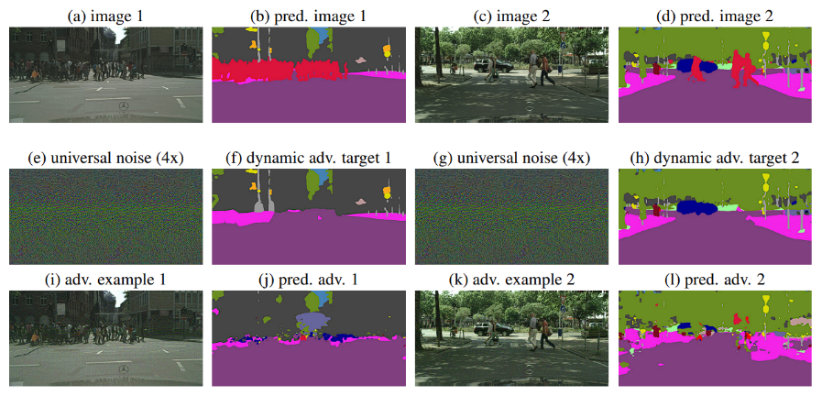

Meanwhile, we also find that there is a lack of implementation on general-purpose segmentation attack pipelines. One-time attacks on classification usually can be constructed easily with integrated library such as PyTorch [20]. There are existing implementations of a few baselines such as [21] which are implemented as scientific language such as Matlab. However, under our search, there is no modularized high-level programming language implementation of segmentation adversarial attacks.

Hence, this project has the following two primary objectives:

1: Study the effect of segmentation attack under different white-box settings and algorithm designs, with Cityscapes dataset. Improve at least one algorithm under these settings, in terms of metrics such as performance, stealthy, or physical realizability.

2: Construct a modularized adversarial attack backbone which support most cases of segmentation tasks. The user of this backbone should only need to implement substituted parts to use this backbone under most cases.

This project studies a few types of segmentation adversarial attacks: naïve white-box, white-box with spatial constraint, static universal, and dynamic universal, with a few changeable algorithm parameters such as norm (L1, L2, etc.) and perturbation update rate. This project also designed and implemented a modularized pipeline that can carry out above attacks with minimum user engagement, based on backbone provided by [7] repository.

[organization of this report]

1. **Material/Equipment Resources and costing**

This project is evaluated on a workstation provided by Prof Tan Rui and Dr. Guo Dongfang:

Workstation name: Server 4

Physical location: HP-NTU Corp Lab

Coordinator: Duc

CPU:

CPU0: Intel® Xeon® Gold 6246 Processor, 24.75M Cache, 3.3 GHz

CPU1: Intel® Xeon® Gold 6246 Processor, 24.75M Cache, 3.3 GHz

RAM: 768GB(12x64GB)DDR4-29 3 3 MHz Reg. ECC Memory

SSD: Samsung 970 Pro 1TB M.2 NVMe SSD

HDD: 3.5” Seagate IronWolf 4TB 64MB Cache SATA Hard Disk Drive

GPU:

4 X PNY nVidia Quadro RTX 8000 48GB

GDDR6 PCIe x16 GPU Card

The nominal cost of this workstation is SGD 48952.50.

Some early works and explorations were done on another workstation provided by Prof Tan Rui and Dr. Guo Dongfang:

Workstation name: Server 1

Physical location: CNCL

Coordinator: Dongfang

CPU: Intel Core i7-6850K 3.60GHz 15MB Cache 6C/12T Processor up to 3.8GHz turbo

RAM: 8x Corsair Vengeance LPX 16GB DDR4 3200 C16 1.35V

SSD:

SSD0: 1 x 2.5” Samsung 960 PRO M.2 Series 512GB NVMe SSD Hard Drive

SSD1: SSD: 2.5” Samsung 860 Pro Series 1TB SSD

HDD:

HDD0: 1 x 3.5” Seagate IronWolf Pro 4TB NAS Drive 7200rpm

HDD1: 3.5” Seagate IronWolf 8TB 7200rpm 256MB Cache SATA Hard Disk Drive

HDD2: IronWolf 8TB 7200rpm 256MB Cache SATA Hard Disk Drive

GPU:

GPU0: PNY nVidia Quadro RTX 6000 24GB GDDR6 PCIe x16 GPU Card

GPU1: GTX Titan V 12GB

GPU2: PNY nVidia Quadro RTX 6000 24GB GDDR6 PCIe x16 GPU Card

The nominal cost of this workstation is SGD 10980.34.

1. **Project schedule**

Here we provide a rough timeline and project works. Dates are approximations, since our project group had meeting biweekly.

* 1. Start~2022.12:  
     Preparation and exploration works are mainly carried out at this stage. We examined and tested a few AV tools, and searched for research results in various directions. We examined an AV simulator, LGSVL [22]. Unfortunately, LG stopped to develop and update LGSVL in Jan 2022, hence some efforts were spent on compatibility issues. We were able to bridge apollo and LGSVL and direct its camera streams for data collection. This acts as data acquisition backup for later stages. We also learnt about various kinds of adversarial attacks on AV perception. We evaluated a couple of existing attacks and attempted to find their implementations. We find while attacks like [23] [24] [25] cover important and safety-critical AV use cases, they include prior knowledge that is out of a typical FYP scope. While we really appreciate interesting yet accessible work such as [17], we find they have missing implementation or missing components.
  2. 2022.12~2023.1.6  
     We implemented a DAG attack on two different tasks as an early attempt. We really thank [26] for this nice support on [8] implementation and our work is mainly improved from this implementation. At this stage, we have applied DAG to 0-1 binary medical imaging segmentation proposed by [7] and on the Cityscapes dataset
  3. 2023.1.6~2023.1.27: We forked [26] as our implementation baseline and adopted a DAG attack on both [8] and the cityscape dataset. We credit the pre-trained model from the published model branch of [27] and [7] repositories to run this algorithm. There are issues, however, about large model support on GPU caused by huge model size from the adopted cityscapes model (in: 1024*2048*3, out: 1024*2048*19) and we only partially verify this attack on cityscapes at this stage (since we worked on server 1 which has less resource than server 4). m We also consider the alternative to self-train a model for cityscapes segmentation task, and we therefore select SCNN as a model baseline. We credit [28] for his nice implementation of SCNN with PyTorch, as its original paper [10] implements their work in Matlab. However, later works prove that this work is unnecessary. Pipeline backbone design & implementation is mostly done at this stage. We also realized targeted one-time attack.
  4. 2023.1.27~2023.2.10:   
     We finished all default modules of our pipeline, as well as visualizing and data saving tools. We implemented untargeted attack for arbitrary set of original classes. We also implemented a targeted substitution/hiding attack. We exploited semantic meanings of L1-norm in attack settings, and proposed a few candidate complex algorithms for later weeks to realize.
  5. 2023.2.10~2023.2.24:  
     We moved our work to more powerful server4, and immediately solved memory and GPU cohesion problems. We implemented both targeted universal and static universal attacks. We implemented supports for general masking attacks, additional loss metrics, and additional constraints. We realized a default masking method (binary spatial mask), a default loss metrics (total variance), and a default constraint (masking). We initially examined attacking process to explain attacking process and component selection.
  6. 2023.2.24~

1. **Methodology**
   1. Research on attack methods  
      This project covers a wide range of attack methods. We use a few abbreviations for clarity of this part and discussion below:  
      X []: a set of X.  
      About algorithm abbreviations:   
      T = targeted attack  
      O = one-time attack  
      U = untargeted attack  
      V = universal attack  
      S = static targeted attack  
      D = dynamic target attack  
      I/O variables are also denoted as follows throughout this report:  
      I: training / target image set.  
      Mo: original mask set.  
      Mt: target mask set.  
      Md: target model.  
      L: loss function set.  
      C: constraint set.  
        
      As algorithms explored in this project are combinations of these properties, we find such abbreviations useful for clarity throughout this report.General definitions of all algorithm categories that are explored in this project are listed below:   
      While black-box form of these algorithms can be clear and unambiguous, some of their I/O parameters can contain much tricks. A few common considerations/tricks on each of parameter are discussed below:  
      Constraint set [] C and loss metrics [] L. C is the set of constraint that the perturbation P must satisfy. This includes a wide range of constraints: spatial constraints (such as a mask where P can only be added inside this mask), value constraints (such as a printable color constraint where perturbation can only alter I to a specified of RGB values), etc. L has some semantically similar possible members, such as spatial constraints (e.g., a loss proportional to the sum of square between any pixel and its 8-neighbour), it can have more terms concerning minima in optimization (such as L-x norms).  
      Target mask Mt. Theoretically, Mt can be selected arbitrarily (and a single target universal attack can be view as a Mt[] with duplications of a single element). However, selection of Mt is heavily correlated to attack objectives and attack performance. One example (hiding attack) consists of Mt where only a specified set of classes in Mo are substituted to a target class (for example, attempting to fool segmentation model to recognize vehicles to vegetation). Since each algorithm has a few sub-types of objectives, there are multiple ways to select Mt. Details of Mt selection are discussed in both following and experiment section along with each algorithm.

Algorithm A: targeted, white-box, one-time attack on segmentation (TO)

Input: original image I, original mask Mo, target mask Mt, model Md, loss metrics [] L, constraints [] C

Output: a perturbation P, which when added to I and fed into Md as input, Md output is as much similar as Mt and as much dissimilar as Mo. P also minimizes loss metrics set L, and fulfilling each of constraint in C.

Algorithm A: targeted, white-box, one-time attack on segmentation (TO)

Input: original image I, original mask Mo, target mask Mt, model Md, loss metrics [] L, constraints [] C

Output: a perturbation P, which when added to I and fed into Md as input, Md output is as much similar as Mt and as much dissimilar as Mo. P also minimizes loss metrics set L, and fulfilling each of constraint in C.

Algorithm A: targeted, white-box, one-time attack on segmentation (TO)

Input: original image I, original mask Mo, target mask Mt, model Md, loss metrics [] L, constraints [] C

Output: a perturbation P, which when added to I and fed into Md as input, Md output is as much similar as Mt and as much dissimilar as Mo. P also minimizes loss metrics set L, and fulfilling each of constraint in C.

Algorithm A: targeted, white-box, one-time attack on segmentation (TO)

Input: original image I, original mask Mo, target mask Mt, model Md, loss metrics [] L, constraints [] C

Output: a perturbation P, which when added to I and fed into Md as input, Md output is as much similar as Mt and as much dissimilar as Mo. P also minimizes loss metrics set L, and fulfilling each of constraint in C.

Algorithm B: untargeted, white-box, one-time attack on segmentation (UO)

Input: original image I, original mask Mo, model Md, loss metrics [] L, constraints [] C

Output: a perturbation P, which when added to I and fed into Md as input, Md output is as much dissimilar as Mo. P also minimizes loss metrics set L, and fulfilling each of constraint in C.

Algorithm B: untargeted, white-box, one-time attack on segmentation (UO)

Input: original image I, original mask Mo, model Md, loss metrics [] L, constraints [] C

Output: a perturbation P, which when added to I and fed into Md as input, Md output is as much dissimilar as Mo. P also minimizes loss metrics set L, and fulfilling each of constraint in C.

Algorithm B: untargeted, white-box, one-time attack on segmentation (UO)

Input: original image I, original mask Mo, model Md, loss metrics [] L, constraints [] C

Output: a perturbation P, which when added to I and fed into Md as input, Md output is as much dissimilar as Mo. P also minimizes loss metrics set L, and fulfilling each of constraint in C.

Algorithm B: untargeted, white-box, one-time attack on segmentation (UO)

Input: original image I, original mask Mo, model Md, loss metrics [] L, constraints [] C

Output: a perturbation P, which when added to I and fed into Md as input, Md output is as much dissimilar as Mo. P also minimizes loss metrics set L, and fulfilling each of constraint in C.

Algorithm C: static, white-box, universal attack on segmentation (SV)

Input: original image set [] I, original mask set [] Mo, target mask Mt, model Md, loss metrics [] L, constraints [] C

Output: a perturbation P, which when added to any images in I and fed into Md as input, Md output is as much similar as Mt and as much dissimilar as any of Mo. P also minimizes loss metrics set L, and fulfilling each of constraint in C.

Algorithm C: static, white-box, universal attack on segmentation (SV)

Input: original image set [] I, original mask set [] Mo, target mask Mt, model Md, loss metrics [] L, constraints [] C

Output: a perturbation P, which when added to any images in I and fed into Md as input, Md output is as much similar as Mt and as much dissimilar as any of Mo. P also minimizes loss metrics set L, and fulfilling each of constraint in C.

Algorithm C: static, white-box, universal attack on segmentation (SV)

Input: original image set [] I, original mask set [] Mo, target mask Mt, model Md, loss metrics [] L, constraints [] C

Output: a perturbation P, which when added to any images in I and fed into Md as input, Md output is as much similar as Mt and as much dissimilar as any of Mo. P also minimizes loss metrics set L, and fulfilling each of constraint in C.

Algorithm C: static, white-box, universal attack on segmentation (SV)

Input: original image set [] I, original mask set [] Mo, target mask Mt, model Md, loss metrics [] L, constraints [] C

Output: a perturbation P, which when added to any images in I and fed into Md as input, Md output is as much similar as Mt and as much dissimilar as any of Mo. P also minimizes loss metrics set L, and fulfilling each of constraint in C.

Algorithm D: targeted, dynamic, white-box, universal attack on segmentation (TDV)

Input: original image set [] I, original mask set [] Mo, model Md, loss metrics [] L, constraints [] C

Output: a perturbation P, which when added to any images in I and fed into Md as input, Md output is as much dissimilar as any of Mo. P also minimizes loss metrics set L, and fulfilling each of constraint in C.

Algorithm D: targeted, dynamic, white-box, universal attack on segmentation (TDV)

Input: original image set [] I, original mask set [] Mo, model Md, loss metrics [] L, constraints [] C

Output: a perturbation P, which when added to any images in I and fed into Md as input, Md output is as much dissimilar as any of Mo. P also minimizes loss metrics set L, and fulfilling each of constraint in C.

Algorithm D: targeted, dynamic, white-box, universal attack on segmentation (TDV)

Input: original image set [] I, original mask set [] Mo, model Md, loss metrics [] L, constraints [] C

Output: a perturbation P, which when added to any images in I and fed into Md as input, Md output is as much dissimilar as any of Mo. P also minimizes loss metrics set L, and fulfilling each of constraint in C.

Algorithm D: targeted, dynamic, white-box, universal attack on segmentation (TDV)

Input: original image set [] I, original mask set [] Mo, model Md, loss metrics [] L, constraints [] C

Output: a perturbation P, which when added to any images in I and fed into Md as input, Md output is as much dissimilar as any of Mo. P also minimizes loss metrics set L, and fulfilling each of constraint in C.

* + 1. TO type attack  
       Since the user can specify target mask freely, there are a wide range of attack objectives. In this project, the following attack objectives are concerned:  
       * Targeted static attack. In this setting Mt is an arbitrary mask which is dissimilar to Mo. This setting may happen if the attacker wants to deploy a man-in-the-middle (MITM) replay attack that tries to duplicate a segmentation result with different data, or falsify image segmentation result for key purpose.  
       * Targeted substitution/hiding attack. In this setting only a specified set of classes in Mo are mapped to a set of target class, and the substitution is Mt. For example, Mt can be constructed by mapping both “car” class and “pole” class to “building” class. This setting is considered harder to train than a targeted static attack, as a hiding attack must also preserve background as much as possible. This scenario may also happen under similar assumption as a targeted static attack; however, this setting is considered stealthier and can evade crude manual inspections.  
       * Targeted masked attack. A 0~1 float mask is introduced such that at each update step the current perturbation is multiplied by this mask. Specifically, if the mask is binary i.e. each pixel can only have value [0, 1], this setting is equivalent to the case that the perturbation can only be added on pixels with mask value 1. This setting must also consider preserving background (as 0-value mask pixels). Though Mt can be theoretically chosen arbitrarily, Mt usually only differs to Mo in 1-valued mask pixels. This setting is also often combined with a hiding attack with a mask covering mapped pixels.  
       Besides these different attack objectives, additional loss terms can also be added to fulfill certain attack requirements, such as physical realizability.
    2. UO type attack  
       Since there is no Mt for UO type attack, there is only one construction for UO type attack covered as above. However, such attacks can be detected by any human inspection, since it does not guarantee prediction result of substituted pixels This setting can happen if the attacker wants to quickly corrupt victim data, as this attack usually has very low execution time.
    3. SV type attack  
       In SV type attacks, Mt is a single target mask. Since there is a set of Mo and pairwise metrics such as dissimilarity cannot be semantically generalized to Mo, there is only one construction for SV type attack: choosing an arbitrary target mask. Typically, SV attacks focus more on similarity between model output of any of perturbed image in I and Mt. This assumption make sense since most possible attacking scenarios requires that any perturbed image is viewed as similar as target image. This scenario may happen to mask a static camera that such cameras cannot detect suspicious activities (as pointed out by [19]).
    4. TDV type attack  
       This type of attacks aims to produce a universal perturbation which when applied to any original image I the model outputs a target mask Mt which is obtained by a transform F on Mo (Mt = F(Mo)). Such transformations can be arbitrarily set with different complexity. A few configurations are explored in this project, listed as below:  
       * Universal flooding attack. This attack aims to corrupt the prediction of a specific region by flooding it with target class(es). Such attack can be quick towards convergence due to some semantic reasons discussed in discussion section, and can evade part of human inspection (a valid evading case is to eliminate pedestrian pixels surrounded by vegetation).   
       * Universal substituting attack. Similar to substituting/hiding attack, the transformation maps a set of classes in Mo to a target set to produce Mt. Typically due to semantic reasons, which are discussed in discussion part, it is the best to set F with one original class and one target class (e.g., a universal perturbation which when added into any image turn “pedestrian” class to “building” class). Other constraints that facilitate stealthy or physical realizability can also be added into this attack, making it more effective. A possible and powerful scenario is to craft semi-transparent stickers, which when applied to victim camera, confuse its segmentation module and decision making.
  1. Pipeline construction  
     With listed attack categories, we are able to design a pipeline that can carry out these attacks with highest level of modularization. Figure [x] is a structural representation of our pipeline. Discussions about general pipeline flow and each component are listed below.

Figure A structural representation of our pipeline. Black arrows denote control flow while red arrows denote data flow.

Figure A structural representation of our pipeline. Black arrows denote control flow while red arrows denote data flow.

Figure A structural representation of our pipeline. Black arrows denote control flow while red arrows denote data flow.

Figure A structural representation of our pipeline. Black arrows denote control flow while red arrows denote data flow.

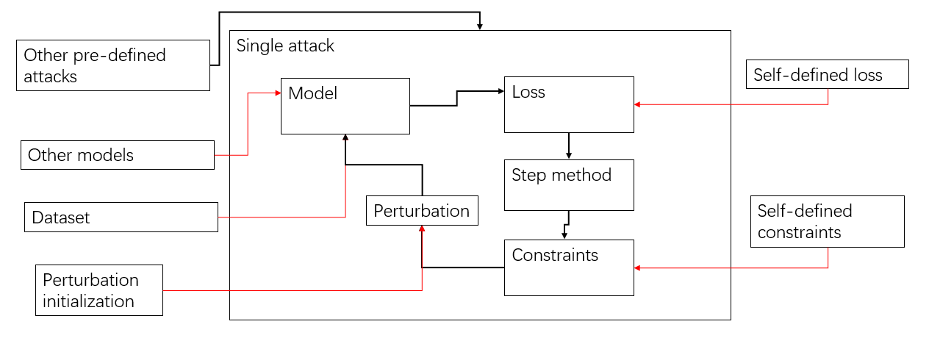

* + 1. General flow of pipeline  
       The single attack function is the backbone of our architecture. This function consists of a list of serialized components which can be substituted by user-defined ones. This function follows a traditional adversarial attack approach, with pseudocode provided below:  
         
       Lines in foreach{} loop of this piece of code show one-to-one correspondence to internal modules in Figure 2, as well as their serialized order. All algorithms discussed in section 7.1 can be abstracted to this topological architecture, with proper components substituted.  
       Implementation details and further discussions about such substitutions are listed in below sections.

Algorithm: General flow of adversarial attack for image tasks

Compulsory input: target model M, original image set [] I, original label/mask set [] Mo, loss metrics [] L, constraints [] C.

Output: a perturbation.

global_perturbation.init()

foreach image in I do {

image_perturbed = image + global_perturbation

predicted_output = M.predict(image_perturbed)

prediction_loss = L[“pred_loss”](predicted_output, Mo[image])

other_losses = sum(foreach loss in L {loss(*args)})

total_loss = prediction_loss + other_losses

total_loss.back_propagation()

step(global_perturbation, global_perturbation.gradient)

foreach constraint in C {constraint.apply(global_perturbation)}

}

return global_perturbation

Algorithm: General flow of adversarial attack for image tasks

Compulsory input: target model M, original image set [] I, original label/mask set [] Mo, loss metrics [] L, constraints [] C.

Output: a perturbation.

global_perturbation.init()

foreach image in I do {

image_perturbed = image + global_perturbation

predicted_output = M.predict(image_perturbed)

prediction_loss = L[“pred_loss”](predicted_output, Mo[image])

other_losses = sum(foreach loss in L {loss(*args)})

total_loss = prediction_loss + other_losses

total_loss.back_propagation()

step(global_perturbation, global_perturbation.gradient)

foreach constraint in C {constraint.apply(global_perturbation)}

}

return global_perturbation

Algorithm: General flow of adversarial attack for image tasks

Compulsory input: target model M, original image set [] I, original label/mask set [] Mo, loss metrics [] L, constraints [] C.

Output: a perturbation.

global_perturbation.init()

foreach image in I do {

image_perturbed = image + global_perturbation

predicted_output = M.predict(image_perturbed)

prediction_loss = L[“pred_loss”](predicted_output, Mo[image])

other_losses = sum(foreach loss in L {loss(*args)})

total_loss = prediction_loss + other_losses

total_loss.back_propagation()

step(global_perturbation, global_perturbation.gradient)

foreach constraint in C {constraint.apply(global_perturbation)}

}

return global_perturbation

Algorithm: General flow of adversarial attack for image tasks

Compulsory input: target model M, original image set [] I, original label/mask set [] Mo, loss metrics [] L, constraints [] C.

Output: a perturbation.

global_perturbation.init()

foreach image in I do {

image_perturbed = image + global_perturbation

predicted_output = M.predict(image_perturbed)

prediction_loss = L[“pred_loss”](predicted_output, Mo[image])

other_losses = sum(foreach loss in L {loss(*args)})

total_loss = prediction_loss + other_losses

total_loss.back_propagation()

step(global_perturbation, global_perturbation.gradient)

foreach constraint in C {constraint.apply(global_perturbation)}

}

return global_perturbation

* + 1. Model and dataset  
       Both model and dataset are provided by the user. They should be in coherence such that the provided model is trained on the same distribution with the provided dataset. The only additional requirement for the model is that it must support back propagation (which is the case for most deep learning implementations), the gradient must be public, and the model must fit into the memory of each provided device. The consideration for the last memory requirement is based on our early explorations on server1. We observe that different types of GPU can suffer coherence problem when splitting model to multiple GPUs.   
       The dataset should be a specific version for each model provided. Each model can require a unique method to pre-process input samples. Since there is no extra transformations within attack pipeline, all pre-processing must be done within dataset. The dataset must support explicit instantiation and indexing (i.e. __getitem__() in python). Furthermore, all samples that should be included in a dataset must have the same directory path.
    2. Loss  
       In theory, a loss used in such adversarial settings can be any function which inputs an image (or original-target pair of images) and outputs a float. This is also the only requirement imposed in this project. However, there are some implicit techniques and constraints about how to craft these loss functions.  
       The first constraint is that this function must have its derivative (or pseudo-derivative). This is required since finding the derivatives of loss is the first step of back propagation. While many built-in arithmetic such as max() does not have its derivative, many deep learning libraries implement alternative versions that have pseudo-derivative (e.g. Pytorch, torch.max() has pseudo-derivatives).  
       The second consideration is about closure. User may want to specify hyper-parameters used by these loss functions. There are to acceptable implementations for this requirement.   
       The first is closure method. With this approach, the user first binds hyper-parameters with function (e.g., via a class definition & instantiation), and define this binding as callable. This binding instance thus computes a loss when called (e.g., by defining __call__() in python). Closures are usually considered with highest level of modularization and integration, and impose least concern for users. However, this complicates implementation as it is naturally more structural, and closures need to handle optional initializations.  
       The second is argument packing method. When called, loss function also accepts a pack of arguments and extract useful arguments for this loss function. This is topological a memento design pattern. It is considered light-weighted, procedural, and tight. It also separates loss computation and arguments, which make structure clear and organized. However, this impose heavy burden on user side since it is user’s responsibility to construct an argument pack. It also forces that two different parameters from different loss cannot share a same argument key, which is a serious drawback for large number of candidates.  
       Due to the following reasons:  
       * We observe that an attack contains no greater than 5 loss terms in most cases.  
       * Loss terms usually share a number of common terms, such as original image/target image, etc., and usually terms that are not shared are unique.  
       We decide to adopt an argument packing approach.
    3. Constraints  
       There are many types of constraints for different attack families. This includes a few types as below:  
       * assertion constraint: if the constraint is not satisfied, the attack halts/returns.  
       * application constraint: if the constraint is not satisfied, the perturbation is transformed by an application function.  
       * algorithmic constraint: if the constraint is not satisfied, the attacking algorithm state is updated (e.g., adjusting perturbation learning rate).  
       We find that assertion and algorithmic constraints are hard to modularize since they usually require a unique control flow within the attacking pipeline. Meanwhile, application constraints can be realized within our standardized pipeline.  
       We implement the most common constraint as example, the masking constraint. The mask is usually a binary mask where the perturbation can only be imposed on “1” pixels of the mask. By masking, many attack objectives can be conducted such as a hiding attack and substitution attack.
    4. Step method  
       Step methods is the update method of perturbation. Step methods should also be a substitutable part. However, with a search, we find that some existing step methods require unique control flows and sentinels which cannot be integrated. Within our research, we find that the Dense Adversarial Generation, proposed by [21], is both effective and simple to act as a baseline, hence we implement it as our default step method.  
       The algorithm has the following pseudocode:   
         
       Analysis:  
       There are a few trivial lines which are identical to a typical attack pipeline. Line 6 is typical perturbation update step where current attack gradient step is added into global gradient, and line 7 is just updating perturbed image. Line 8 is max iteration sentinel.   
       Line 3 is to compute predicted top-1(max) label for each pixel.   
       Line 4 is to compute the loss gradient. The goal of updating r by gradient descent is to both maximize adversarial prediction confidence and minimize original prediction confidence. For two terms inside the summation over predicted output, the first term is the gradient of loss computed with adversarial target (step to minimize adversarial loss) and the second term is the reversed direction of gradient of prediction (step to maximize prediction loss).  
       Line 5 is to normalize current step, with a homogeneous step length gamma.   
         
       This simple stepping method is proven [8] effective to segmentation tasks and object detection tasks. We hereby implement a variation that adopt dynamic step update provided by [7] as default stepping method. Since details and analysis of dynamic stepping method involve much theory, they are discussed under section 9.1.

Figure Pseodocode of DAG. Adopted from [8].

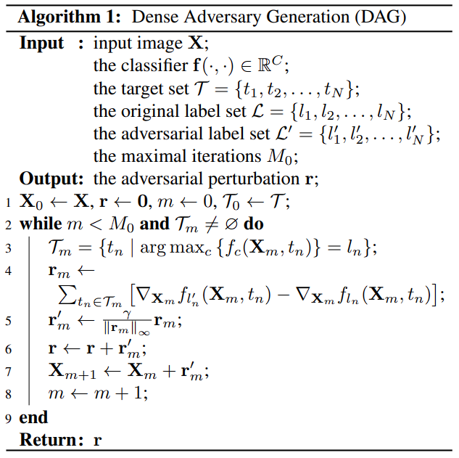

* + 1. Other attacks  
       Besides internal substitutable parts of one-time attack function, this function is also intended to be used as one-time black box for more complex attacks. This includes multi-pass attacks, and universal attacks as explored in this project.   
       A multi-pass attack is a couple of sequential attacks that exerts on the same input. Since perturbations (no matter this is obtained from a white-box derivative or from black box estimation) contains attack optimization information, a purturbation produced by a previous attack can contain instructive information for a later one.   
       We propose a multi-pass attack and name it as L1+Ln attack. We find that there is only works that apply such attack to object detection / classification tasks

1. **Experiments**

This section evaluates our methodology with experiments. Due to natural complexity of Cityscapes dataset, we have no way to select a set that can represent all characteristics of this dataset and do evaluation on it. Hence for simplicity and deterministic nature, we only select a small subset of dataset to perform attack evaluation.

For one-time attacks, we select two pairs of images:

* Aachen_000005_000019 and Aachen_000000_000019. This pair is selected because by human inspection they both have acceptable uniform distribution across common classes (e.g., pedestrian, car, building, road, etc.), and they have dissimilar orientation. If not otherwise specified, the right one is used as original image and the left one is the target image.  
  images  
  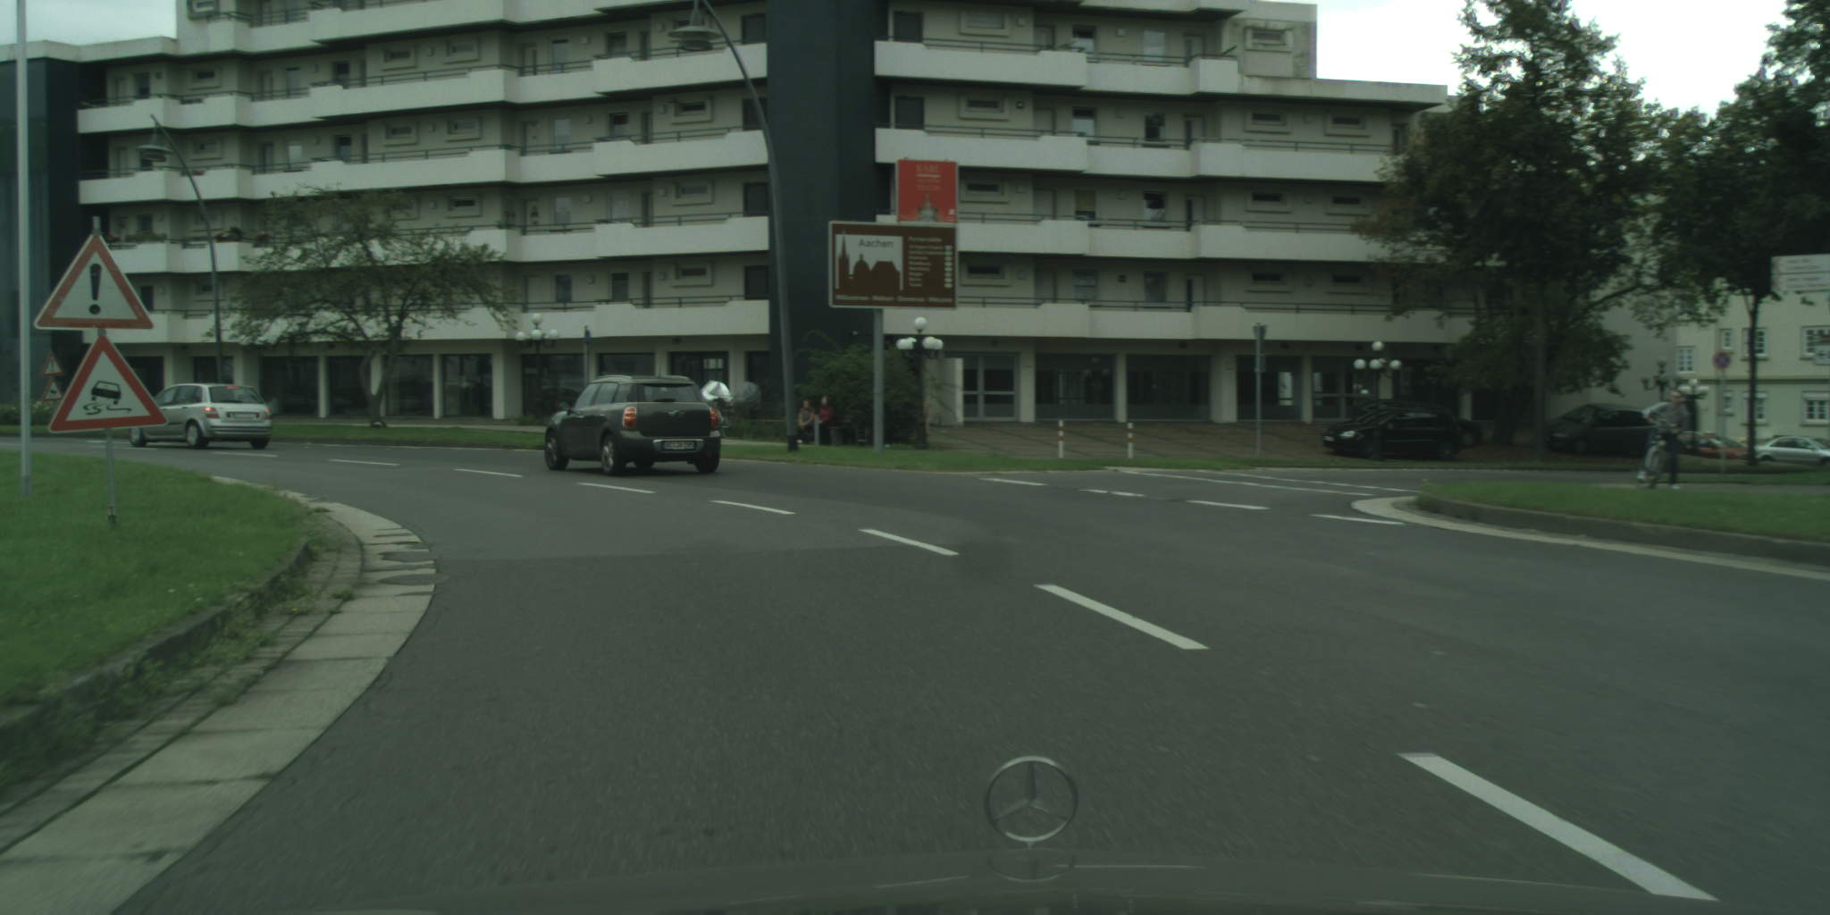 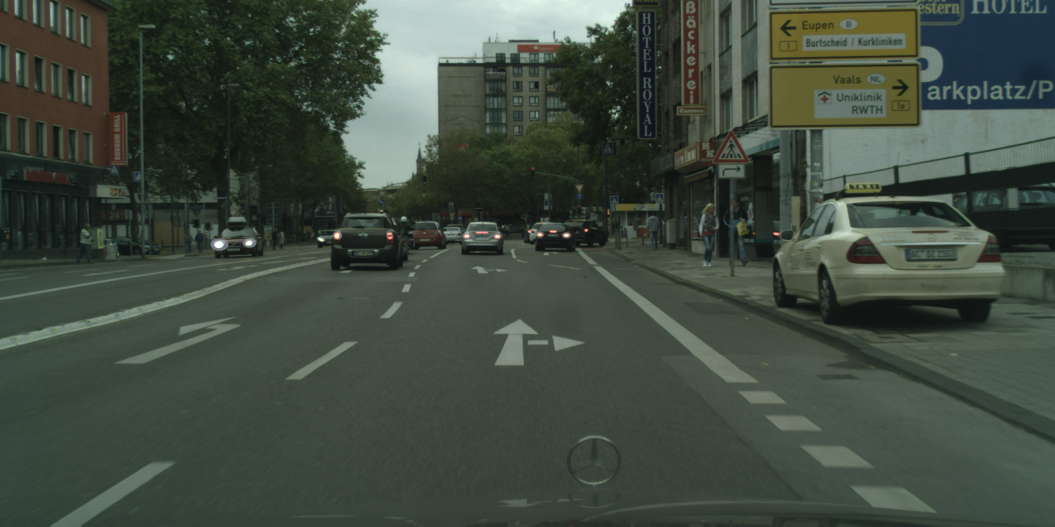  
  masks  
  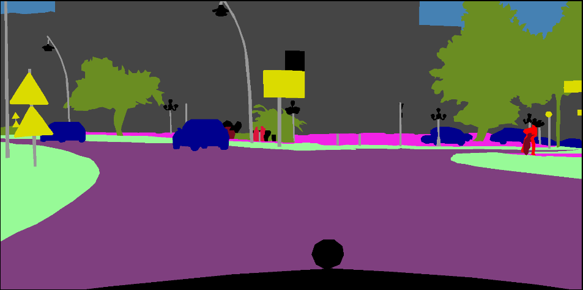 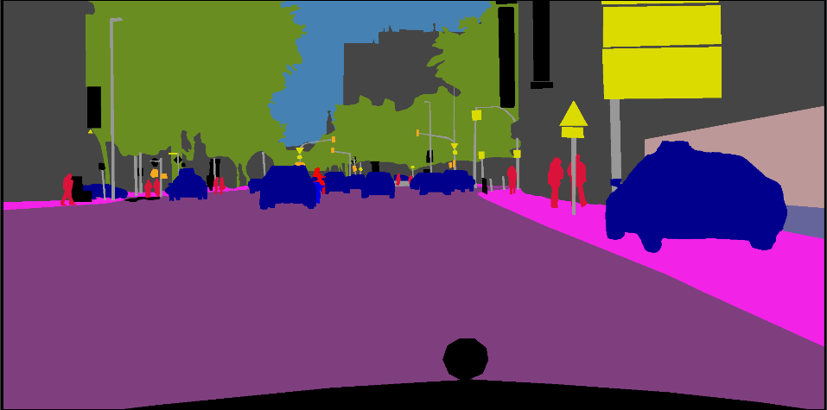  
  model output on original image  
  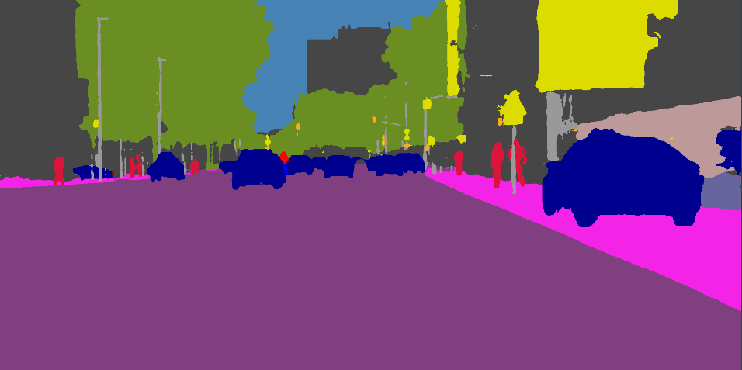
* Aachen_000007_000019 and Aachen_000008_000019. This pair acts as extreme case since they both have little pixels as car and pedestrian. Both of them has plenty of vegetation and building pixels while they share different orientation.  
  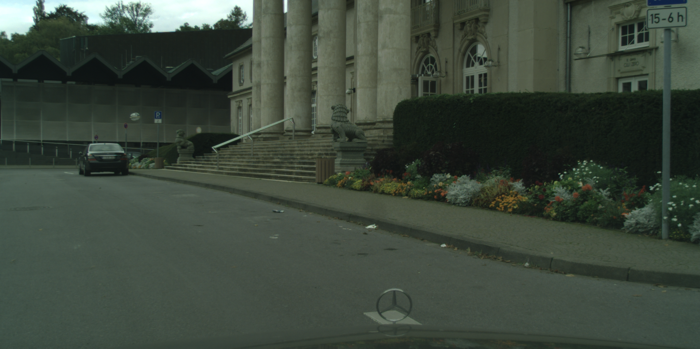 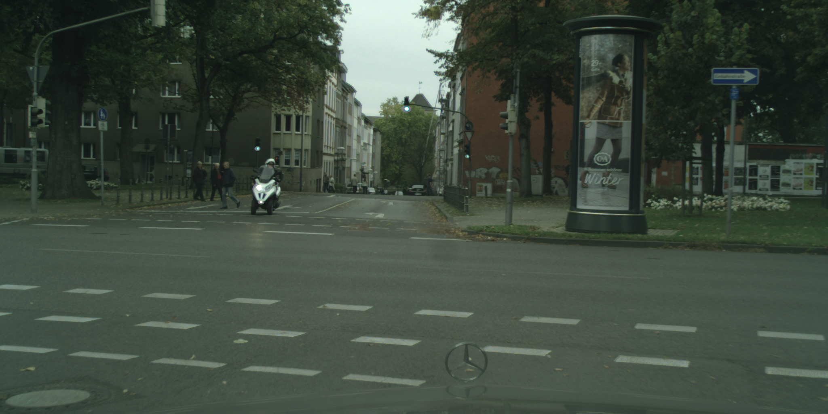

For universal attacks, quick evaluation is done with a mini dataset:   
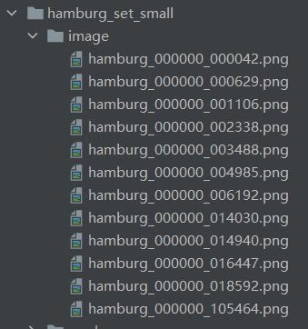 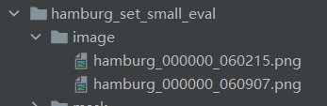  
They are manually selected such that they cover most types of city scape. While we do not have any guarantee how algorithms would perform on such a small set, we hope such manual construction may help attacking algorithms somehow.  
A full training is done with all images under Hamburg dataset, consists of around 500 training images.  
We borrow a pre-trained model from [27]. They provide a bunch of models on two datasets with a backbone-feature extraction approach. Our adopted model has a DeepLabV3+ = ResNet101 architecture and is trained with 18 classes + a null class on cityscapes. Such architecture treats segmentation as a pixel-wise classification task and employs a traditional forward dense prediction schema. With unknown training methods, they guarantee an acceptable performance on any of these models. However, due to time cost of exploring attack configurations, we do not consider attacking an alternative model, and this is a good future work.

For dataset implementation, since we borrow a pre-trained model, we follow [27] with their dataset labels.   
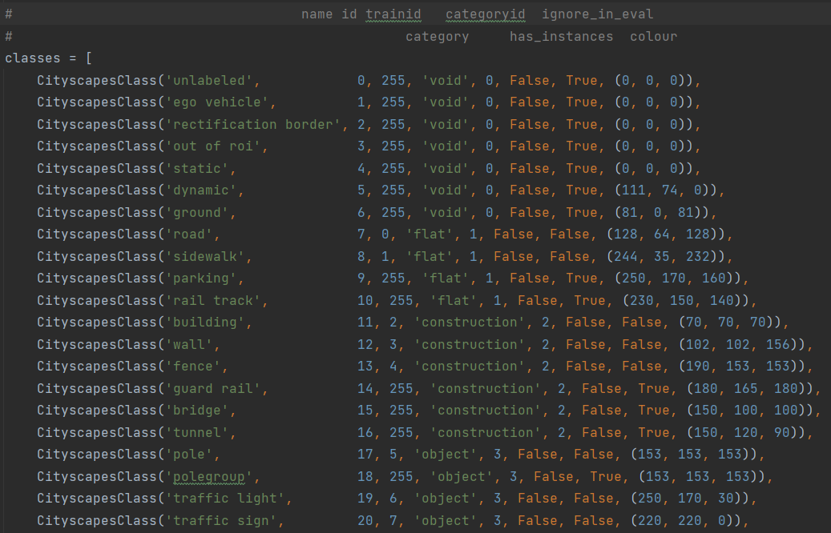  
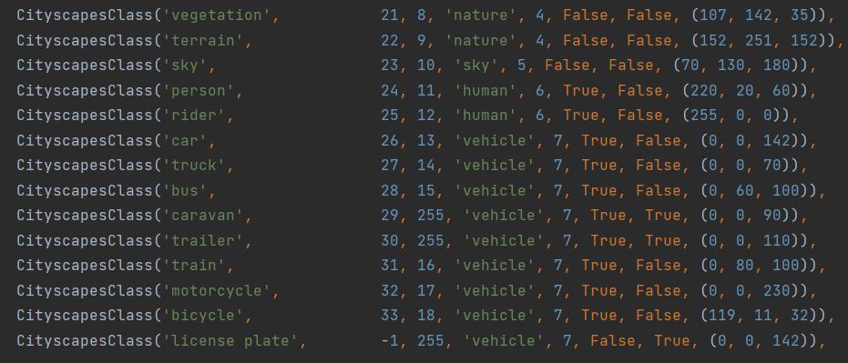

The left most columns (the names) are class names used in original Cityscapes dataset. The model is trained with column “train_id” (i.e. masks are encoded with train_id column), and this encoding shows that the model is only trained on most common classes. The dataset is also normalized with mean (0.485, 0.456, 0.406) and standard variation (0.229, 0.224, 0.225) such that the value distributes approximately in interval (0, 2.64).

We find it necessary to further explain one of our metrics: IOU. We define that IOU used all of our experiments is:

$$IOU= \frac{1}{len(I\left(X,Y\right))}\sum_{c ∈Ic(X, Y)}{\frac{{I(X,Y)}_{on C}}{{U(X,Y)}_{on C}}}$$

Where ${I(X,Y)}_{C}$ denotes intersection respect to class C and similarly ${U(X,Y)}_{C}$ is its union. $Ic(X,Y)$ is the intersection of unique class collection of X and Y. Semantically this computes the average of IOU of each single class which appears in both X and Y. If a mask is provided, IOU only considers valid pixels from that mask. And if this is computed across multiple pixels, the final IOU is the average of individual image’s IOU. This is a direct generalization to multiclass from mIOU (mean IOU).

If not otherwise specified, segmentation results are encoded with pre-defined colors for each class id, and perturbation images are normalized to 0-255 by default.   
If not otherwise specified, we use 1:16 as a ratio of prediction loss and distance loss. However, as prediction loss is computed over the entire 1024x2048 image, we still find this ratio somehow biased towards prediction loss. Hence, some sections provides an exploration about different ratios.  
For additional loss, we use a default weight of 16.

* 1. **TO type attack**
     1. Naïve targeted attack (static attack)  
        In this attack setting, the attacker aims to add a perturbation to a single target image, where this perturbed image is classified as similar as a target prediction provided by the attacker by the target model.  
          
        The first pair of selected images is used as evaluation for this attack. The original prediction by the target model is shown as [fig].  
        model out for original  
           
        target mask  
          
          
        1600 LR4 L1 last epoch  
        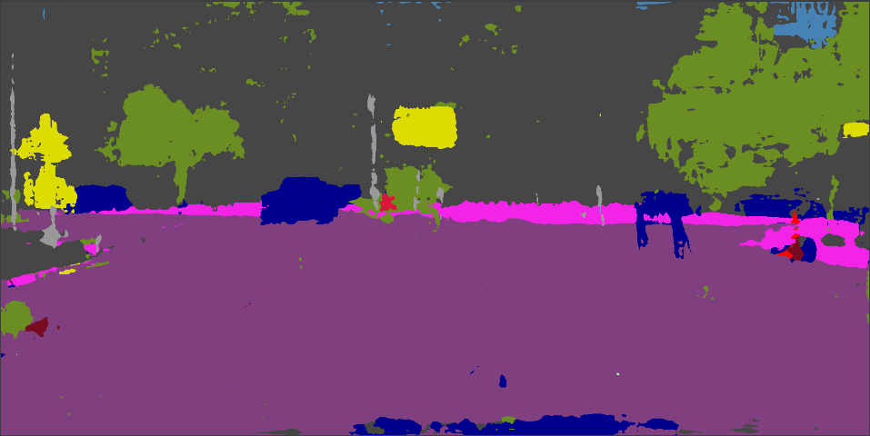 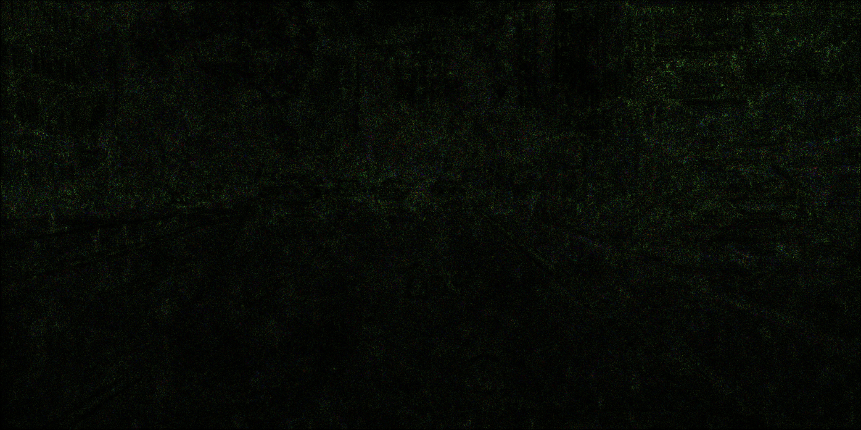  
        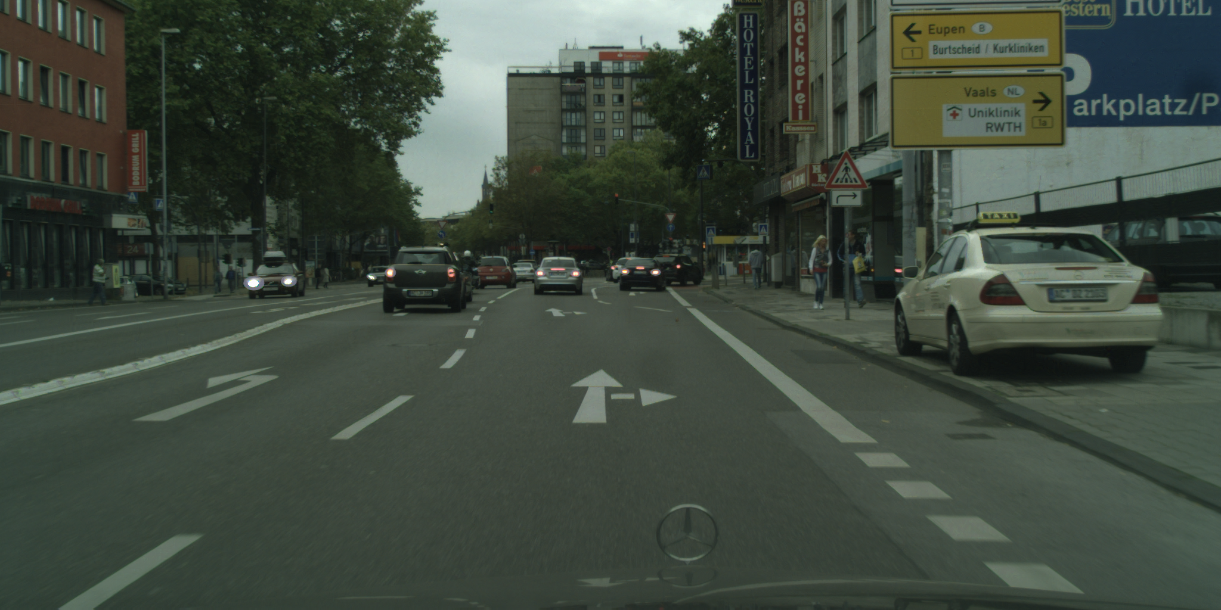  
        50% epoch  
        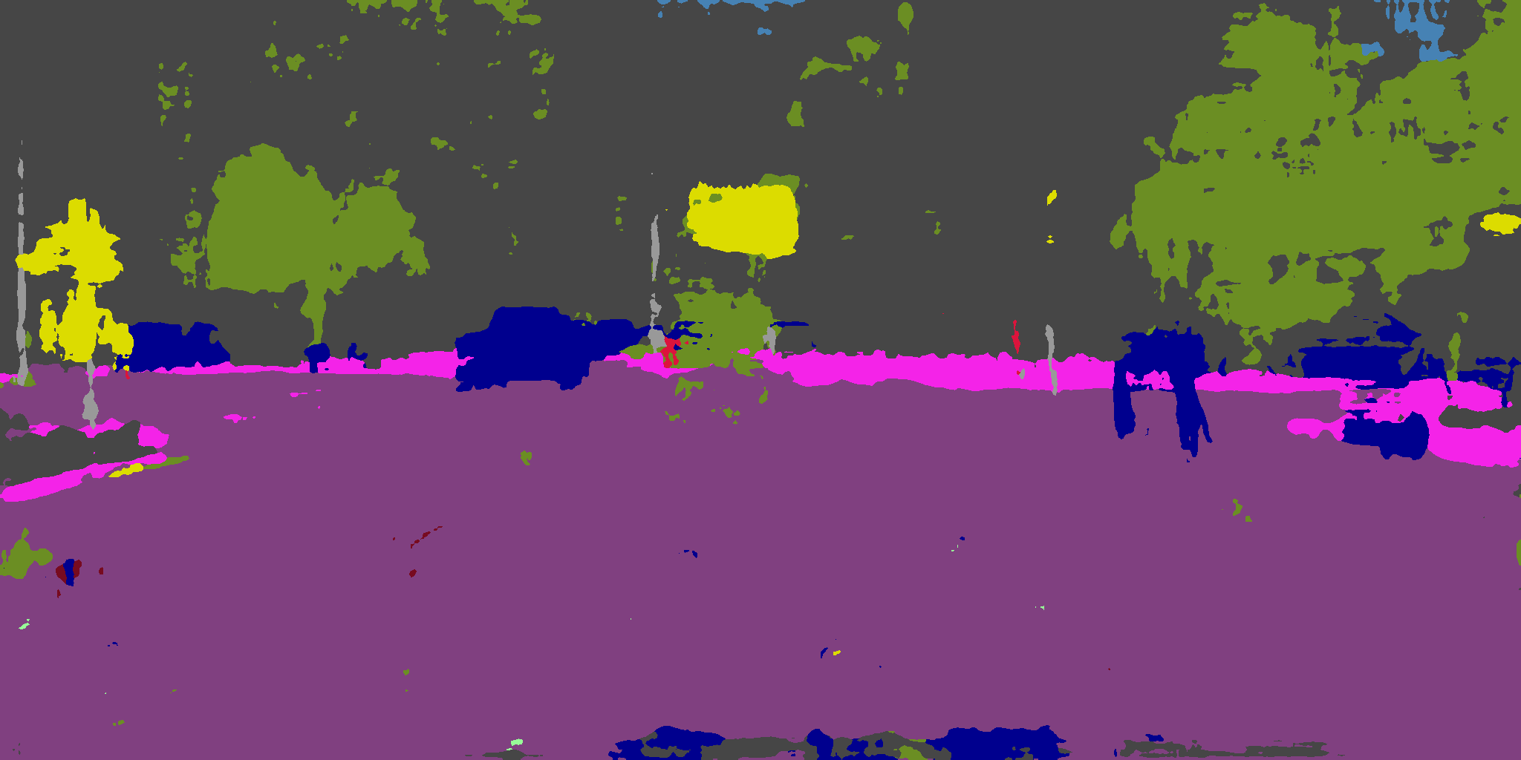  
        25% epoch  
        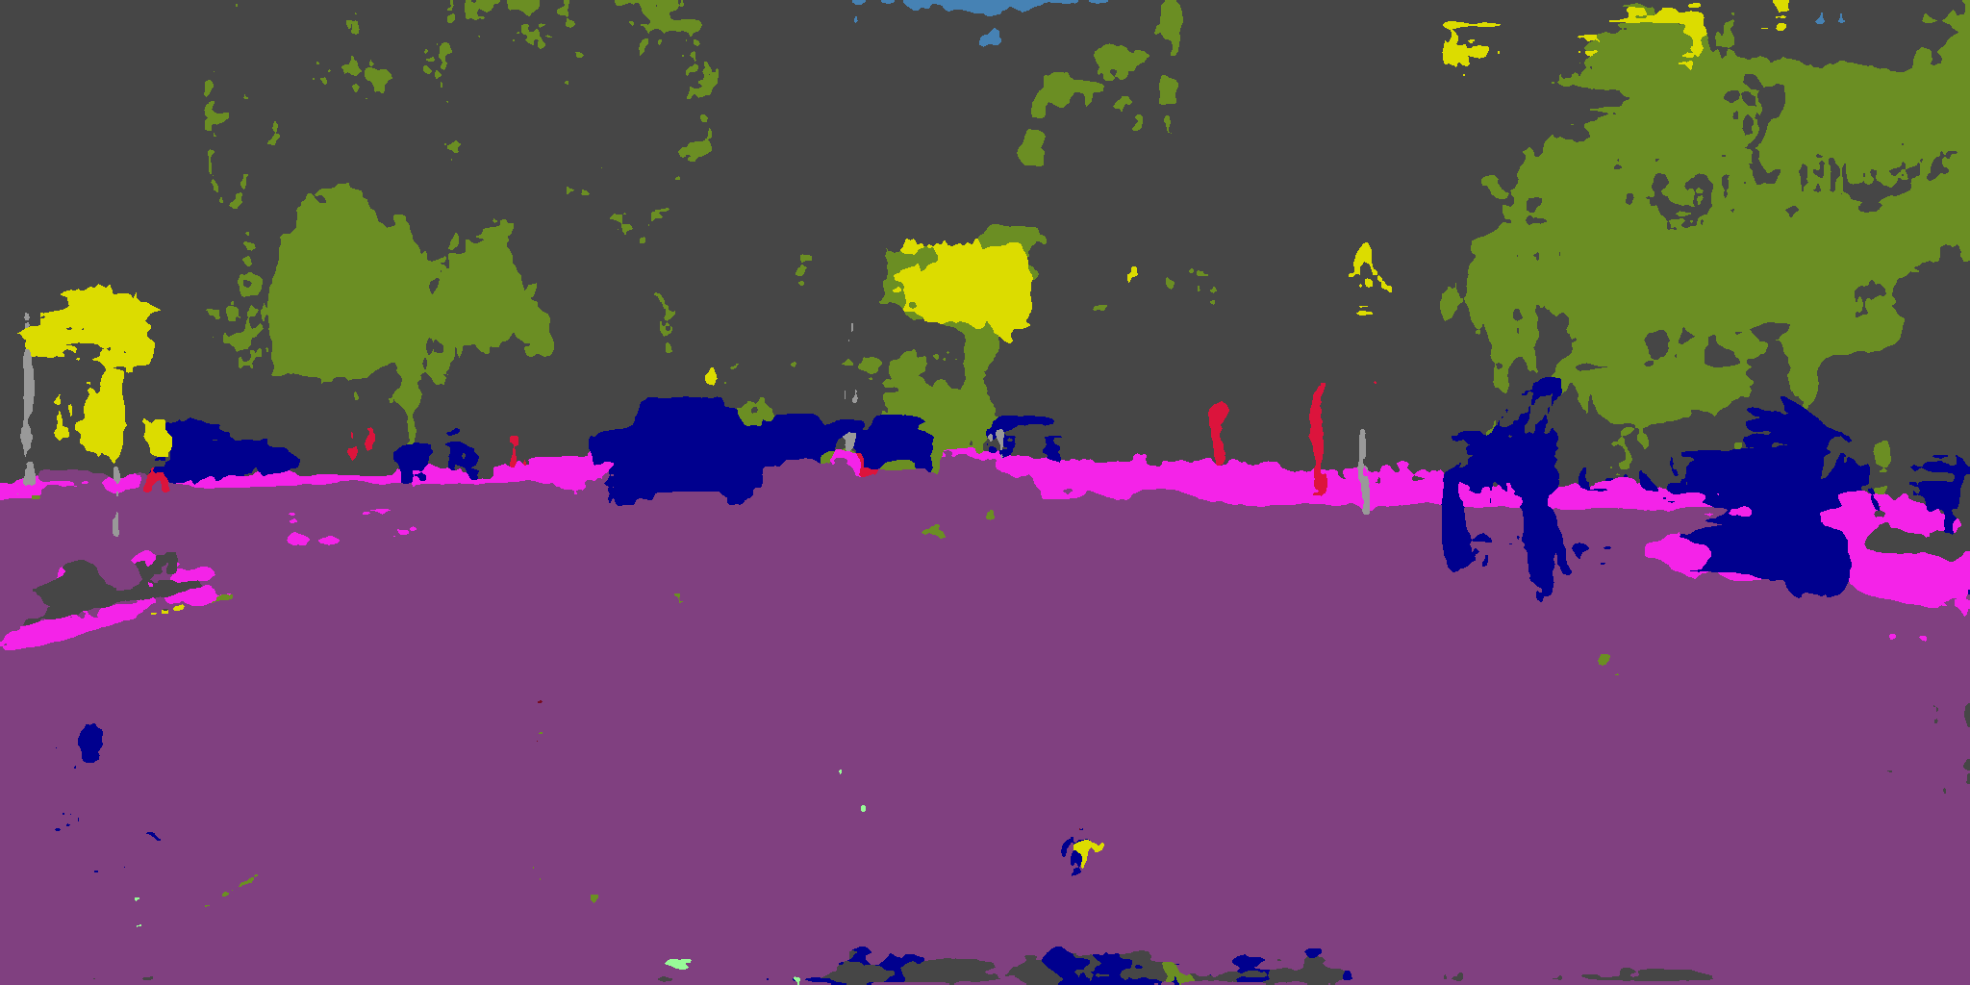  
        12% epoch  
        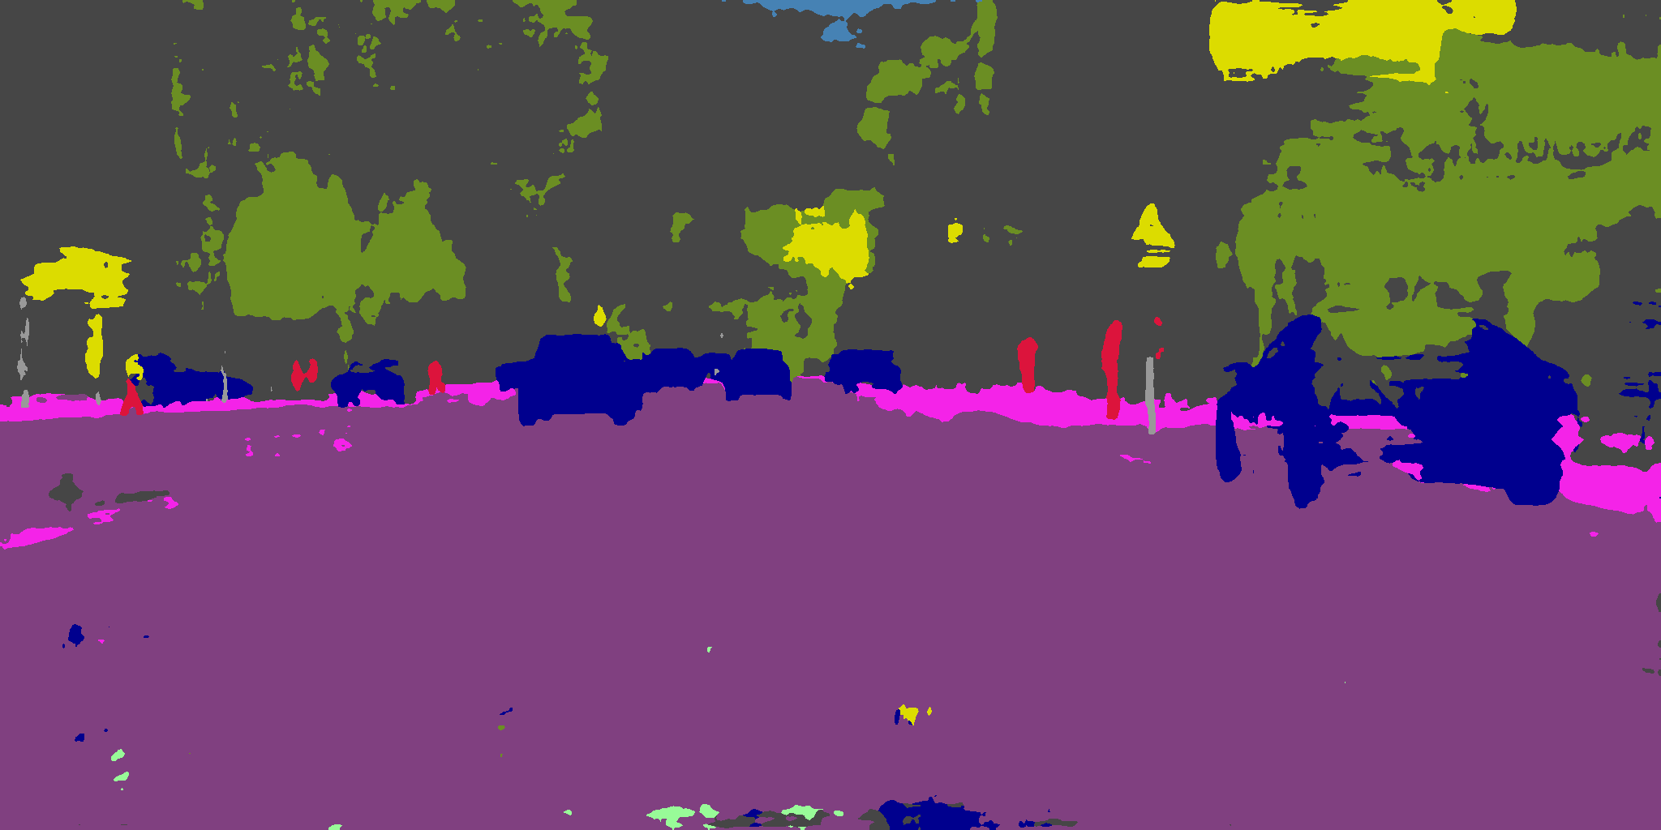  
          
          
        1600 LR4 L2 last epoch  
        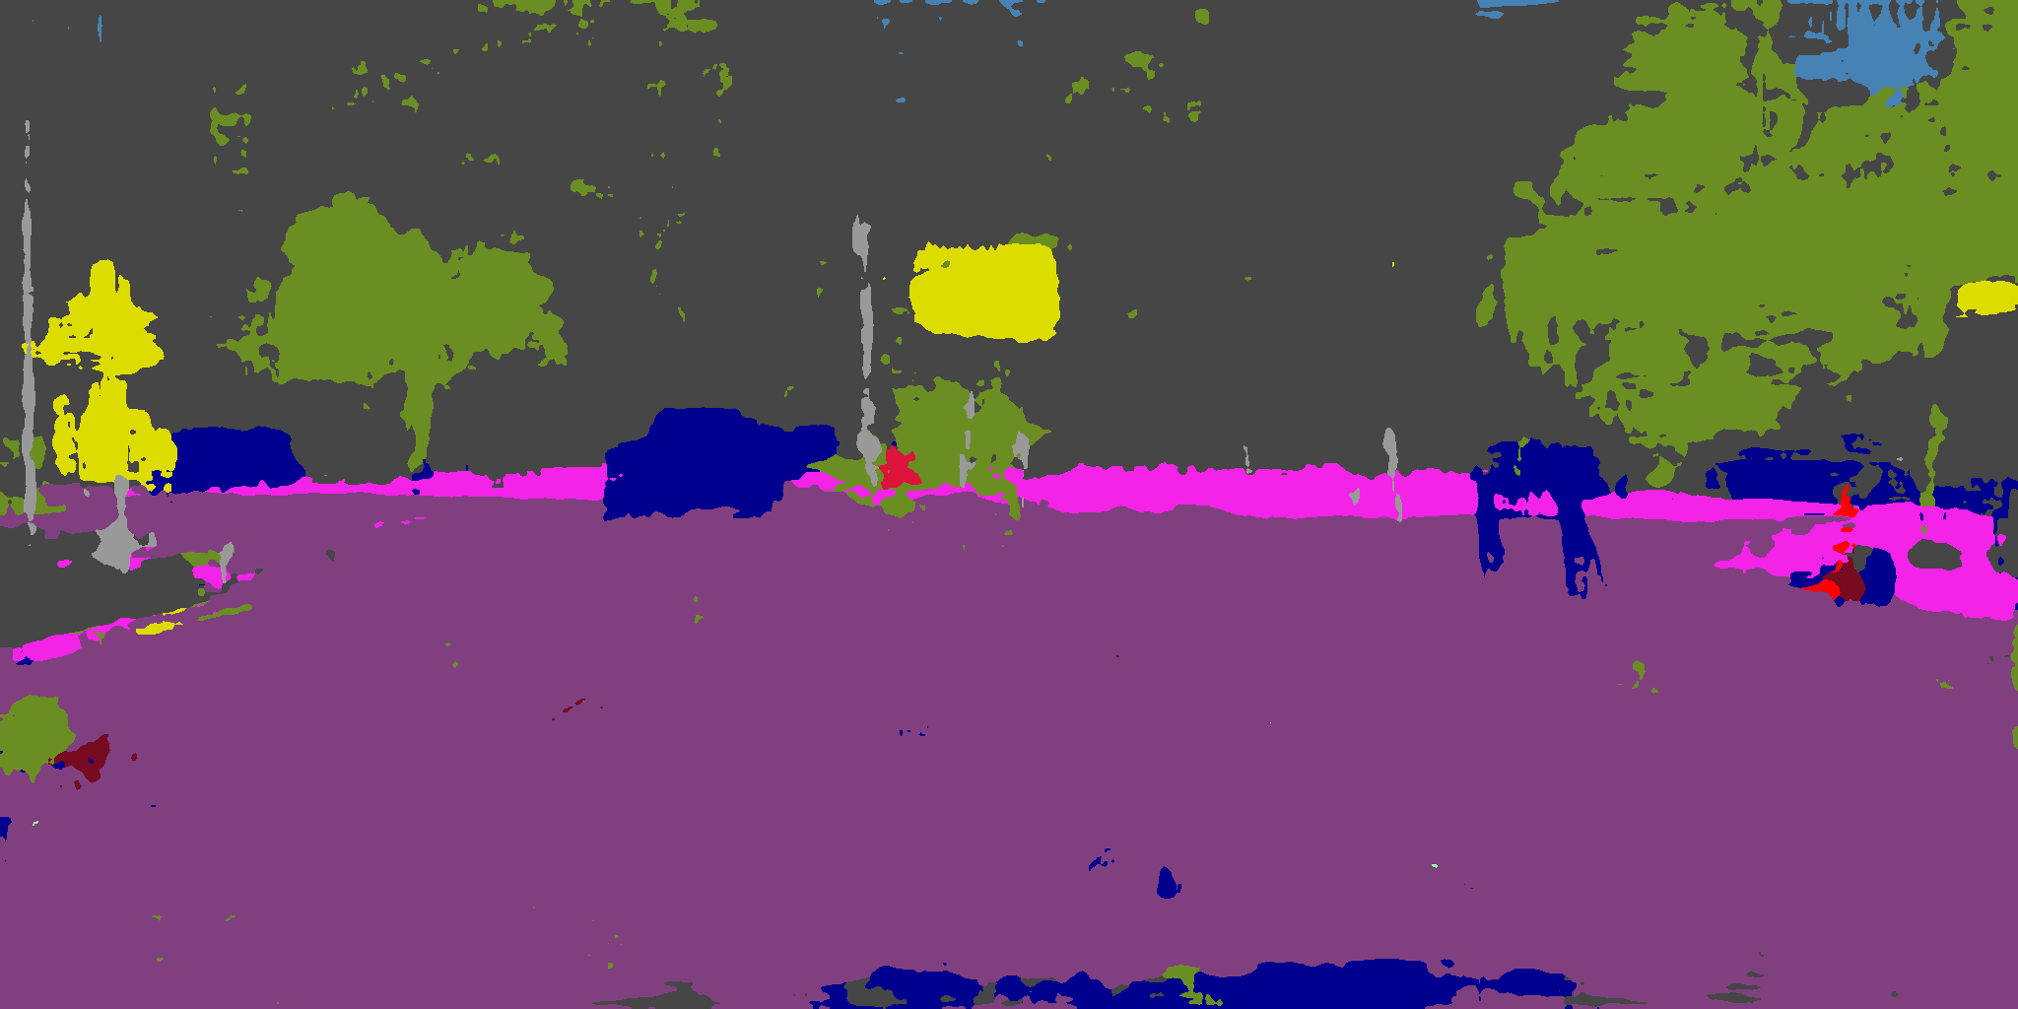 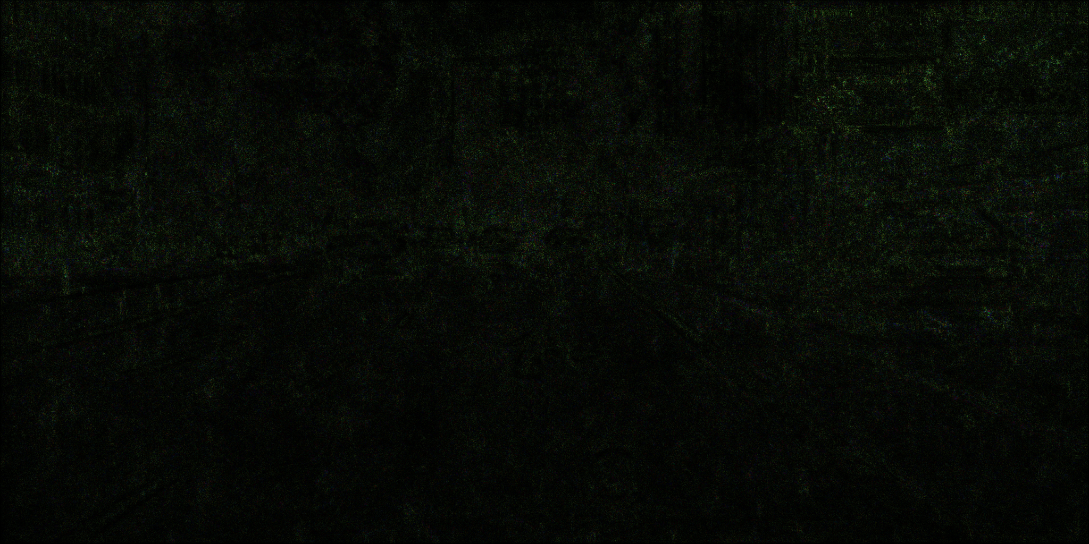  
          
        1600 LR8 L1 last epoch  
        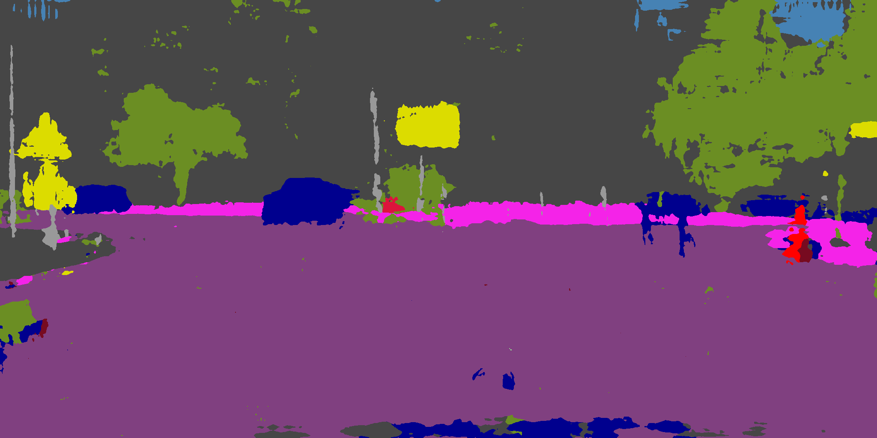 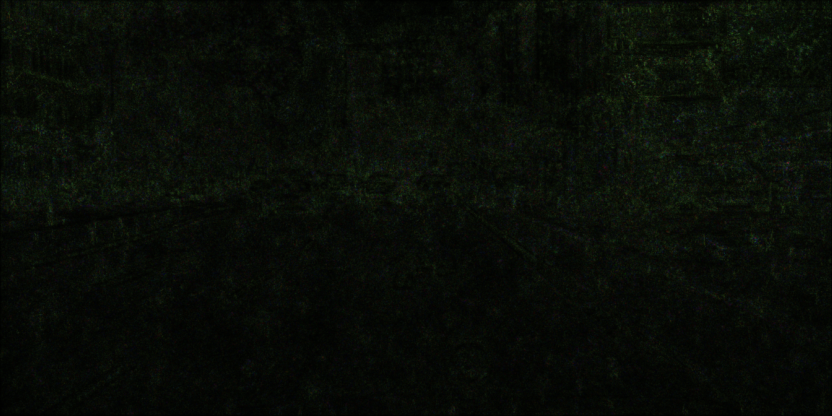  
        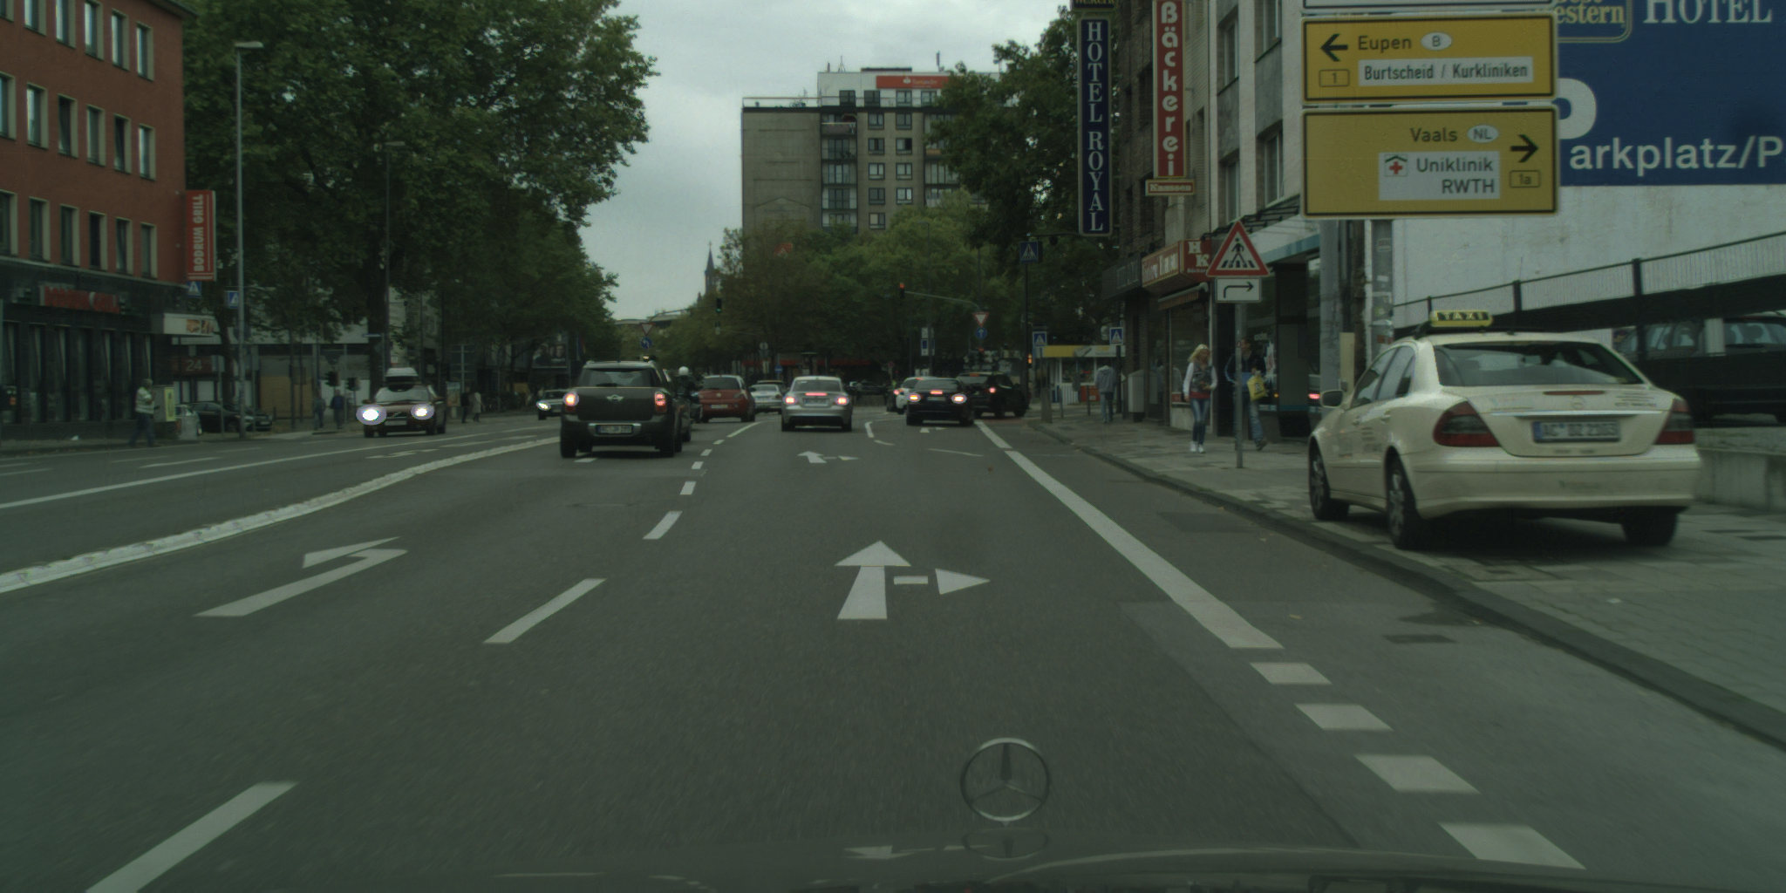  
          
        1600 LR8 L2 last epoch  
        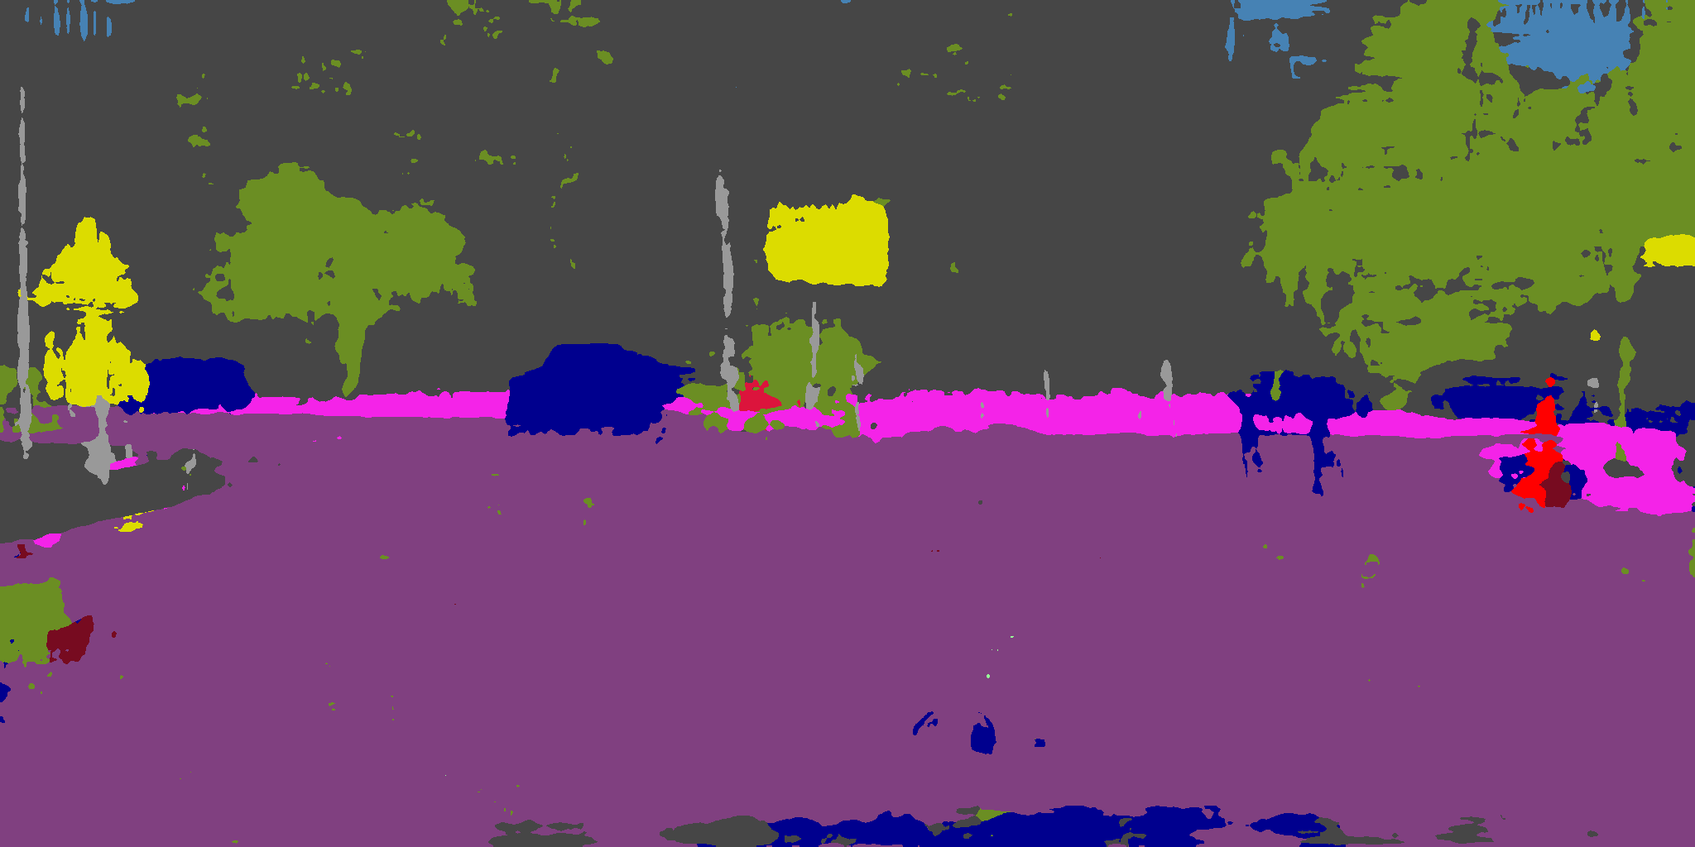 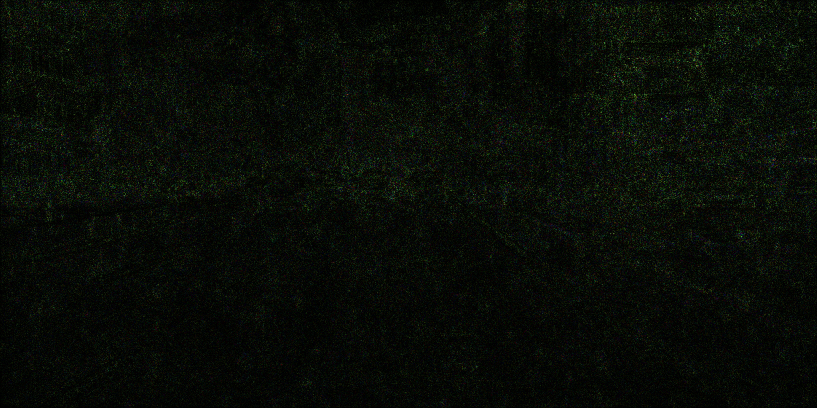  
          
        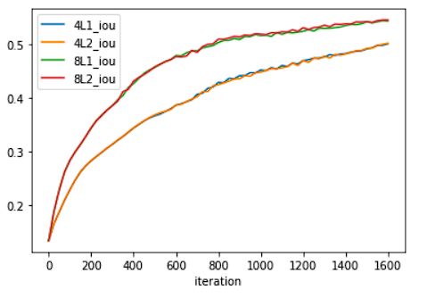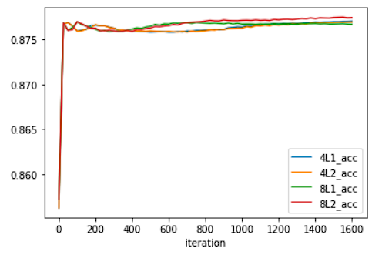  
          
        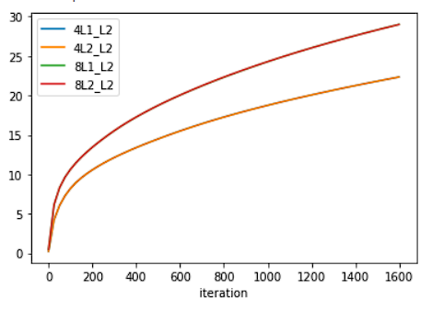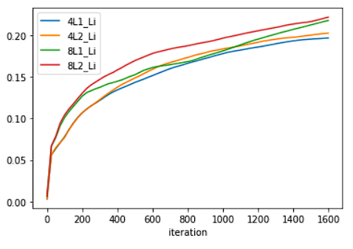  
        The pixel accuracy used in this setting refers to the percentage of perturbed image prediction pixel that is the same as target mask, over the whole set of pixels. As both accuracy and visual inspection on intermediate images shown, a static attack can run to near convergence very fast even with low LR, and with little perturbation magnitude as Linf plot shown. Such perturbation is completely invisible under human inspection.  
        There are also some interesting facts about attack process. Notice that while Linf norm of 4 configurations show a dissimilar pattern, their L2 norm show an almost deterministic plot, only decided by LR. Two of configurations use L1 as loss norm, however their performance difference at convergence is only determined by LR with sub-linear relationship. Without further data on this attack setting, while in other attack settings we observe similar patterns, we state that L1 and L2 norm have no significant impact on performance at convergence. More discussions about L1 and L2 norm can be found under discussion section 9.
     2. Substitution/Hiding attack  
          
        In this section, we mainly consider a case that substitutes vehicle class (class number 13) as vegetation class (class number 8). We evaluate with this case since it makes reasonable safety concerns. We also briefly consider other attack cases at the end of this section.  
        * naïve substitution/hiding attack  
        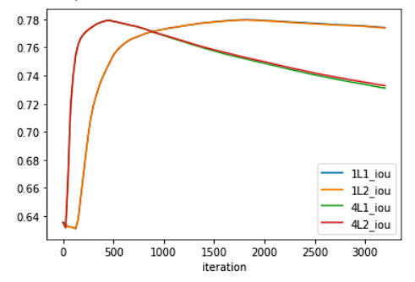  
        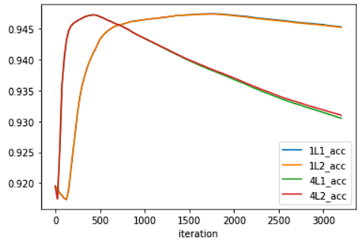  
        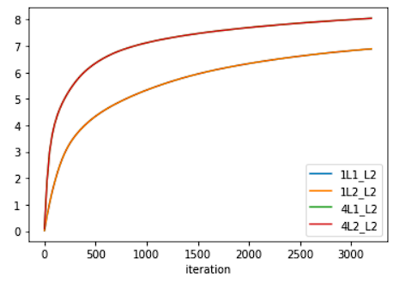  
        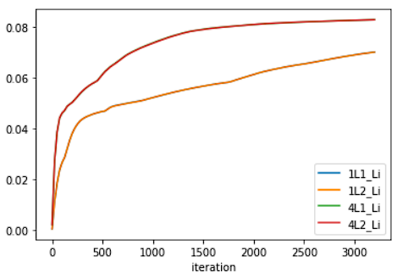  
        3200, LR1, L2, last epoch  
        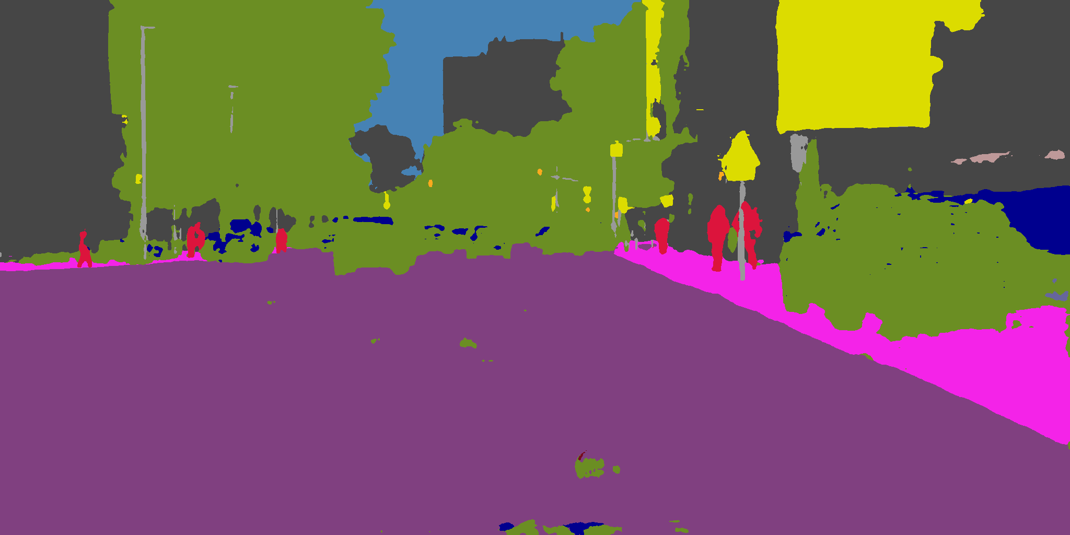 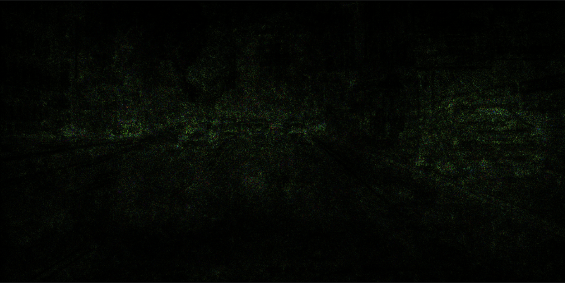  
        50% epoch  
        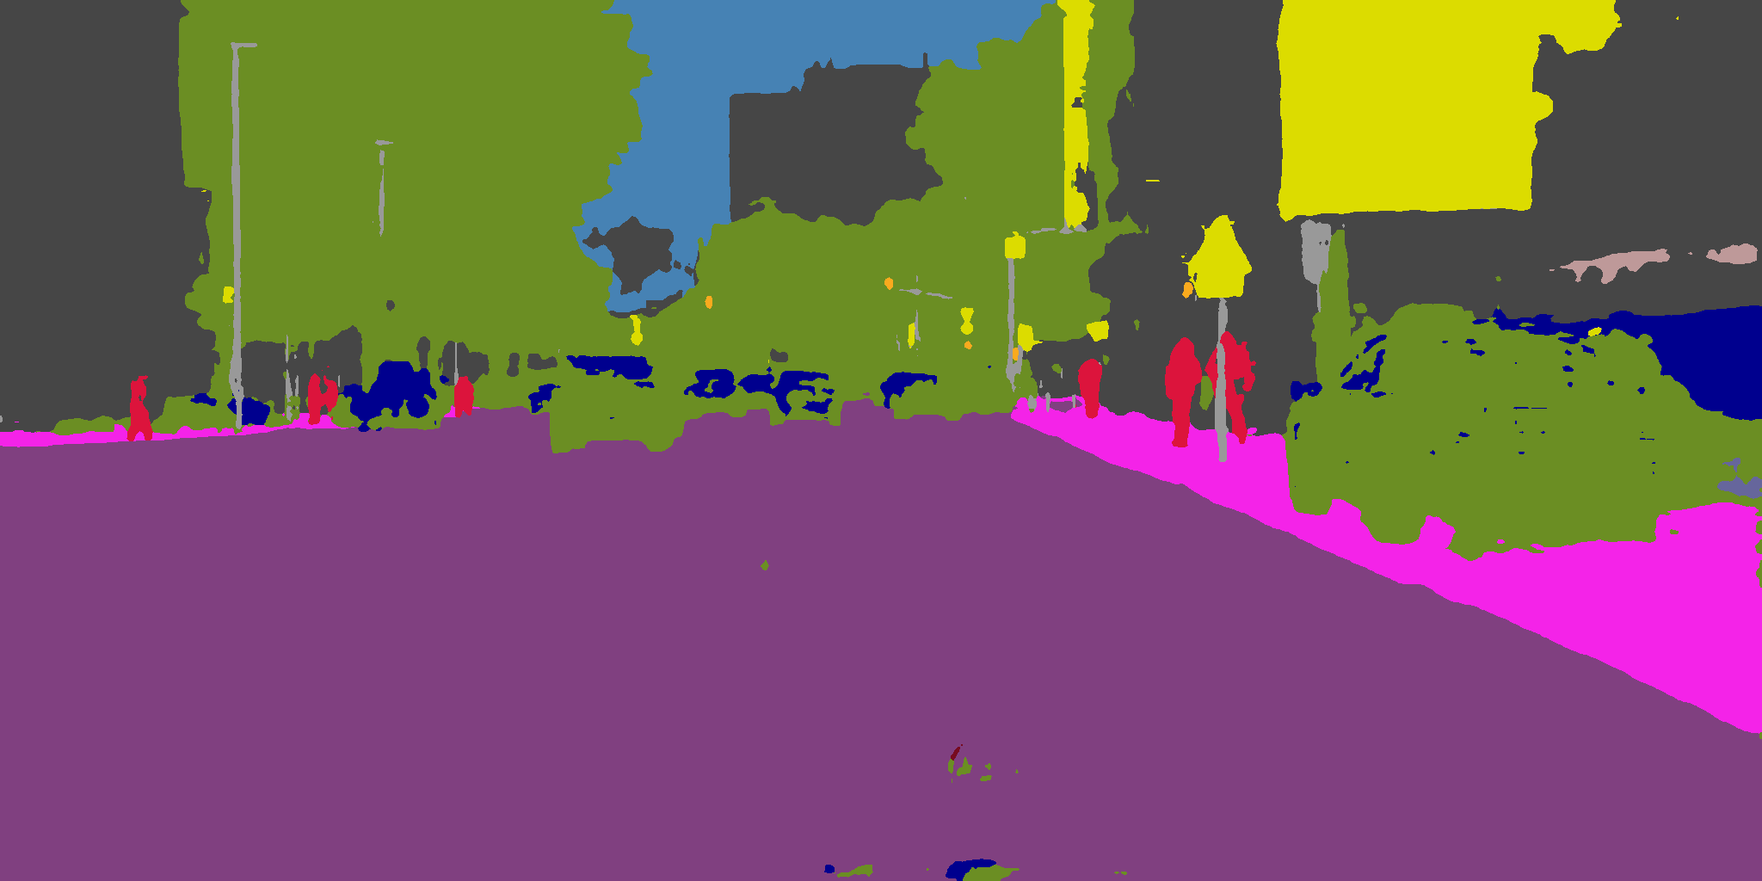  
        25% epoch  
        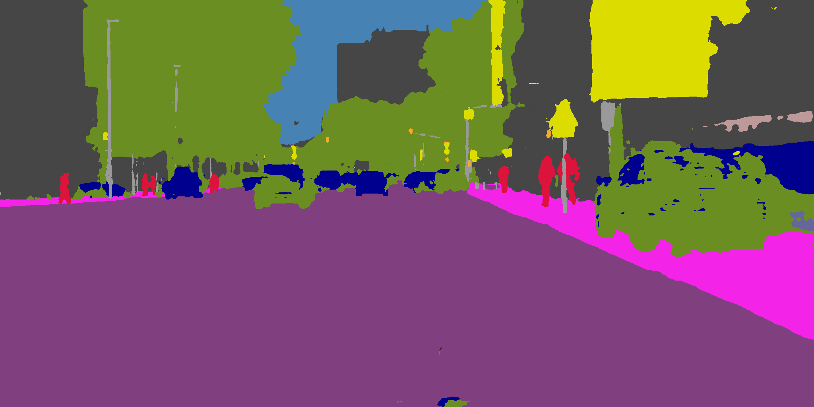  
          
        3200, LR4, L2, last epoch  
        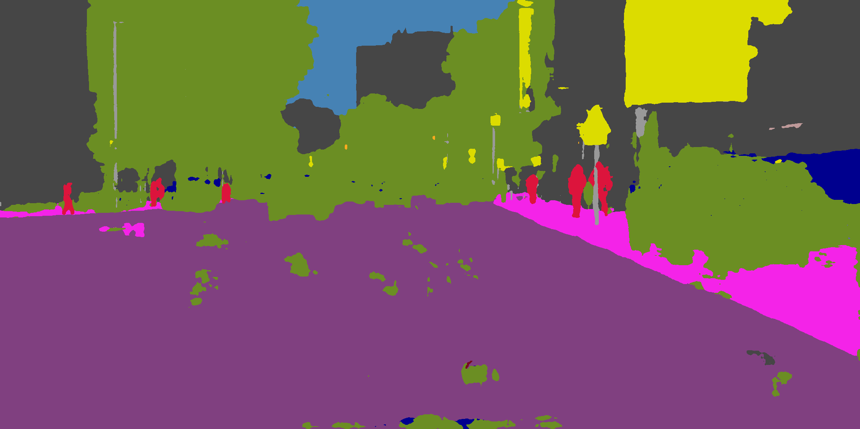 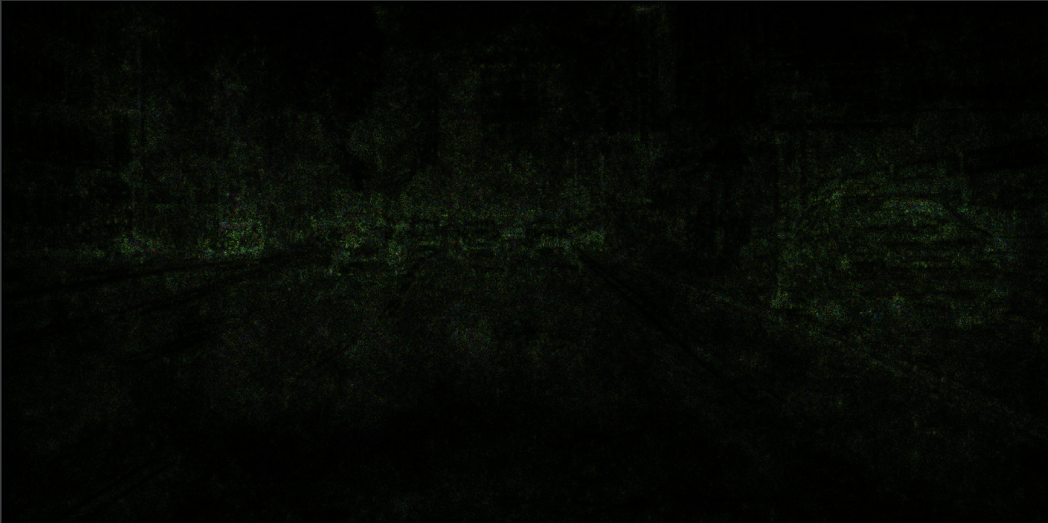  
        50% epoch  
        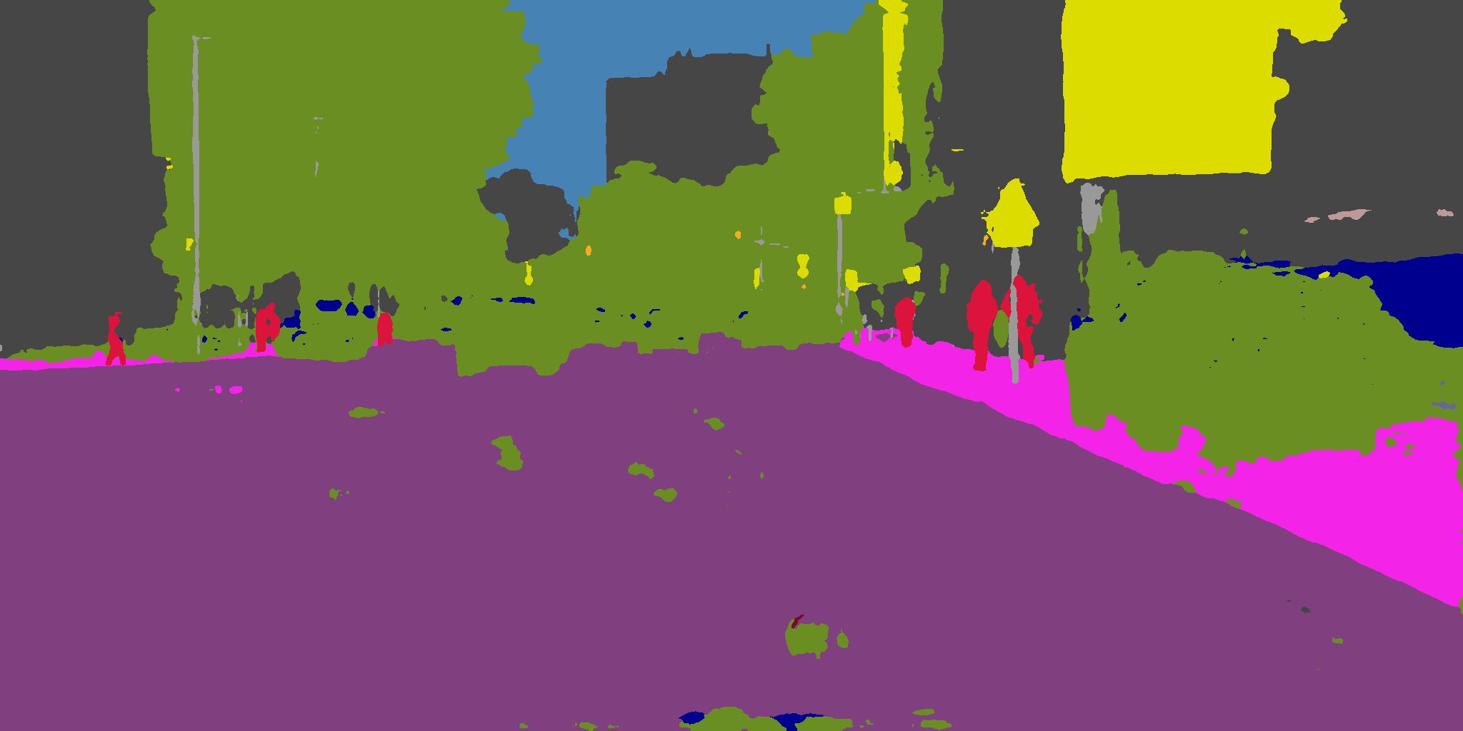  
        25% epoch  
        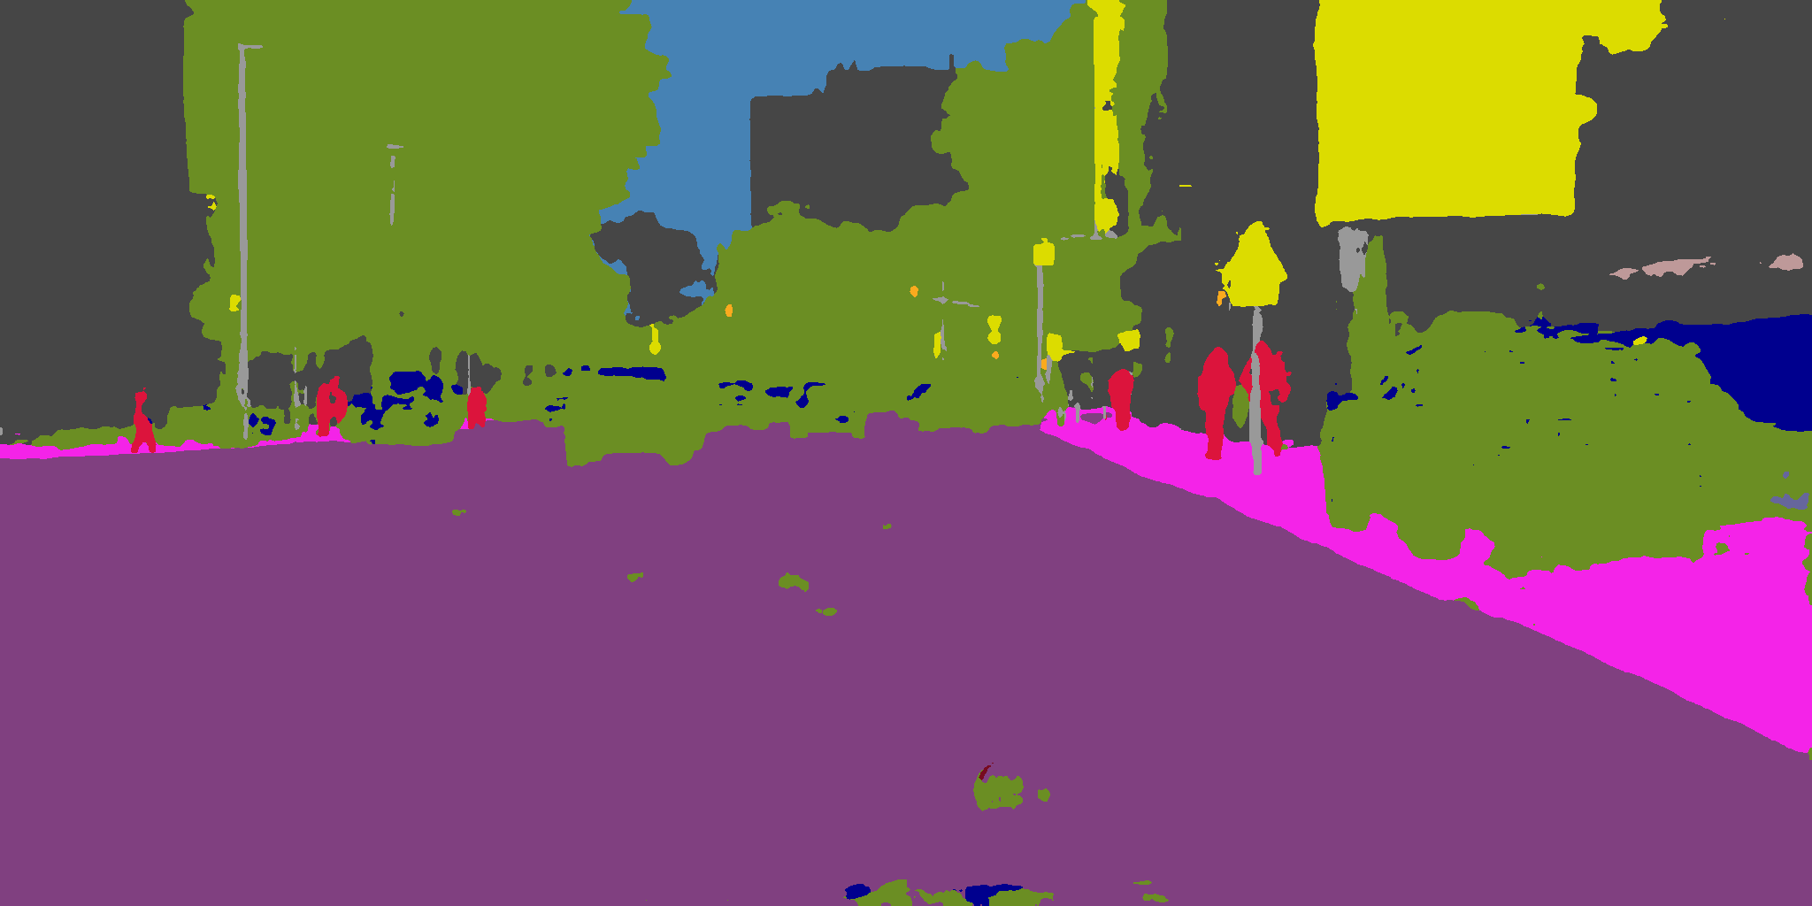  
        12% epoch  
        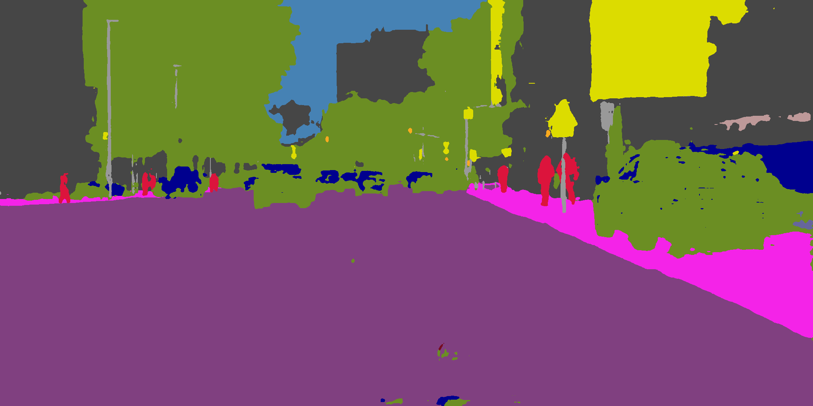  
        7% epoch  
        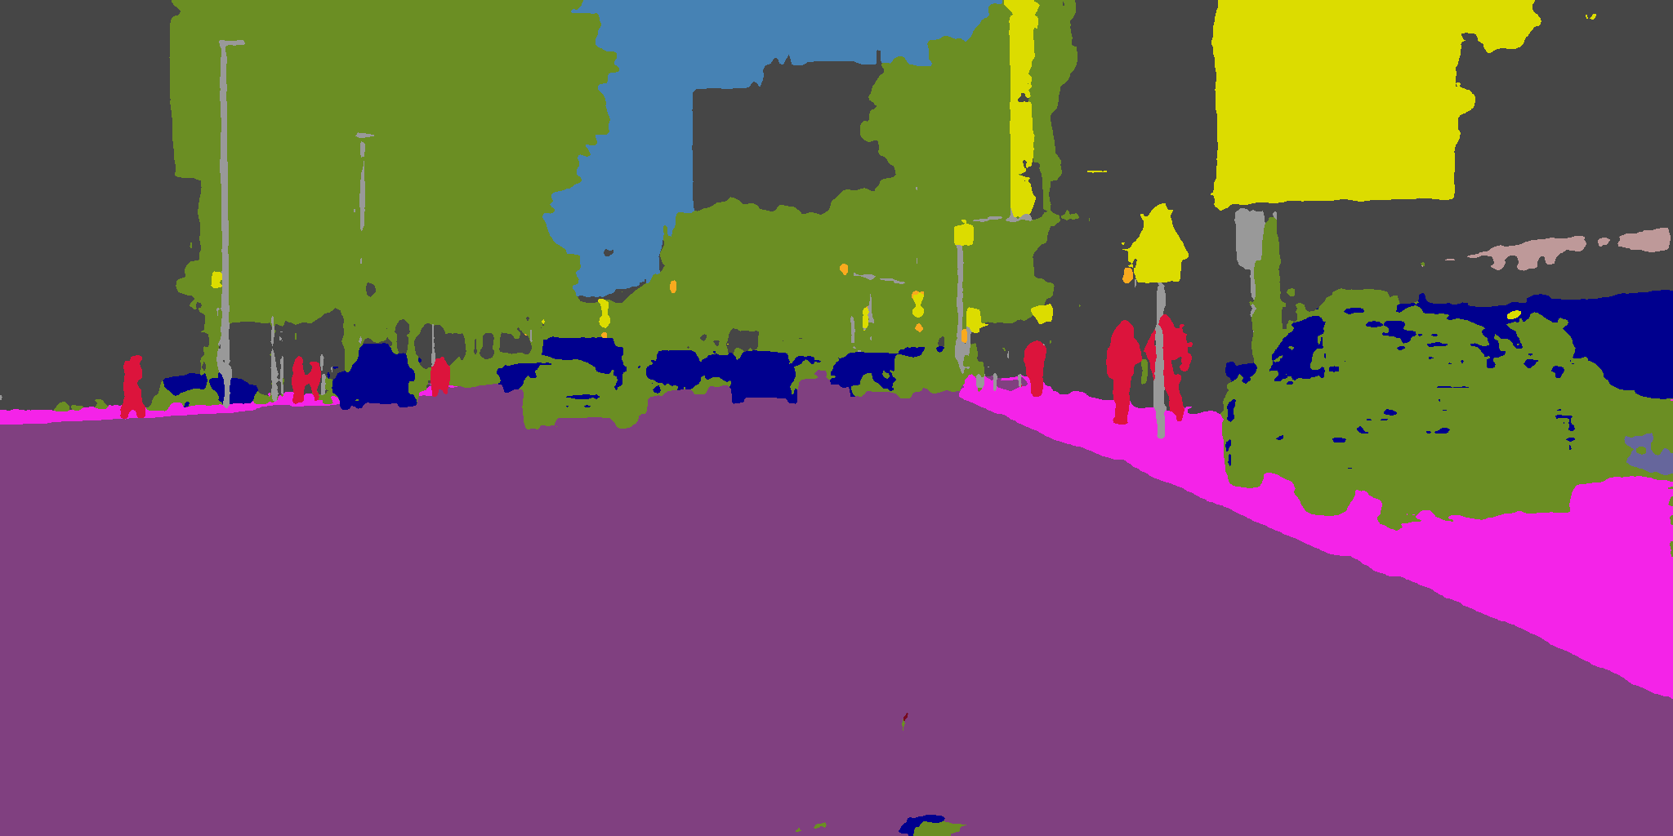  
        3200, LR4, L1, last epoch  
        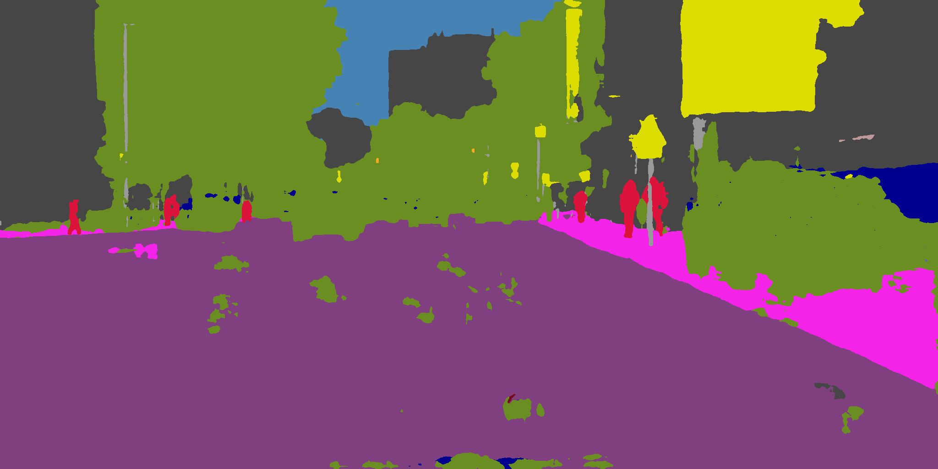 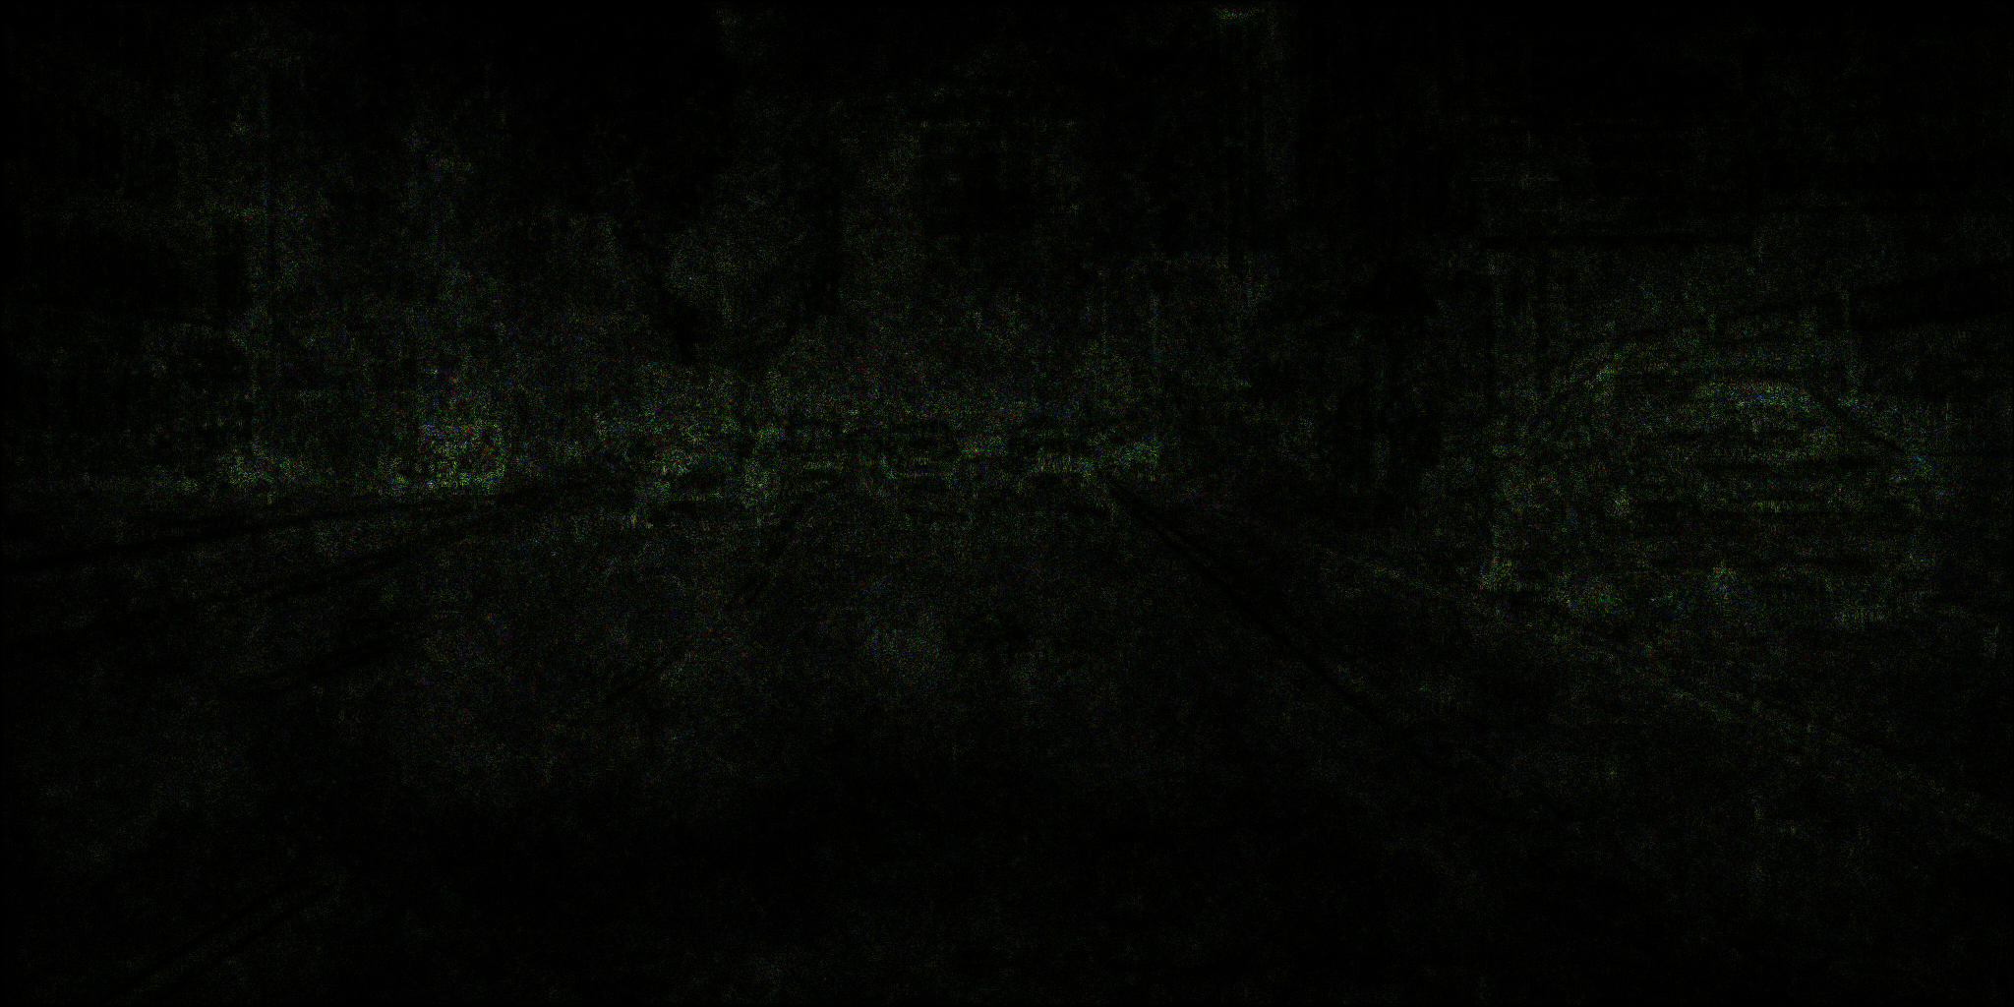  
        3200, LR1, L1, last epoch  
        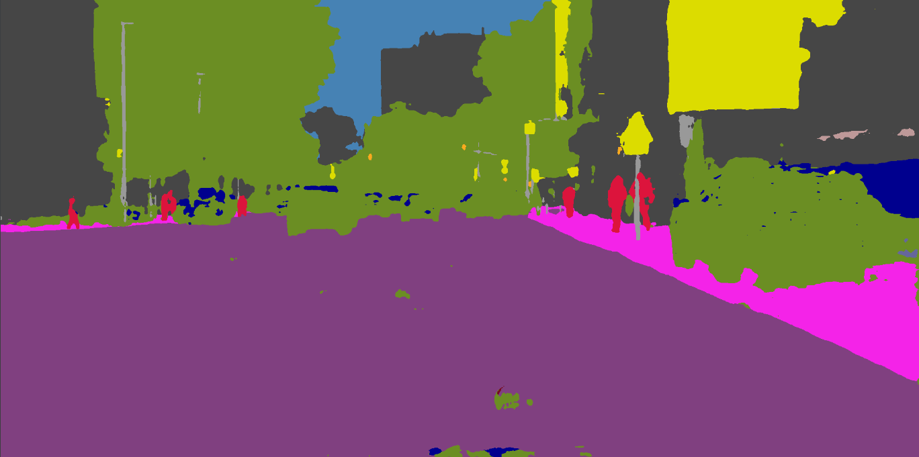 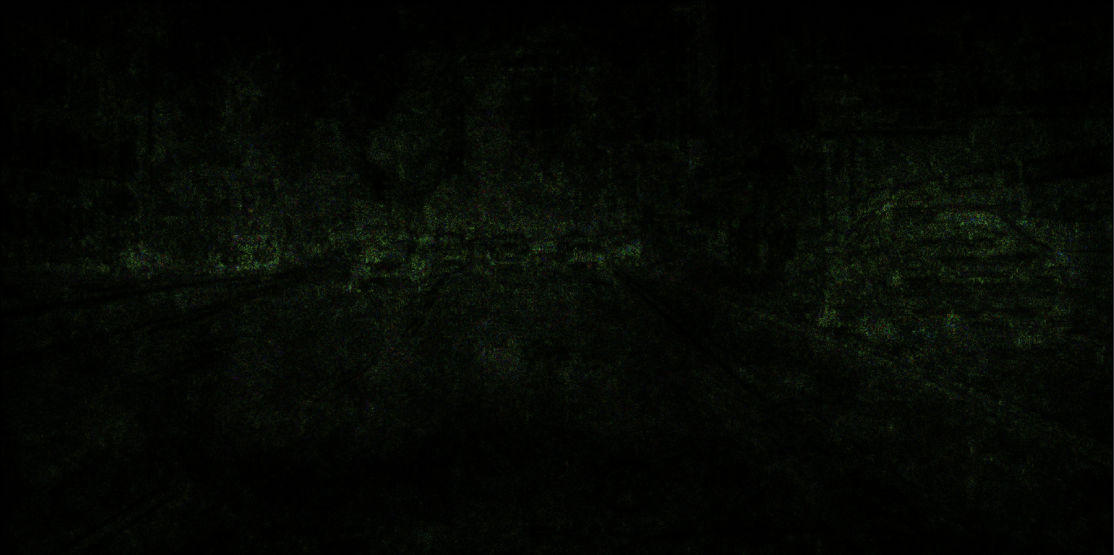  
          
        Since the target substitution can also be considered as a mask, a naïve substitution has the same effectiveness as a naïve targeted attack, as [fig] shown. It also converges very fast just as naïve targeted attack. Since preserving background and substituting target class are both considered inside the equivalent target mask, this attack can be just performed with a naïve targeted attack algorithm. By more data on this attack (due to simplicity they are not shown here), we notice that setting LR to $2^{k}$ (k is a positive integer) is equivalent to down-sampling the LR=1 attack process with interval $2^{k}$ with negligible difference. Though we choose LR as exponential of 2 as baseline, since our observation has no relation to properties of exponential, we assert that this observation is also true for any positive LR=k. While in model training this is not the case, we hypothesize that this is because evading or approaching a manifold has large regions of homogeneous gradients hence at these regions step size has linear impact on attacking process.  
        However, we notice an interesting drop in accuracy towards convergence. By human inspection we find that after most original classes are successfully substituted, some background pixels begin to be substituted as well. A common explanation for this phenomenon in model training is overfitting. By our sample images, we find that for a higher LR some non-target classes are also substituted to target class, thus lowering pixelwise accuracy. Hence, we find such overfitting assumption natural and effective under this scenario. A possible reason why this scenario can overfit, unlike naïve targeted attack, is that all original class pixels are mapped to target class. Thus, perturbations on original class pixels can be too strong and affect background prediction.  
        We also notice that Linf is determined by LR, but not by norm selection. This contradicts the observation from naïve targeted attack and the reason is unknown.  
          
          
        * masked substitution/hiding attack  
        When a mask is introduced, however, things can be very different. In this attack setting, we provide a mask covering and only covering all original class pixels. Here, a similar attack configuration similar to the one above fails if we provide a mask:  
        1600 LR2 L1 ptmask  
        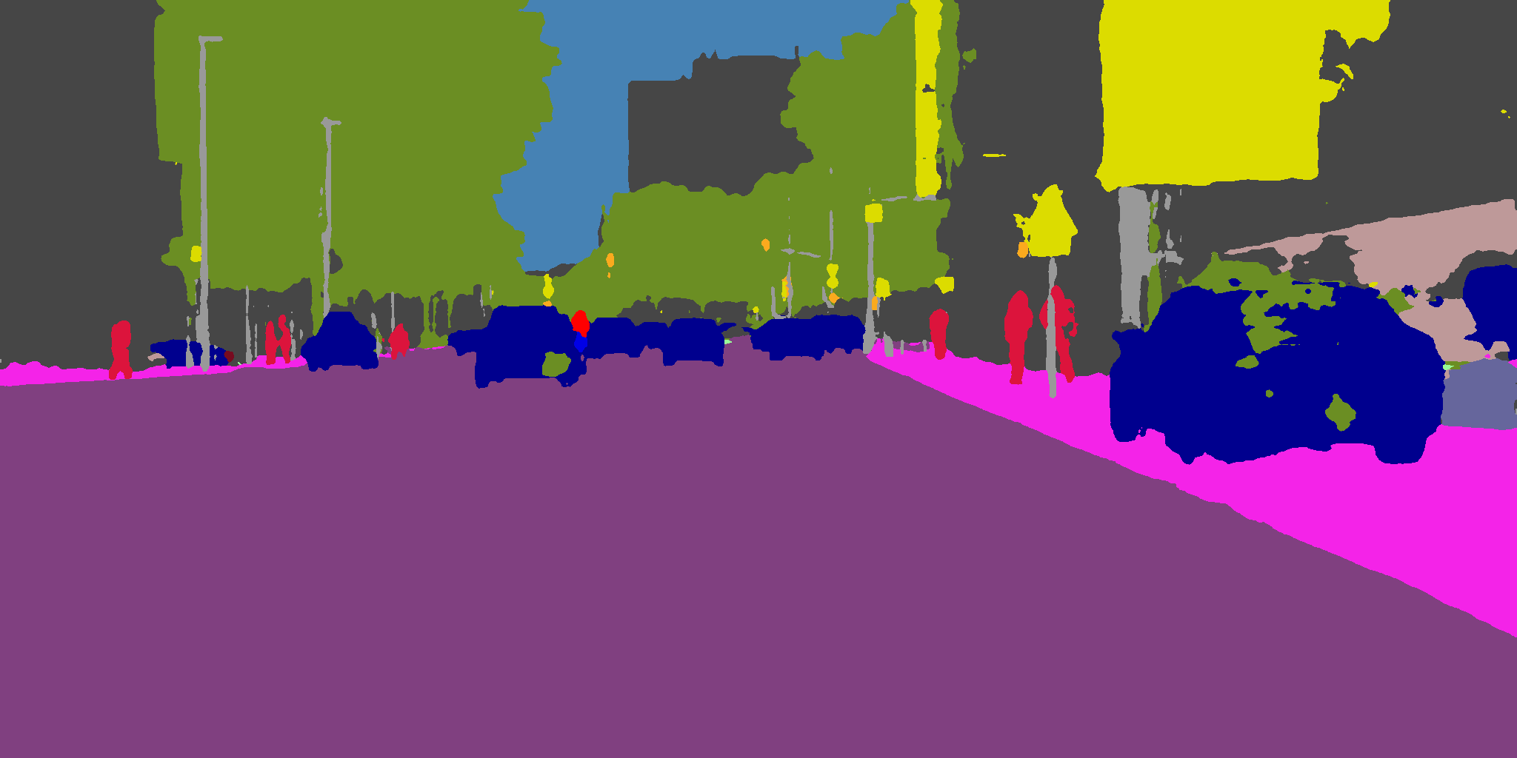 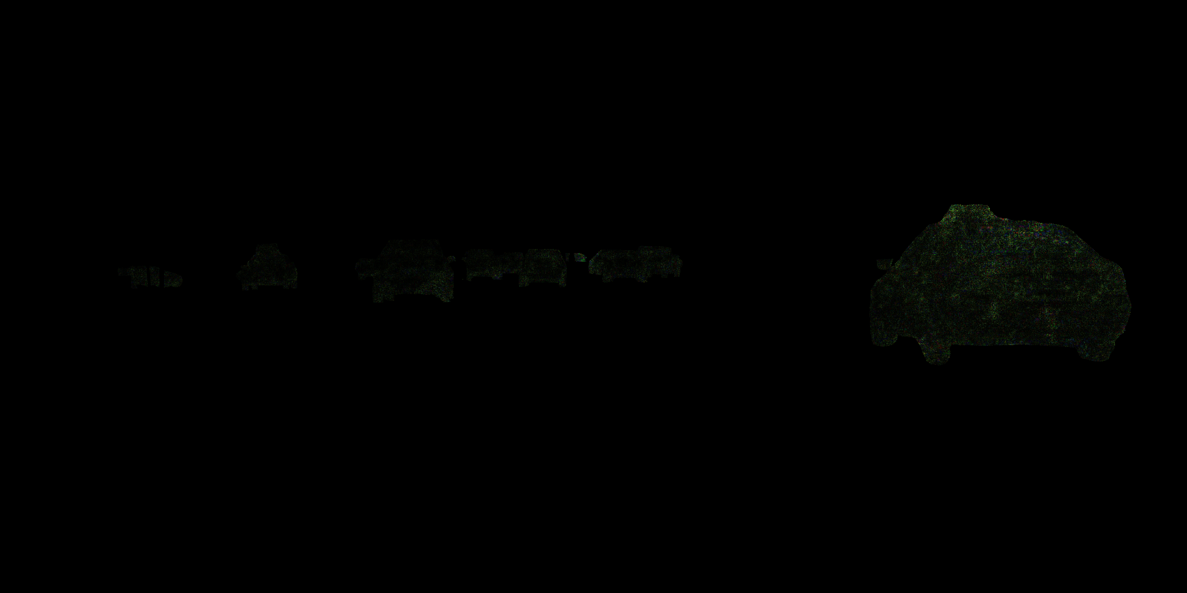  
          
        1600 LR2 L2 ptmask  
        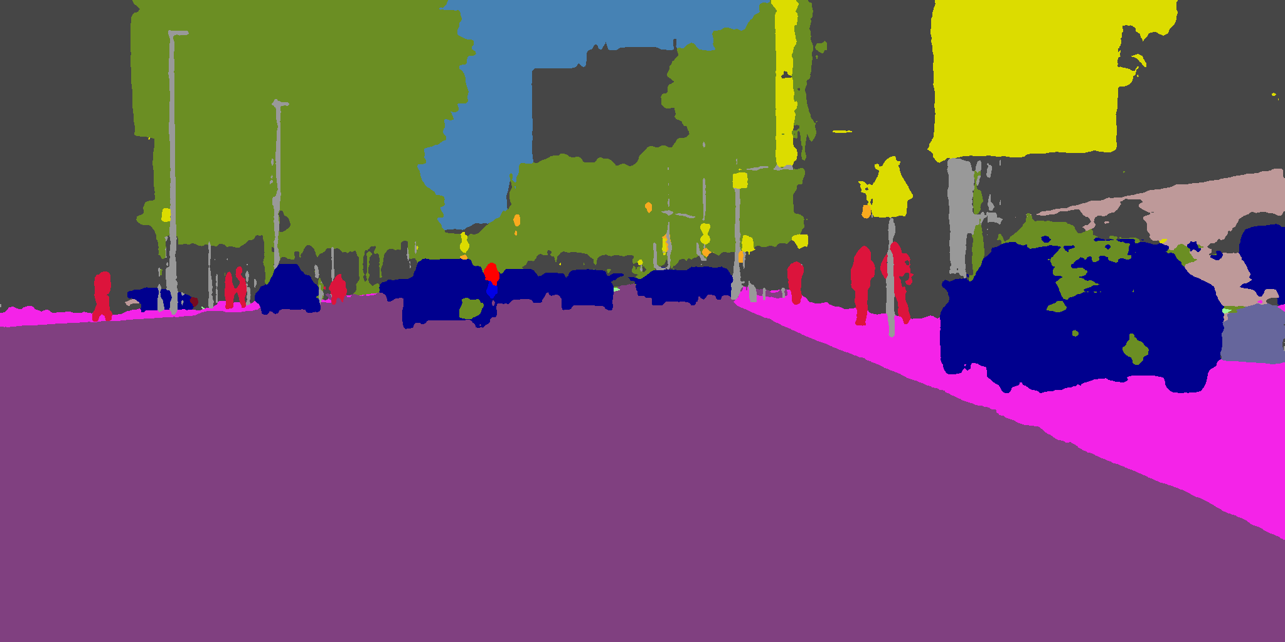 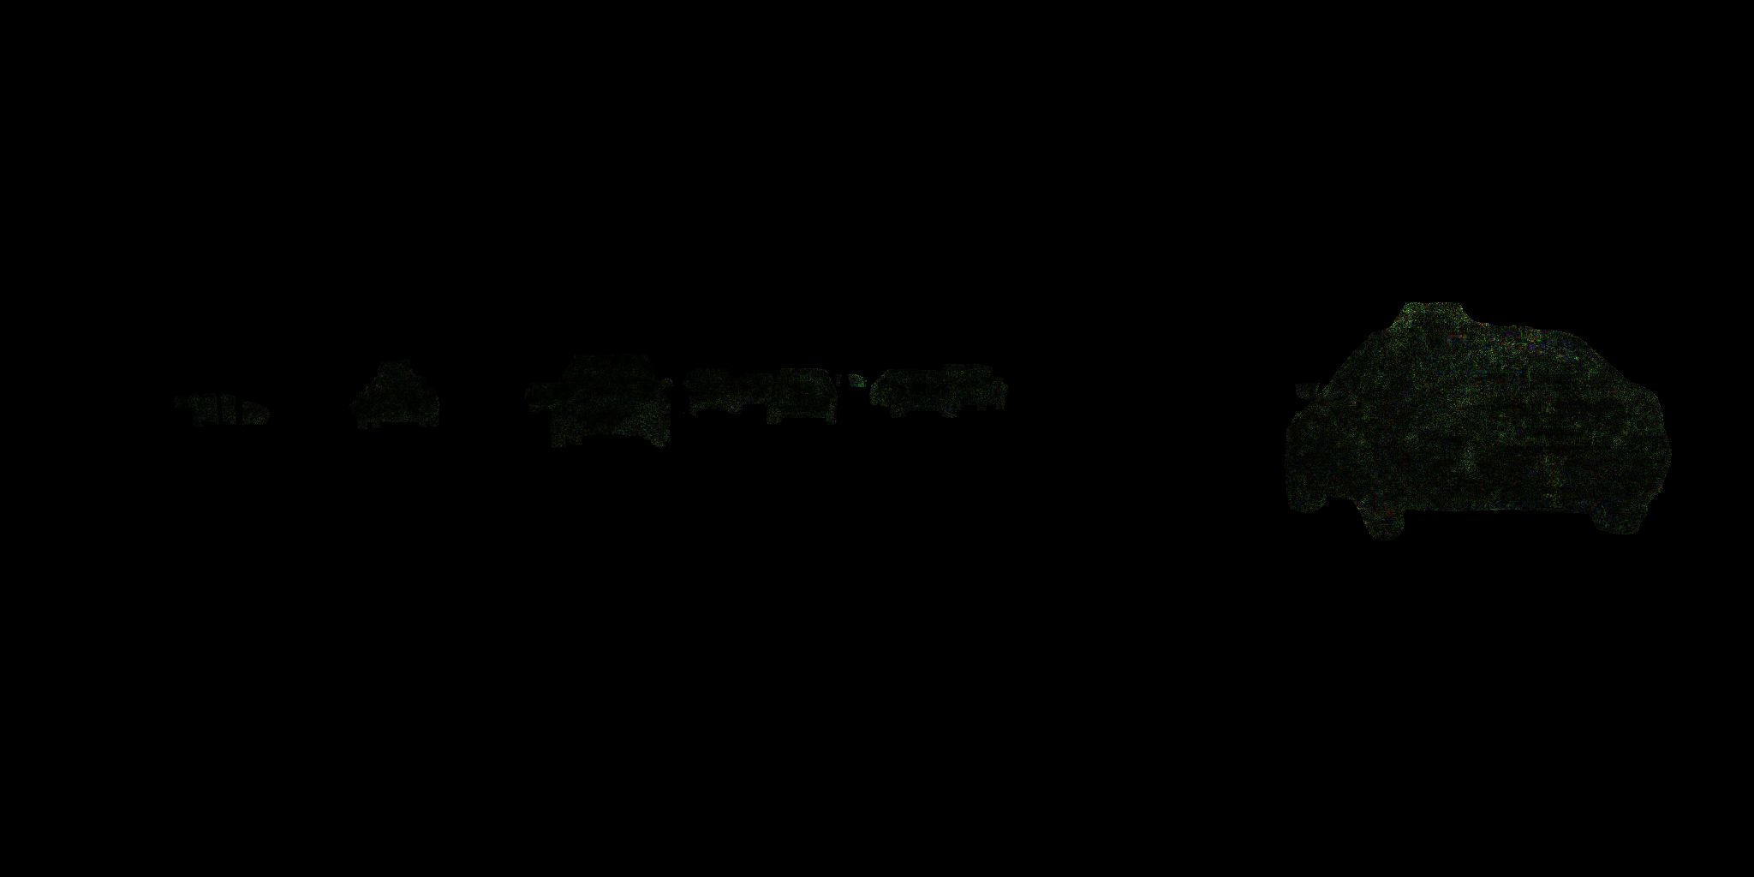  
          
        1600 LR8 L1 ptmask  
        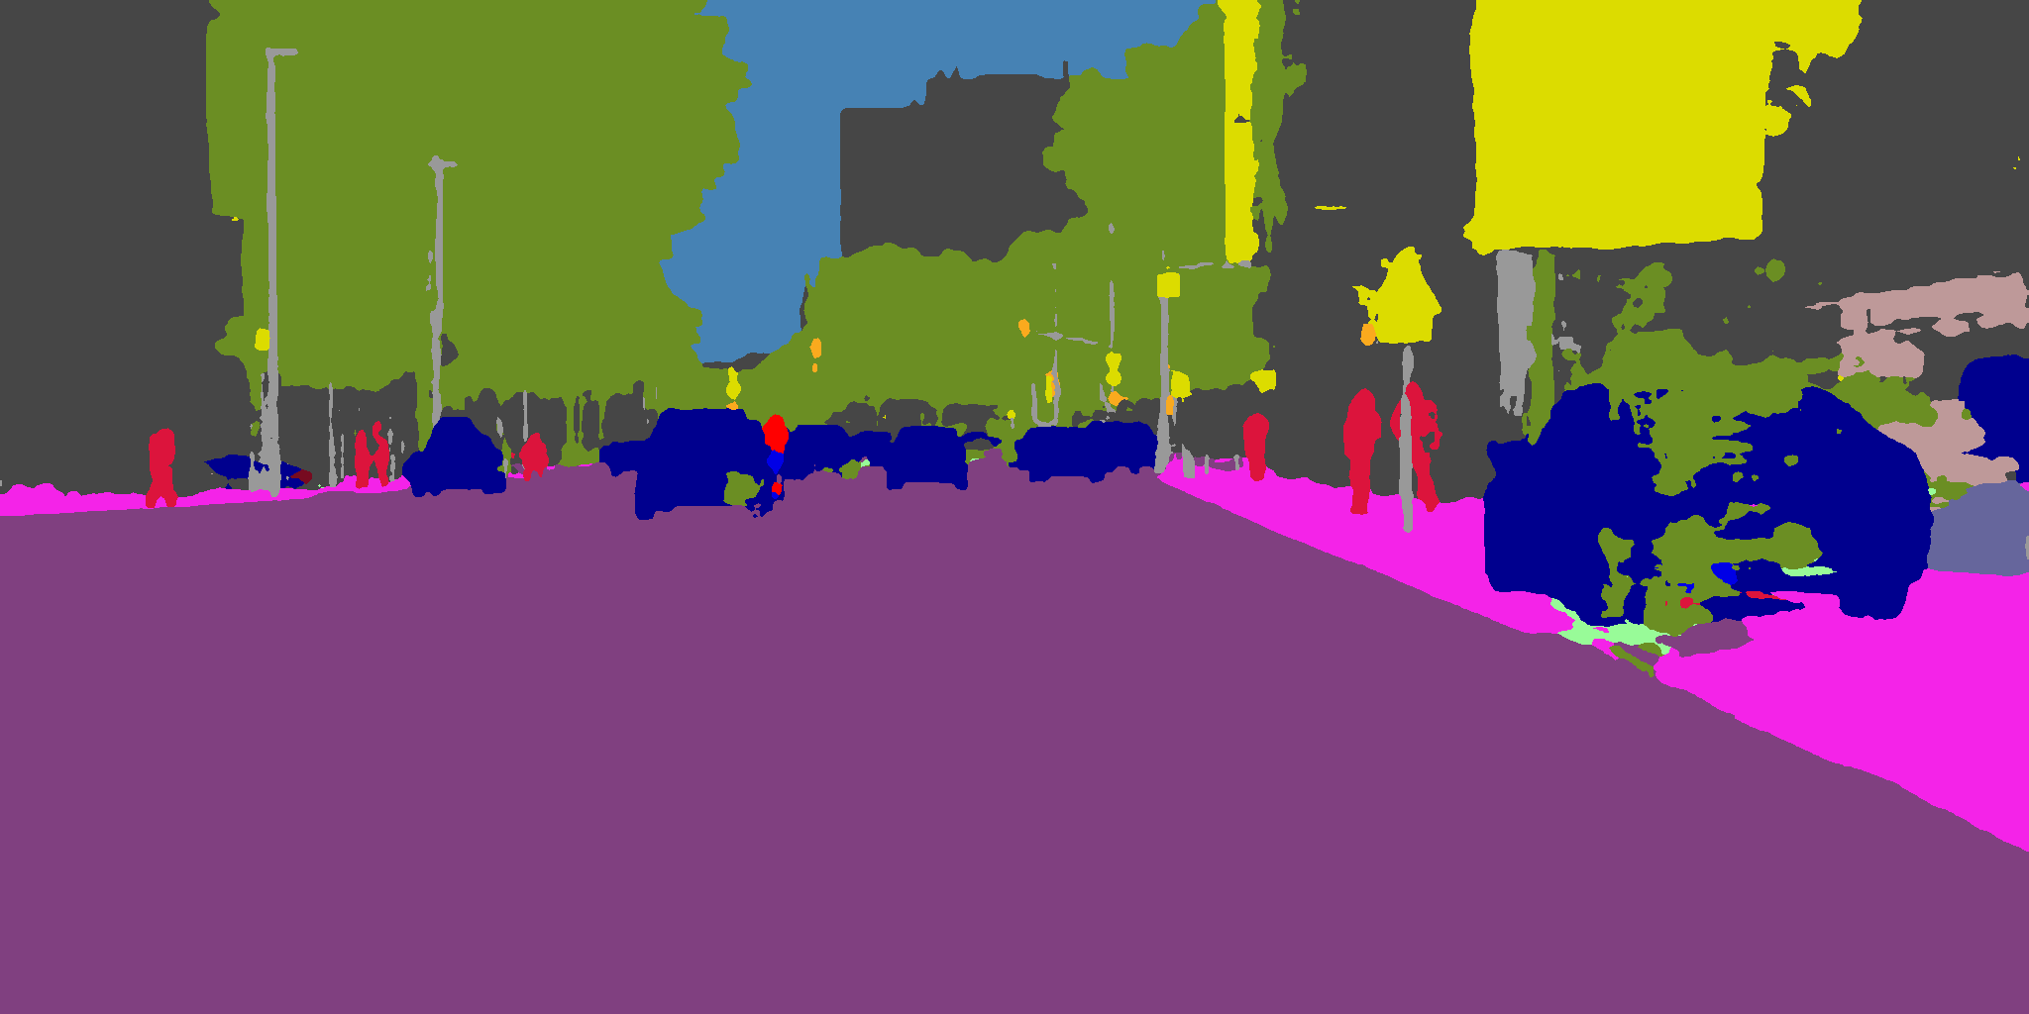 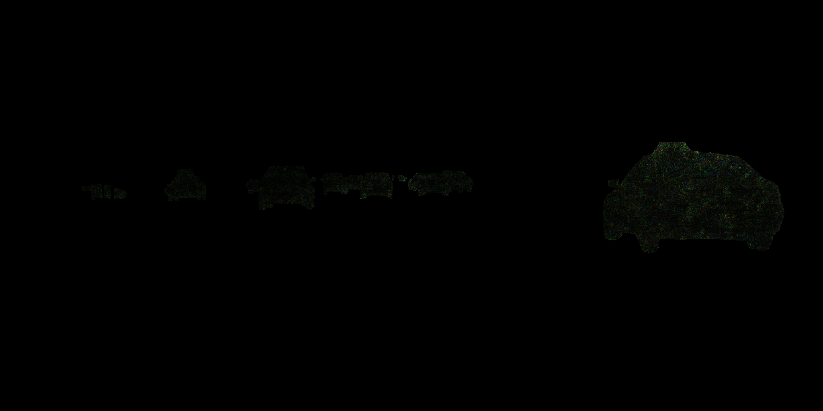  
          
        1600 LR8 L2 ptmask  
        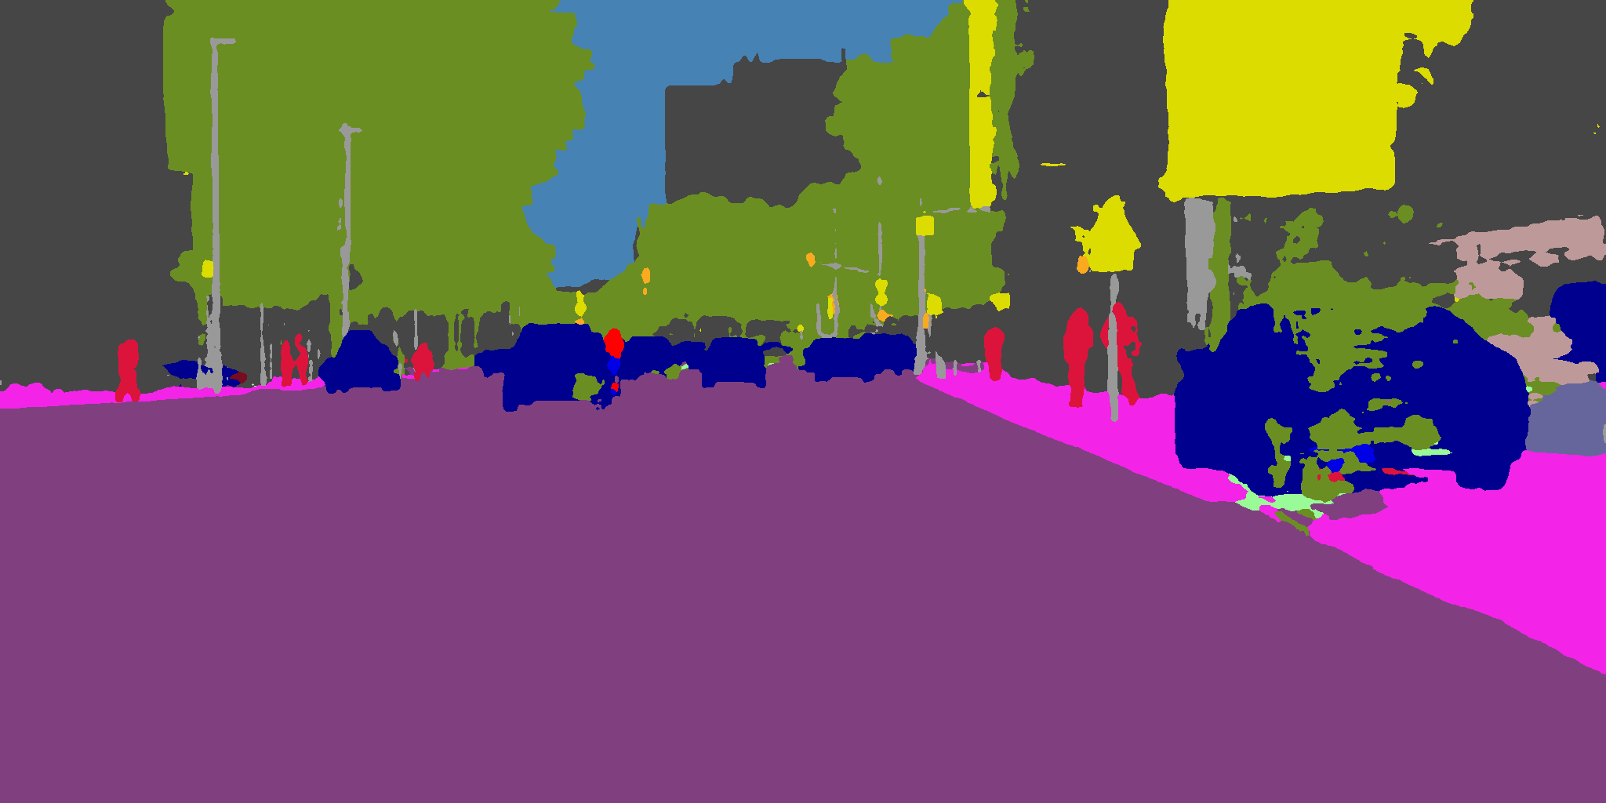 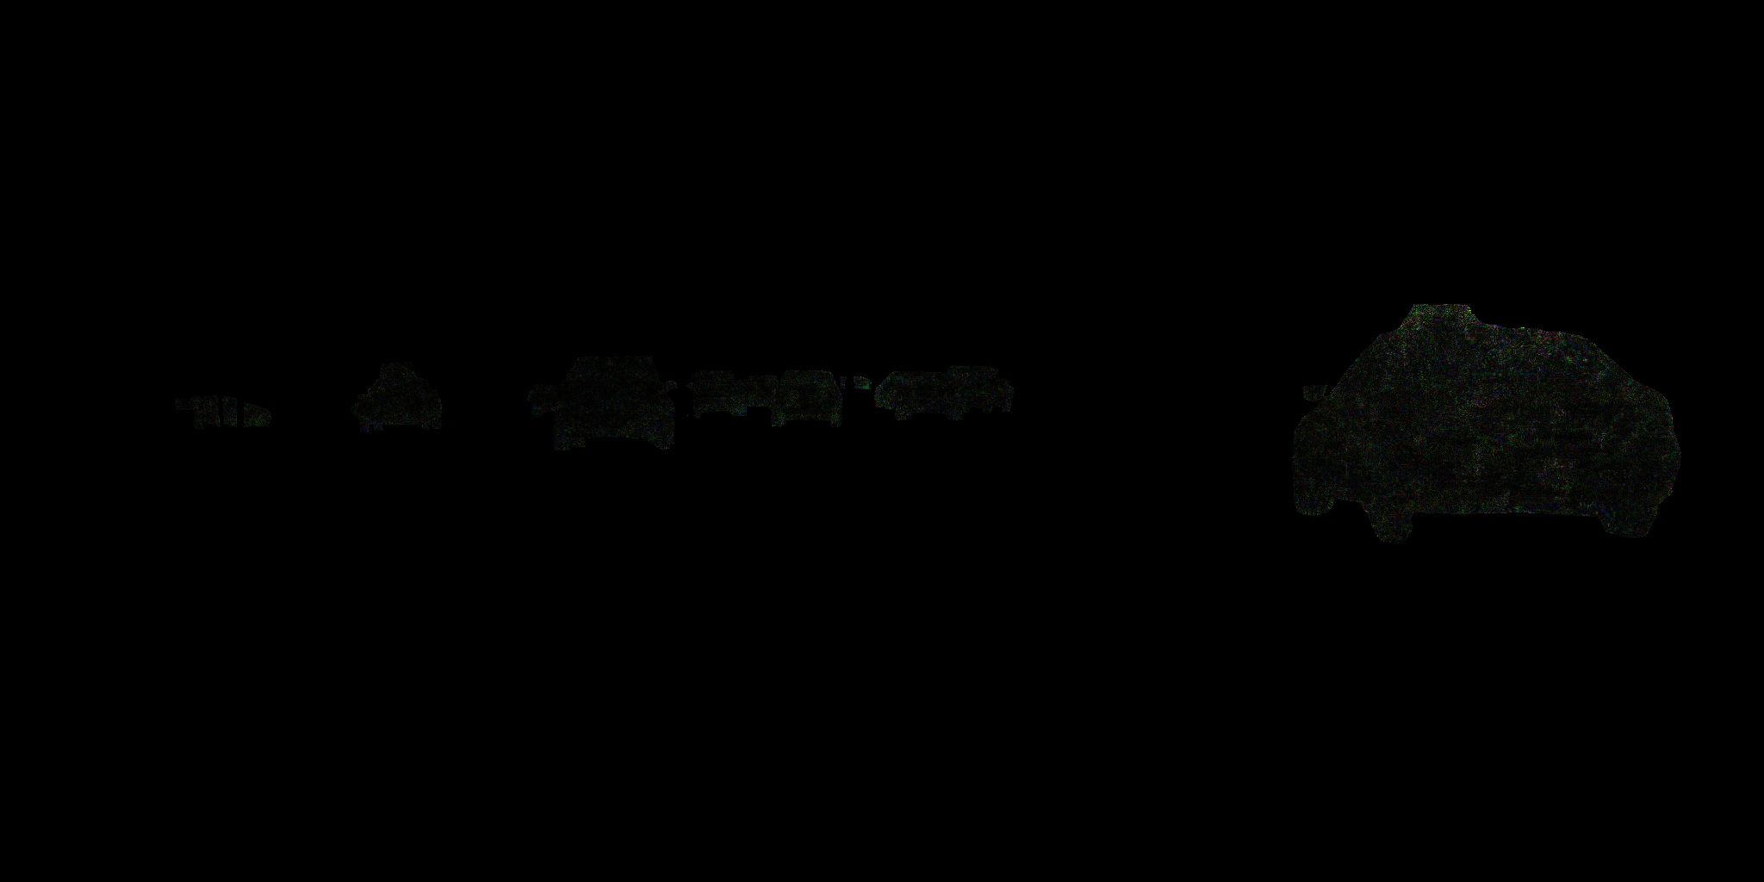  
          
        This group of attacks are obviously underfitting. Hence, we turn to more aggressive attacks. Below are some examples which are, though not quite acceptable for human, more optimal than above settings:  
          
        T_1600_LR256_l2_LW32.00ptmask_incr_  
        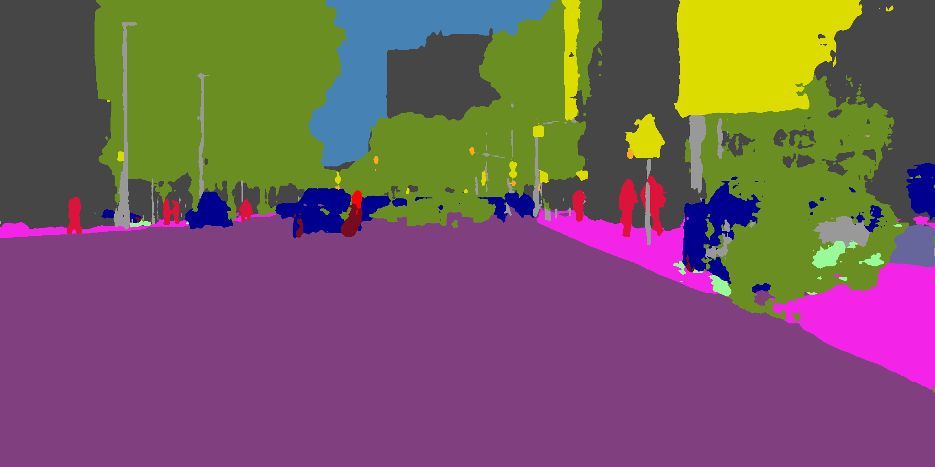 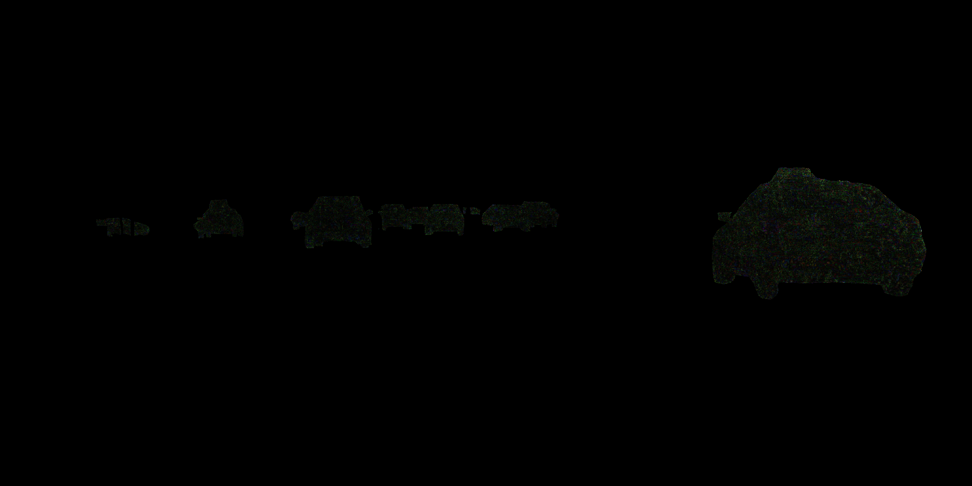  
        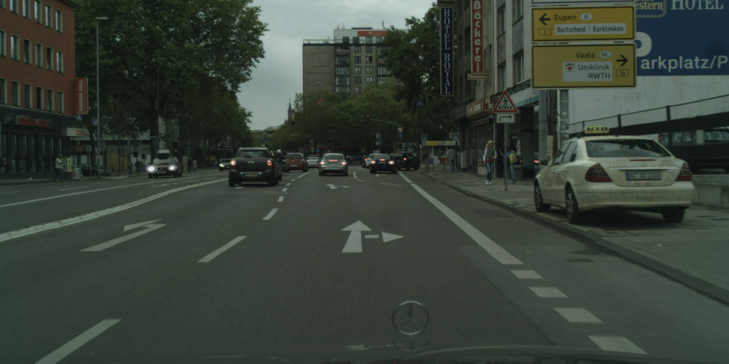  
          
        1600 LR512 L2 LW32 incr  
        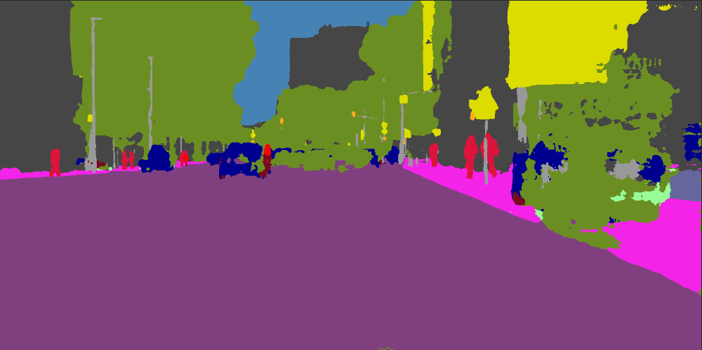 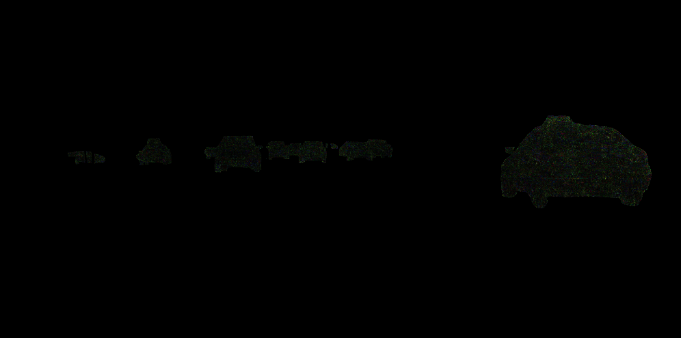  
        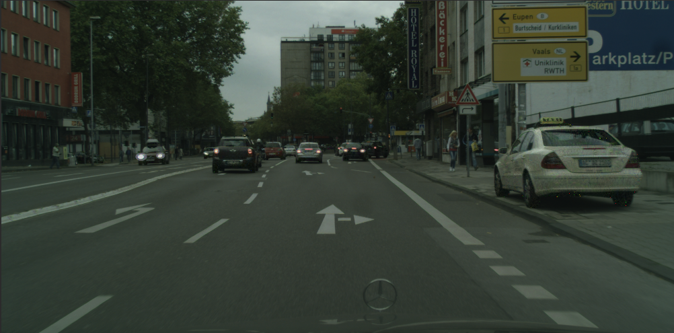  
          
        We observe that though perturbation is only limited within mask, our perturbation still forces some background pixels to be classified as target class. Such externality partially supports our previous assumption such that a substitution attack can overfit because the perturbation to enforce class mapping is sometimes too strong to intervene background pixel classification.   
        Besides this, we also notice that within mask the prediction is more chaotic than a substitution attack without a mask, and perform poorer in terms of pixelwise accuracy. Due to the fact that a pixel’s prediction result can be affected by potentially all pixels (with closer neighbor with expected high weights), original pixels within the mask can be affected by pixels outside the mask. Hence, compared to an unmasked attack, a masked attack has less option to manipulate prediction process and perform poorer.  
        Notice that, for high LR (such as 512), there already exists visible spike noises on modified images. Hence, we stop such explorations beyond this LR.  
          
          
        With metric (total variance):  
          
        1600 LR65536 L4 LW2048 W2048 incr  
        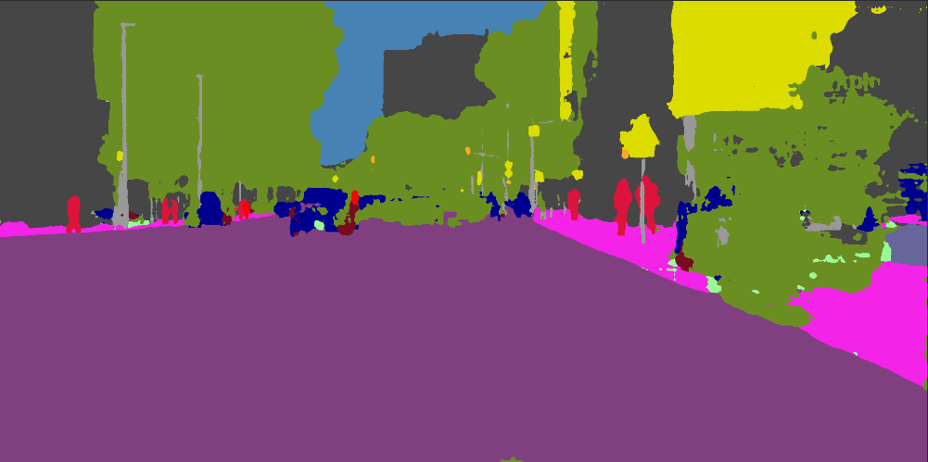 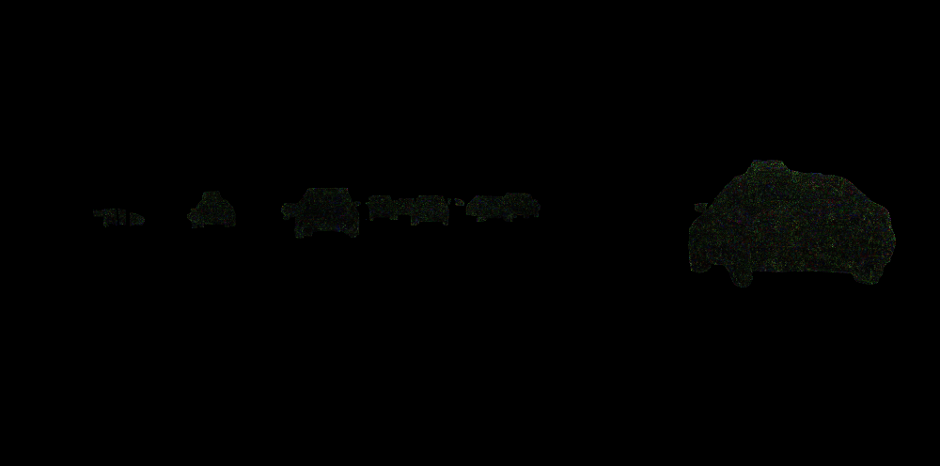  
          
        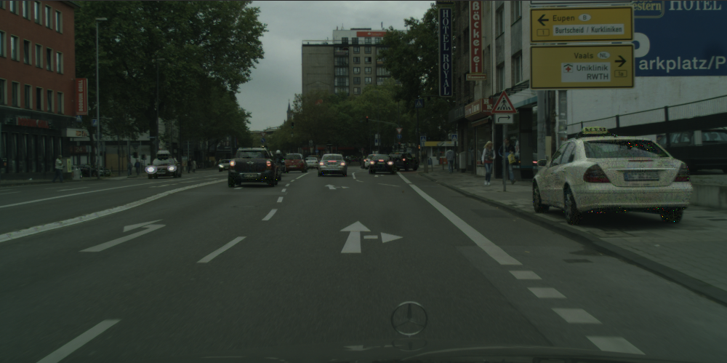   
          
        1600 LR65536 L4 LW2048 W9192 incr  
        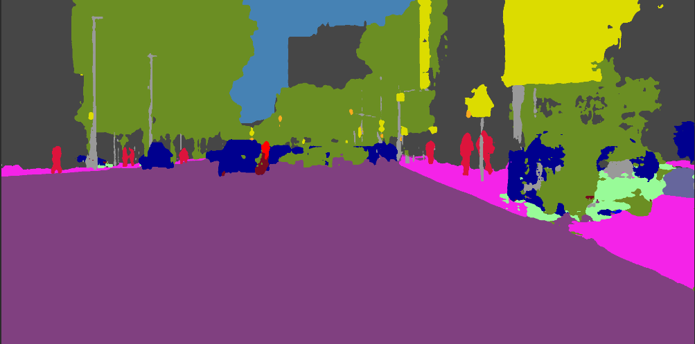 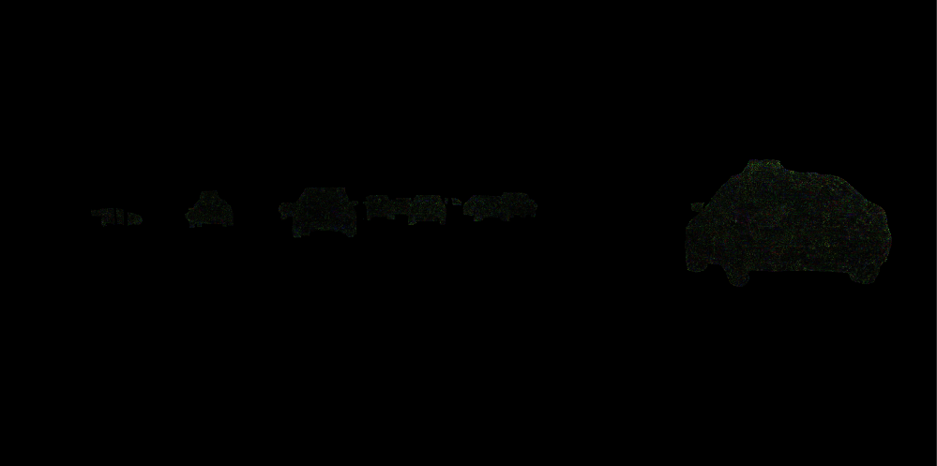  
        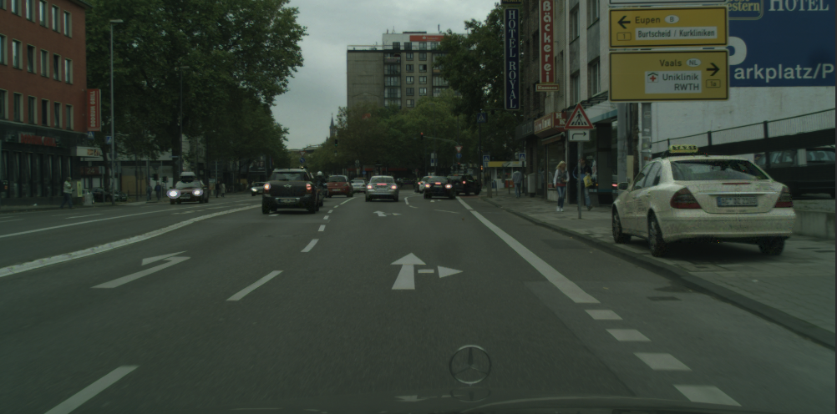  
          
        1600 LR512 L2 LW4 W16 incr  
        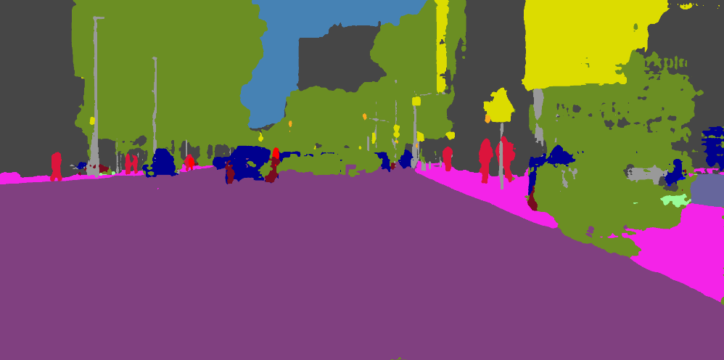 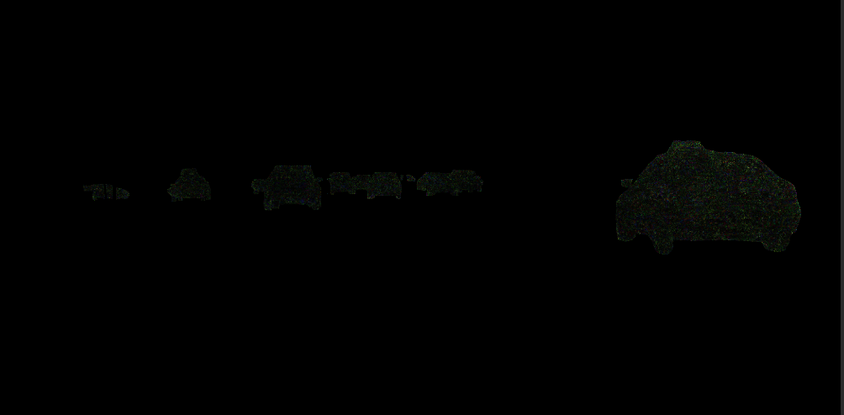  
        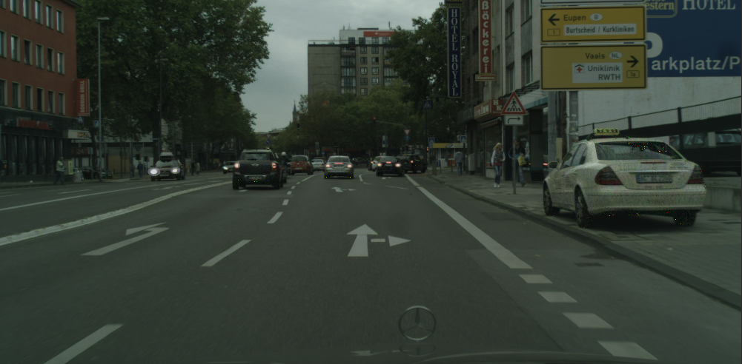  
          
        Here we adopt a single additional loss metric, total variation. Total Variation (TV) is proposed in adversarial attack papers from [5] where Carlini & Wagner measures distortion of a perturbation by TV. TV is computed with a single image with following formula: $$TV= \sum_{(x,y) ∈ I[:-1, :-1]}{{\left(I\left(x, y\right)-I\left(x+1,y\right)\right)}^{2}+{\left(I\left(x,y\right)-I\left(x, y+1\right)\right)}^{2}}$$ 
        Semantically, TV is the sum of square of difference between a pixel and its 4-neighbors. If a perturbation has high TV value, it must have high first order derivatives at many local regions and thus have more fragile semantic structures. Such perturbation is hard to realize in physical world with such a high variance and vulnerability to physical transformations such as lightning change and view change. On the other hand, if TV is a loss term during backprop, TV has the effect of smoothing perturbation such that it looks even more homogeneous to human eyes. On the other hand, without surprising, it can decrease attack performance. If the attack aims to provide a physical perturbation, there is a trade-off between performance and realizability.   
        Compared to similar attack settings from previous subsection, an attack with TV can have less or none visible spike noise in perturbed image, while slightly decrease performance.  
        We also notice that decreasing classification weight (equivalent to increasing all other weights, since each step is normalized) has little impact on final performance. This may because other loss terms points to origin (e.g., norm loss) or specific axles (e.g., TV), and direction provided by classification loss can still be non-trivial and dominating on this direction.  
          
        We have some pity for this section that some of our early evaluations are shown very effective yet we cannot reproduce those results. An example is shown below.   
        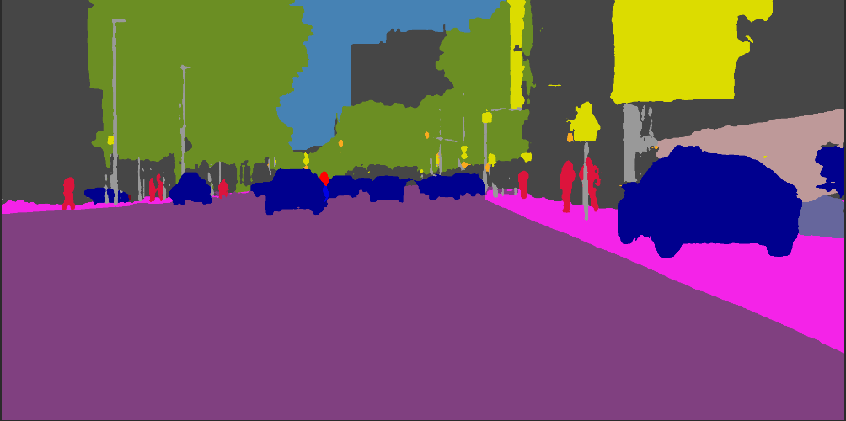 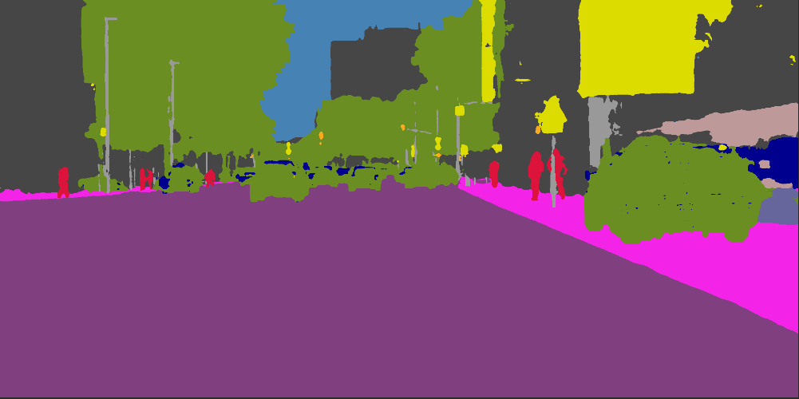  
        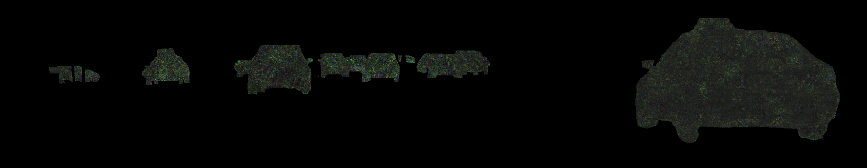  
        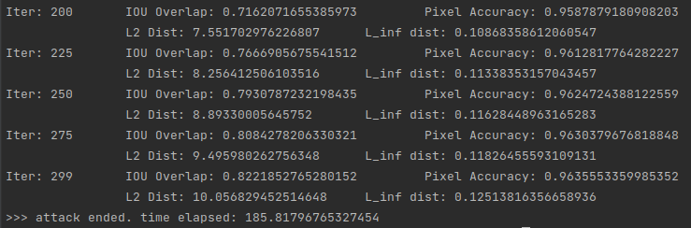  
        This is obtained before pipeline integration and normalization, and is used as a demonstration of module functionality during a weekly meeting. Different from previous examples, this early evaluation is close to our expected optima. It has high substitution rate, low externality, and homogeneous texture. However, though we attempted to re-engineer this example with new pipeline, we give up due to high cost of producing examples after ~30 tries. This may because this optimal configuration is out of our search region, or we introduce an implicit bug during pipeline integration.  
        Despite such pity, this example shows great potential of this attack type.
  2. UO type attack  
       
     In this attack setting, the attacker specifies a region on target image, and produces a perturbation such that each pixel in the specified region is classified as any class except original class. In our evaluation, we specify a collection of target classes and all pixels with original class within this collection are selected as target.  
     In UO setting, the definition of IOU is slightly changed, since there is no target class but only original class. We define IOU under UO setting as: $$IOU_{UO}=\frac{1}{len\left(C\right)}\sum_{c ∈C}{\sum_{I(x,y)=c }{0 if P\left(x,y\right)=I\left(x,y\right) else 1}}$$ 
     Where P is the predicted output of perturbed image, and I is the predicted output of benign image. Semantically, this is the percentage of original class pixels that are no longer classified as original class.  
     U_[8]_400_LR1_l1_LW4.00_  
     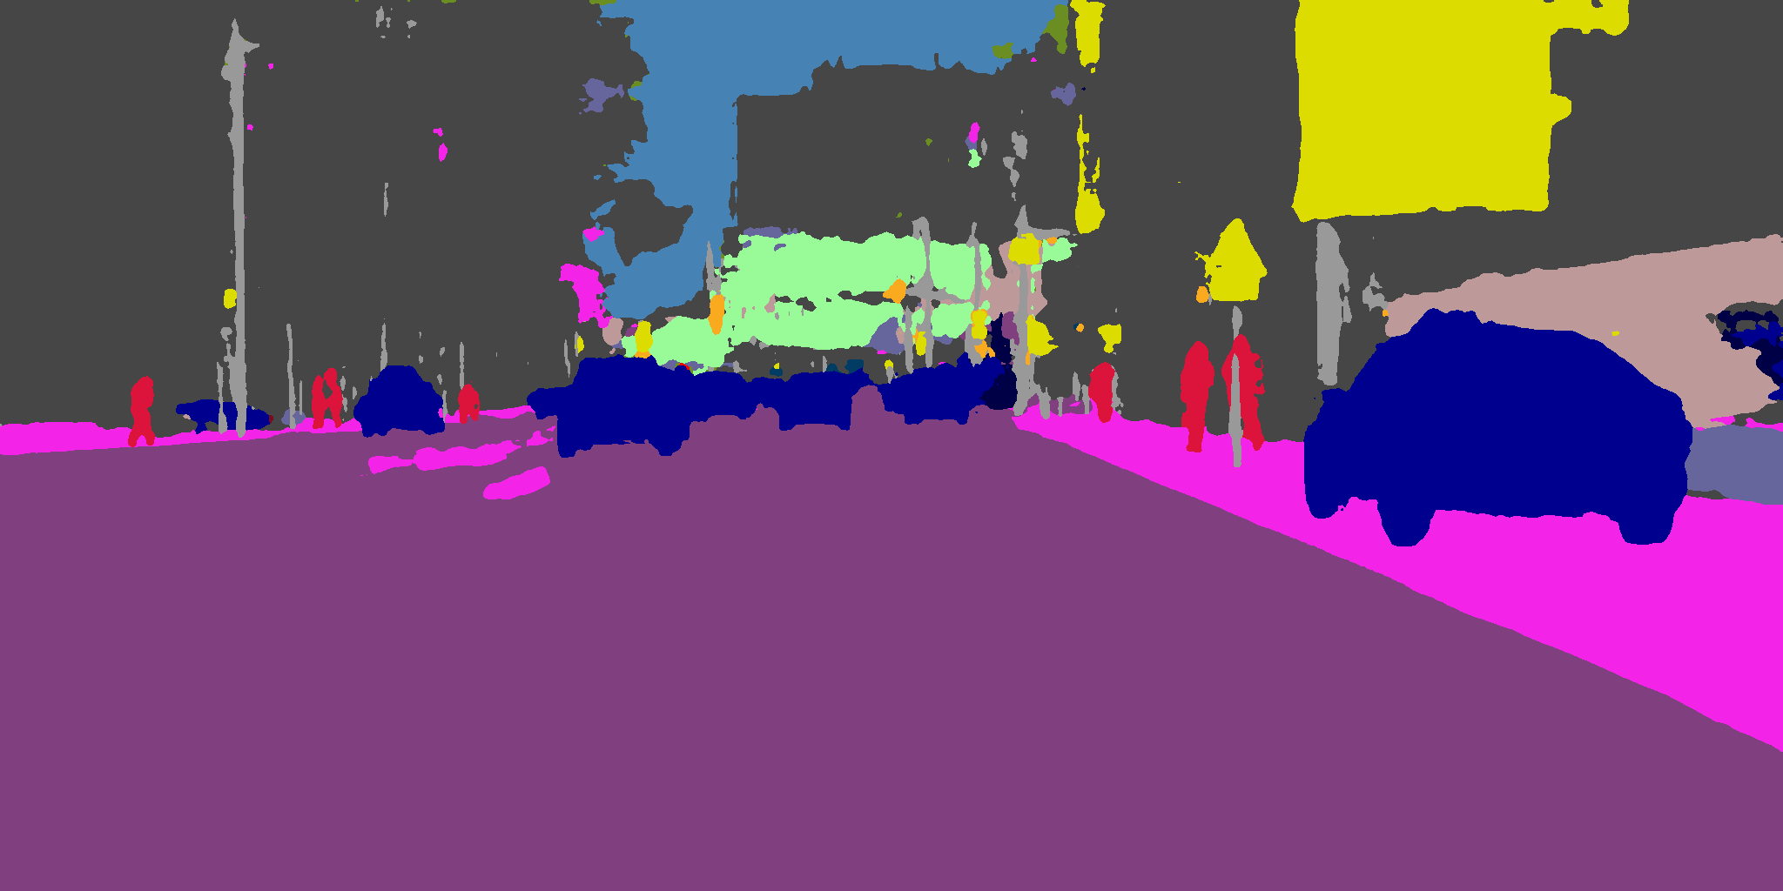 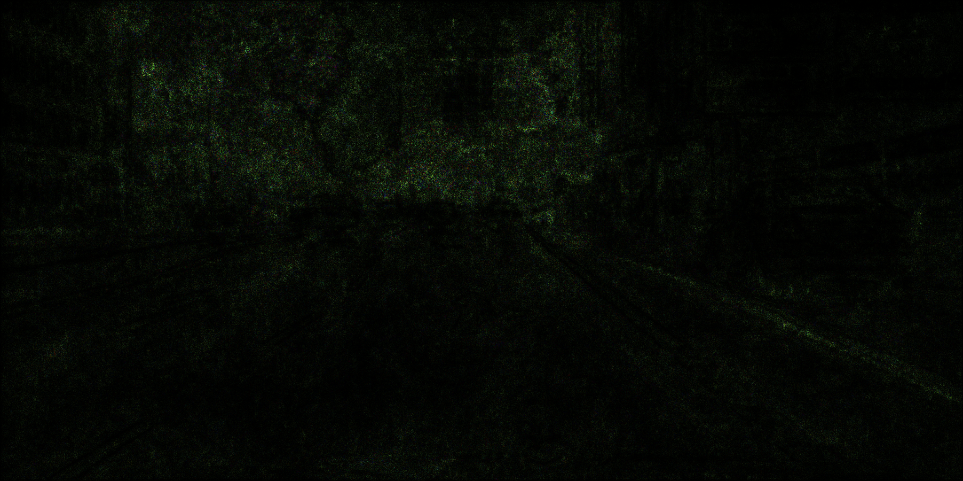  
     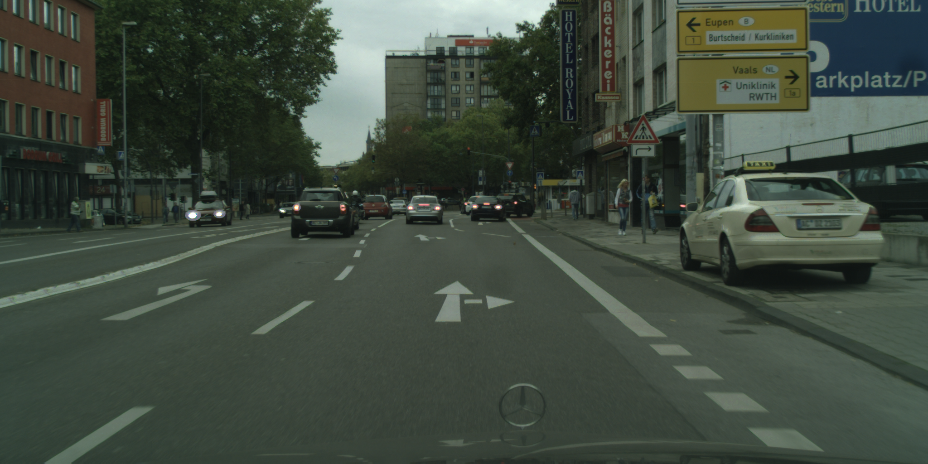  
     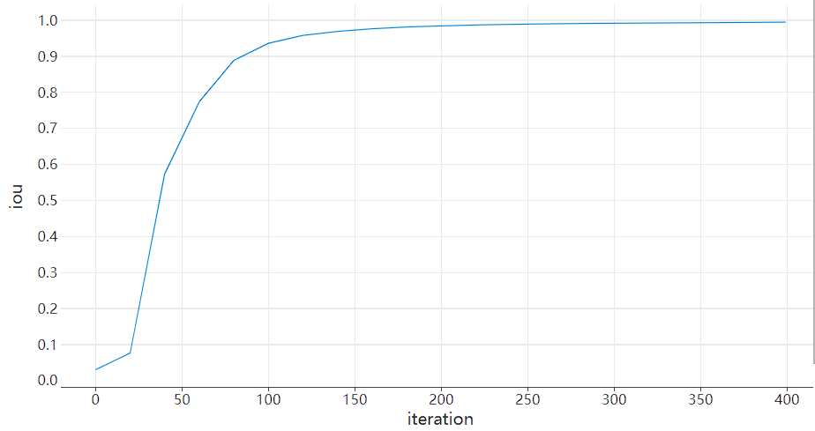  
     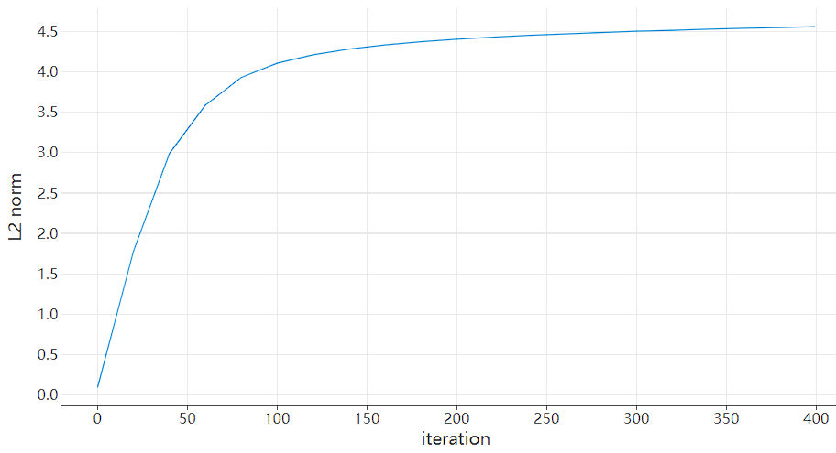  
       
     U_[13]_400_LR1_l1_LW4.00_  
     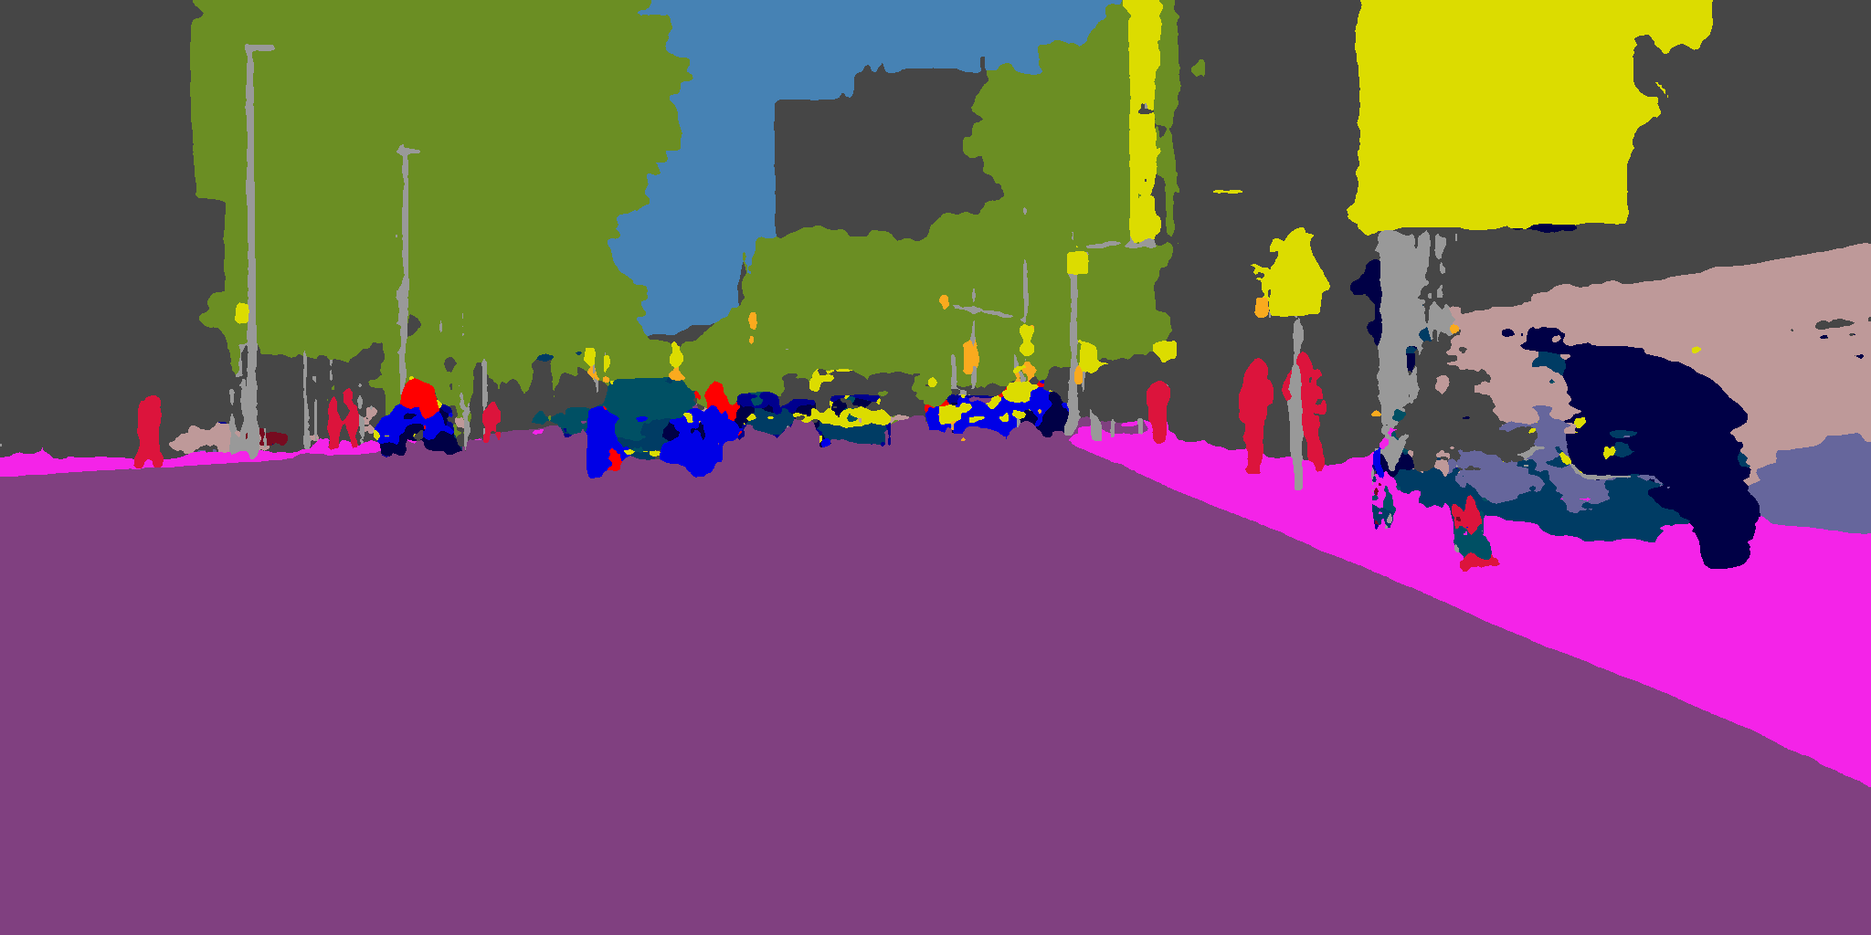 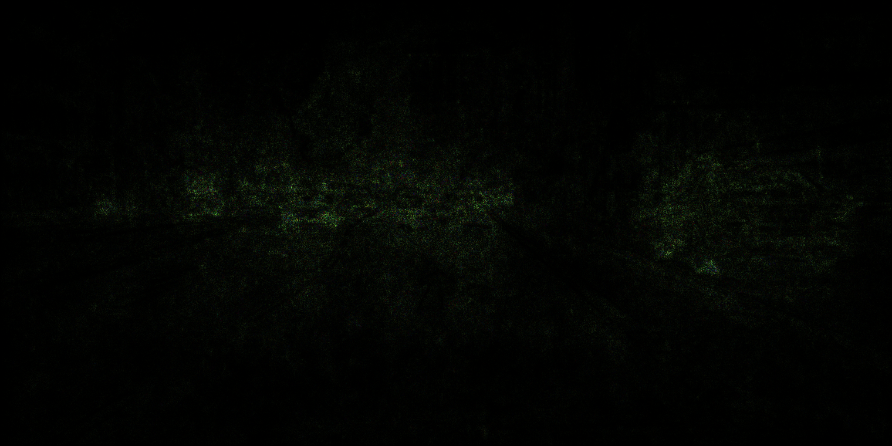  
     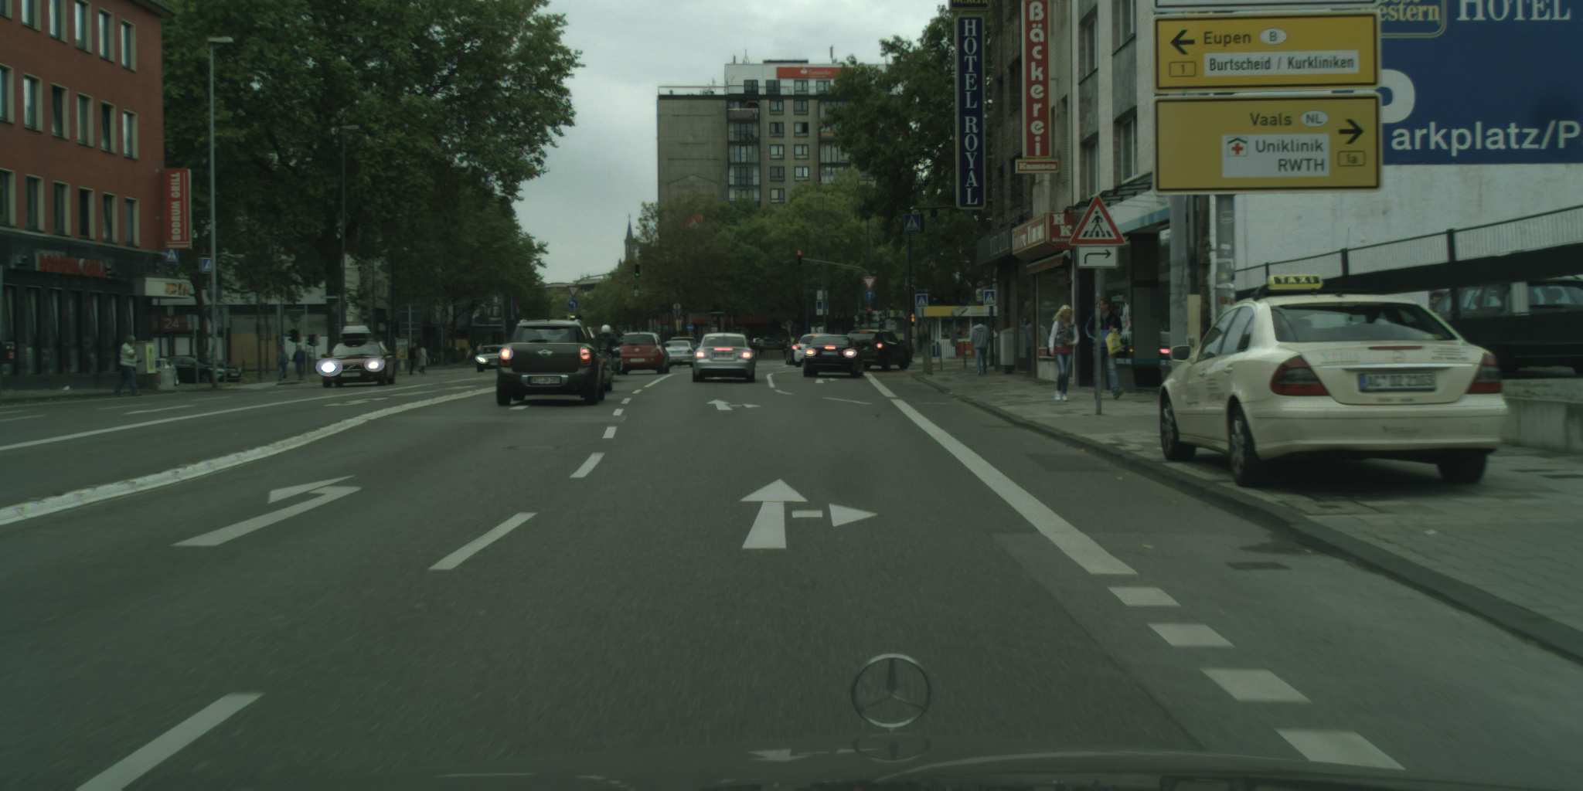  
       
     We first evaluates two single-target attack: attack class 8 (vegetation) and attack class 13 (car). These two samples quickly converge even if a low LR is used (LR=1), as IOU plot and L2 plot shown. Both samples are near convergence only around iteration 130, which is a very low value compared to other attack settings. Furthermore, the perturbation is even invisible to human inspection at last epoch. Meanwhile, background pixels are almost preserved, possibly because the perturbation can only focus on destroying structures and textures useful to classify pixels as original class. Notice that, since UO does not guarantee what actual class will be classified for original pixels, there are chaotic patterns for original pixel regions in both samples. This phenomenon is especially great for car (13) class, since it is common knowledge that classifiers usually rely more on structures compared to textures to classify cars. Each local structure can require different perturbations to erase them from being recognized, hence car class attack produce more chaotic segmentation pattern. The attack on vegetation is likely to focus more on ruining textures, based on the fact that classifiers usually rely on textures to classify vegetation. This can also explain why most vegetation is classified as building (which is also more texture-based).  
       
     U_{0, 1, 2, 5, 7, 8, 9, 10, 11, 12, 13, 18}_400_LR1_l1_LW4.00_  
     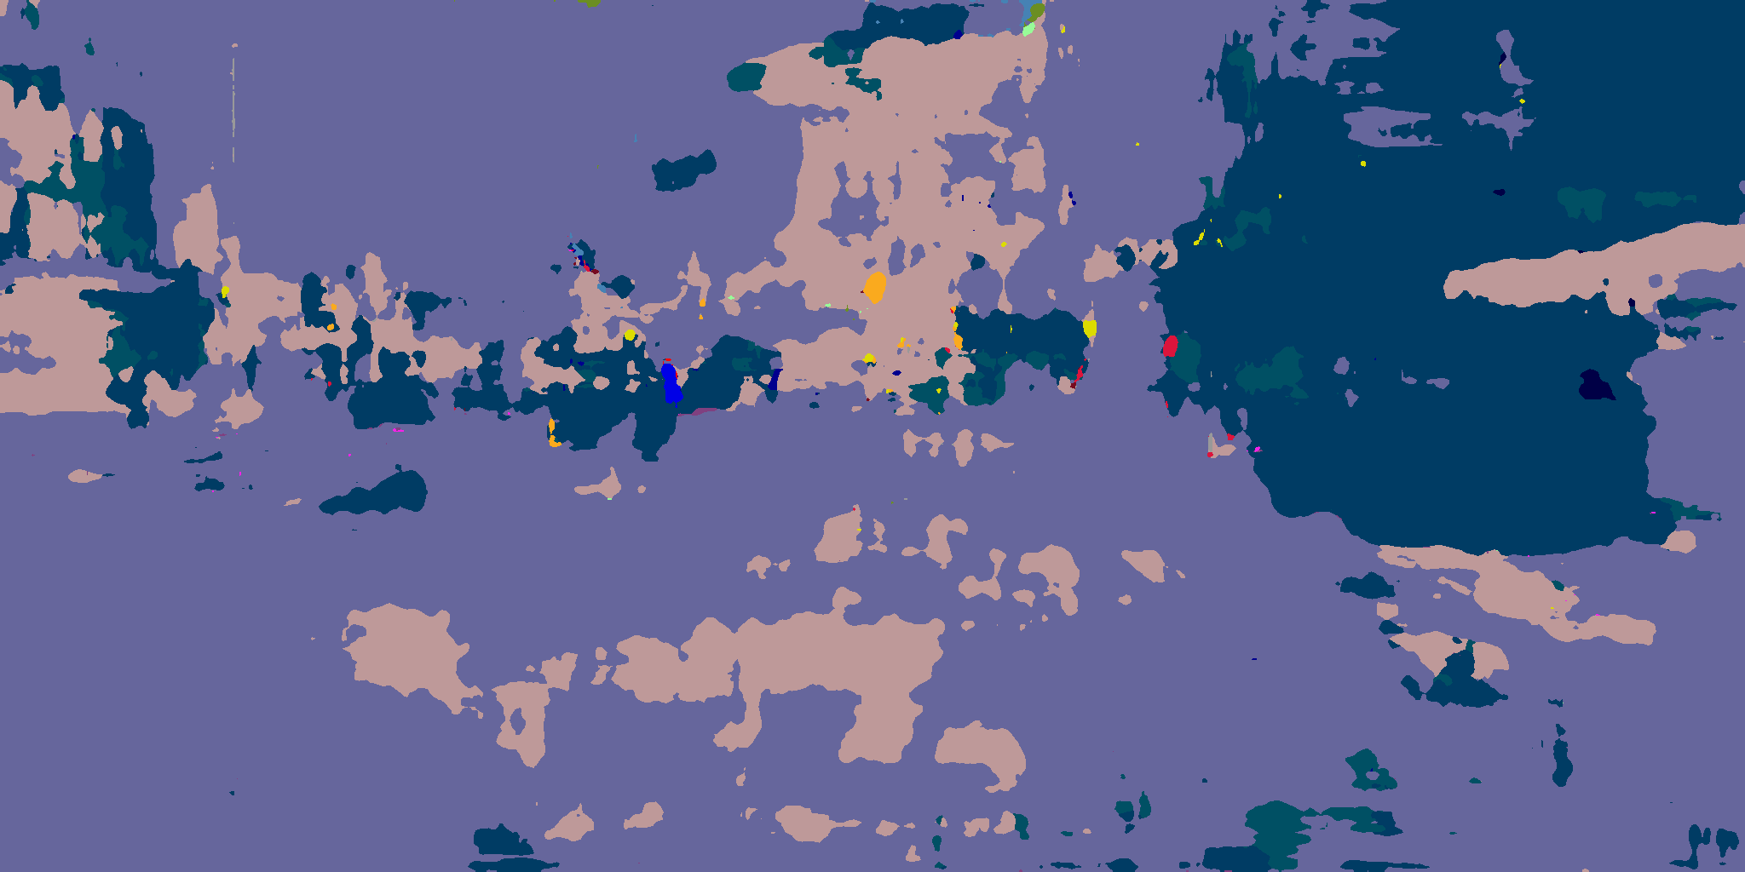 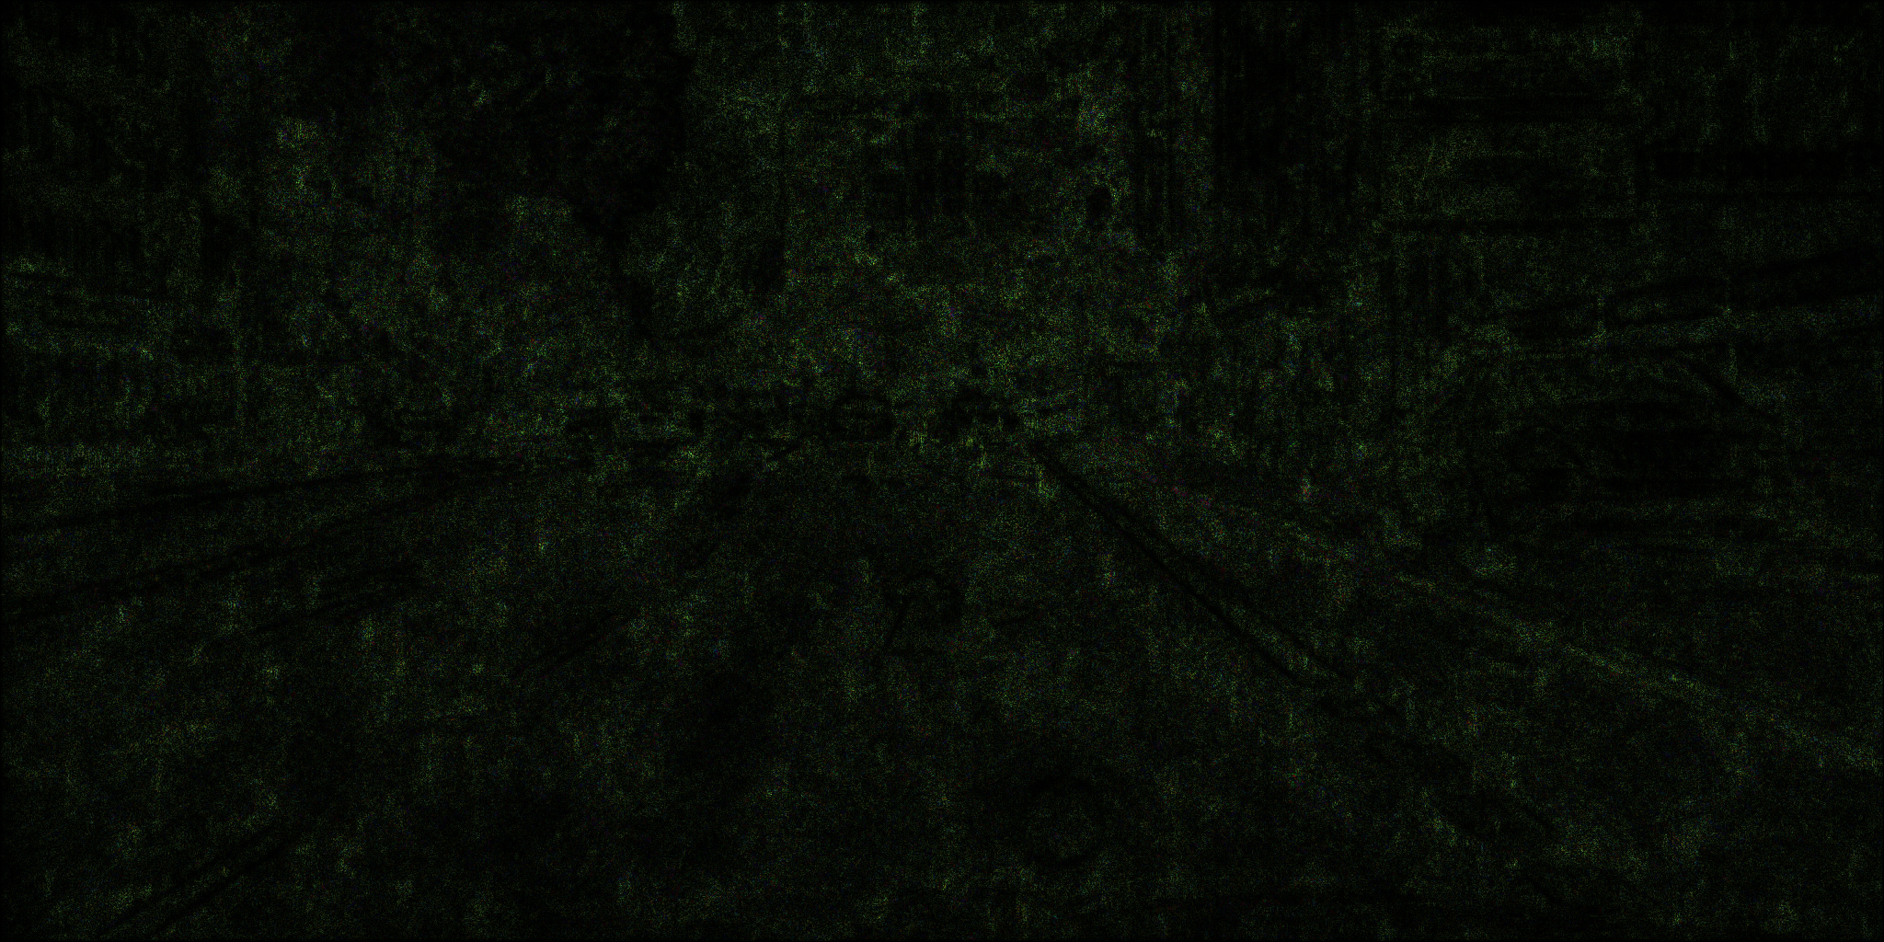  
      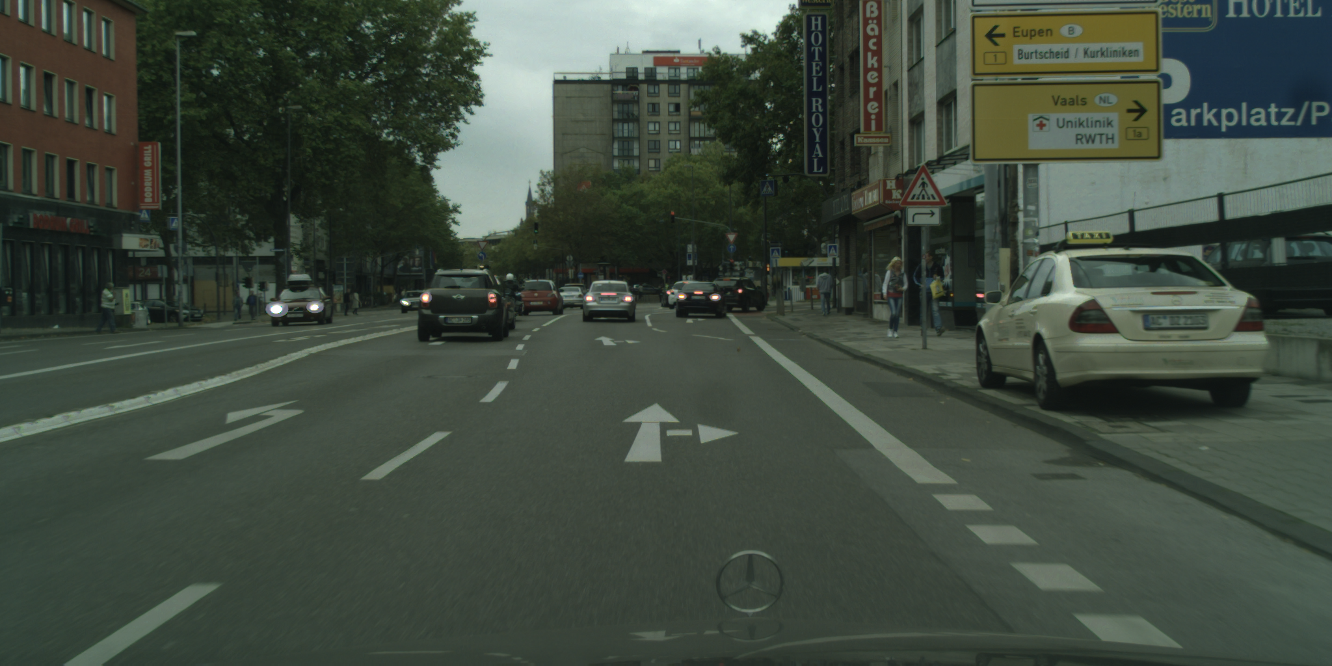  
     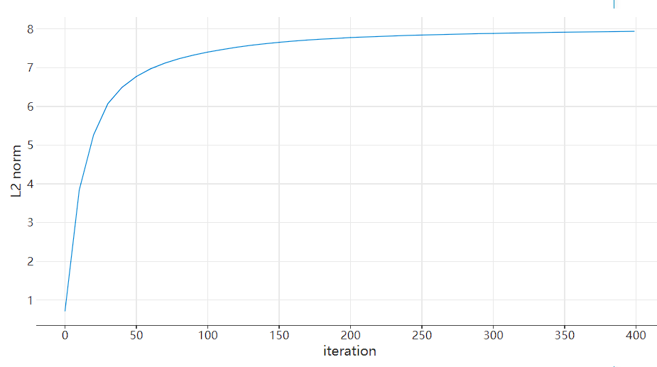  
     Here is another attack that attacks all classes in original mask. This attack also converges very fast compatible as single target UO attack. Notice that while almost all pixels are misclassified in the perturbed image, it spends almost the same time as single-target UO attack (203.1 seconds for 400 iterations; ~0.5 second for 1 iteration), showing a high similarity between these two attacks.  
     Such UO attacks are mostly visible to human inspection. However, it is very fast to carry out (around ~30s for an acceptable perturbation on our computer), and is proved to be transferable between different images of a same model.  
     This also partially assures the manifold assumption under our attack configurations, which is also proven by [29]. It is easy to exit a manifold than approaching a manifold (based on the fact that in very high dimension spaces the surface area of a sphere is distributed heavily towards its center), that is why UO attacks usually converges very fast. Such attacks are thus useful to corrupt massive data or conduct a MITM attack.
  3. TDV type attack  
     For this section and next section 8.4, we adopt a quick and naïve implementation for universal updates, summarized as follows:  
       
     Different from [19], where they update the global perturbation for each batch of images, we implement a quick attack which updates on every image. Intuitively, since the perturbation is added to each image, if the perturbation is near optimal, the attack would not improve perturbed image by a large magnitude.   
     Notice that this algorithm has a very similar stepping logic as Stochastic Gradient Descent (SGD) method. By such design considerations, our current algorithm is proven very fast to carry out, yet it suffer from the same hard-to-converge problem very famous for SGD. By our empirical evidence however, it can produce a perturbation with acceptable structures.  
     We implement the interpolation() function as a simple linear interpolation when we do this evaluation.  
       
     For TDV attack settings, the attacker aims to produce a perturbation from a set of targeted images, and add the perturbation to any image which is sampled from the same distribution as the target image set. The attacker also specifies a class mapping F (e.g., map all car pixels to vegetation pixels) and a target model M. Any such perturbed image Ip should fulfill the constraints: $$M\left(I_{p}\right)=F(M\left(I_{i}\right)) \\ I_{p}=I_{i}+perturbation$$  
     Where $I_{i}$ is the original image.  
     Semantically, for example ,the attacker aims to produce a perturbation, when added to an image within same distribution, forces the model to classify all pixels with car as ground truth to vegetation. This is also the attack setting evaluated in this section.  
     Since there is no standardized evaluation set for Cityscapes, and we do attack on a small dataset, we thus evaluate on image-by-image basis. Hence, this section only shows visual performance of TDV attack under our settings. We believe that showing visual performance is more important than cross comparing metrics such as L2 norms and IOU.  
     We implement TDV attack by iteratively calling attack utility for each iteration. It has a simple update logic for universal perturbation between two iterations, a linear interpolation. For an evaluation, this implementation is to function. If we would like to pursue better attack performance, such simple implementations must be changed.  
     Here is our best attack that train on a down-sampled subset of Hamburg, consisting of images ending with 7 or 9 (with a size of 56 due to time cost). The evaluation is done on 12 images that are not in the attack set, and are manually selected to maximize variation of city scape. The attack aims to substitute all car (13) to vegetation class (8). The sample attack evaluation is shown below:  
       
     T_13-to-8_step16_aLR512_pLR0.06_l1_LW16.00_sel  
     global perturbation  
     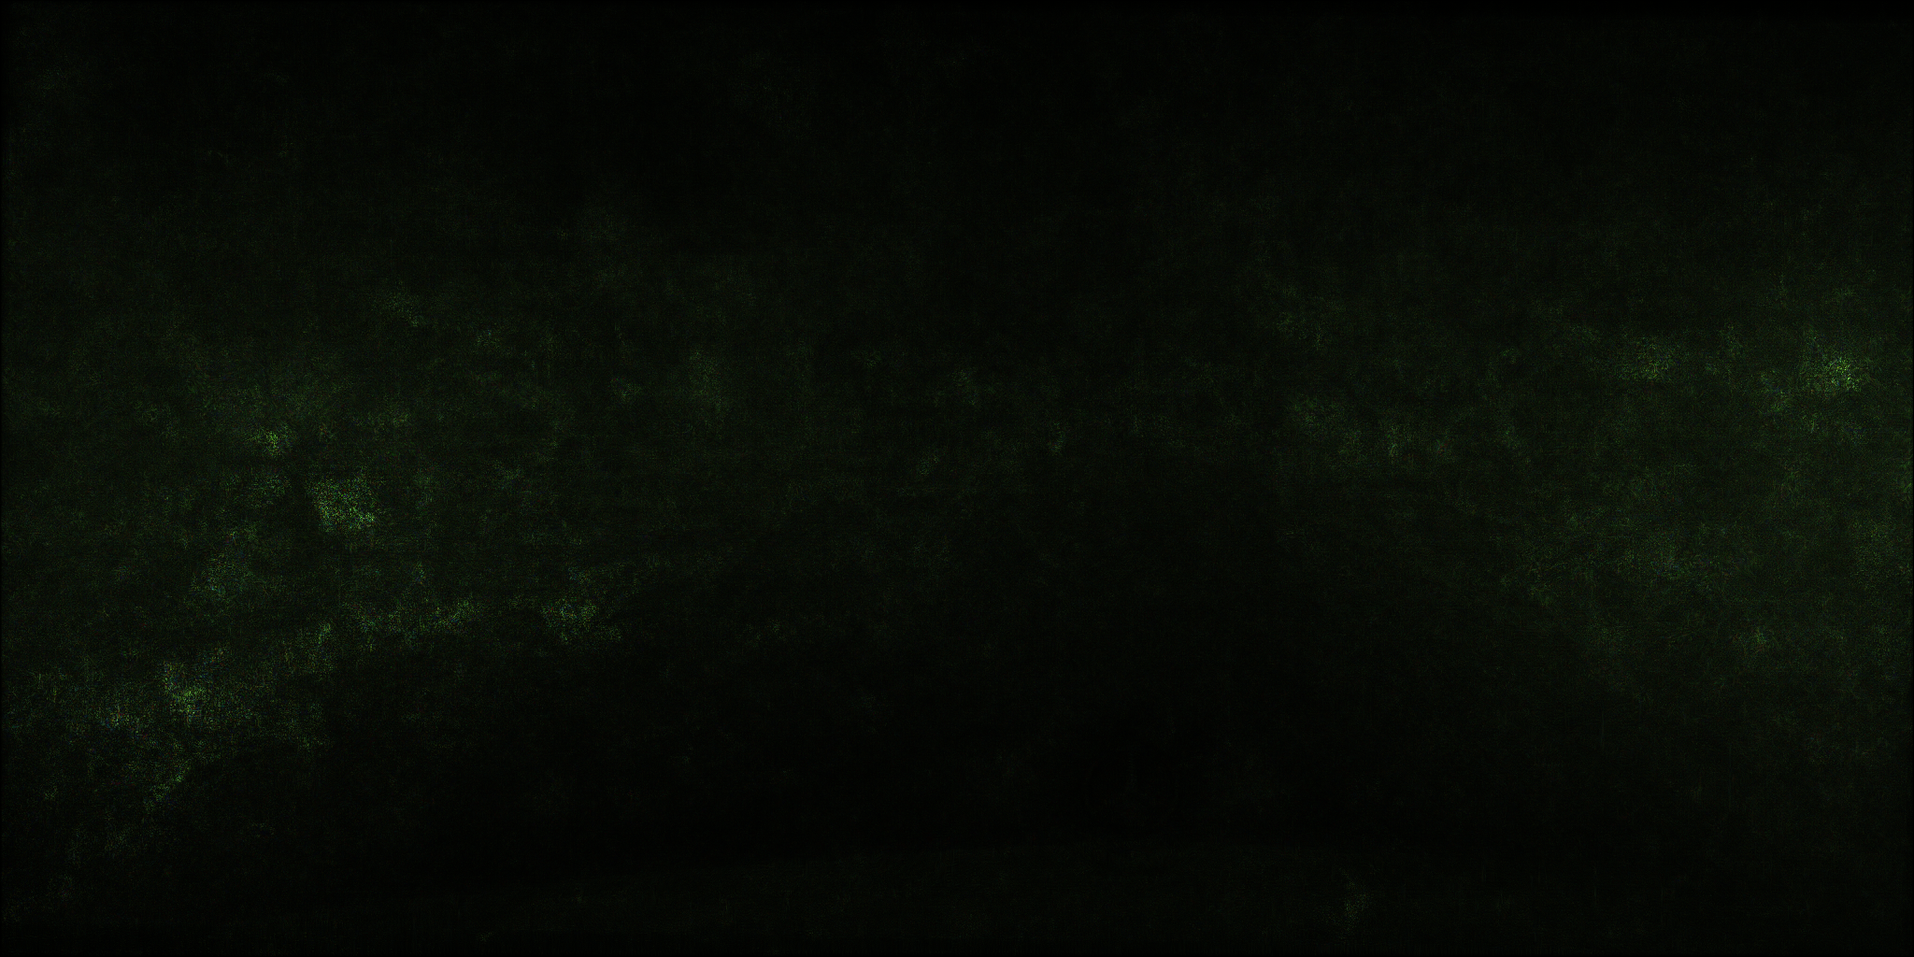  
     evaluation  
     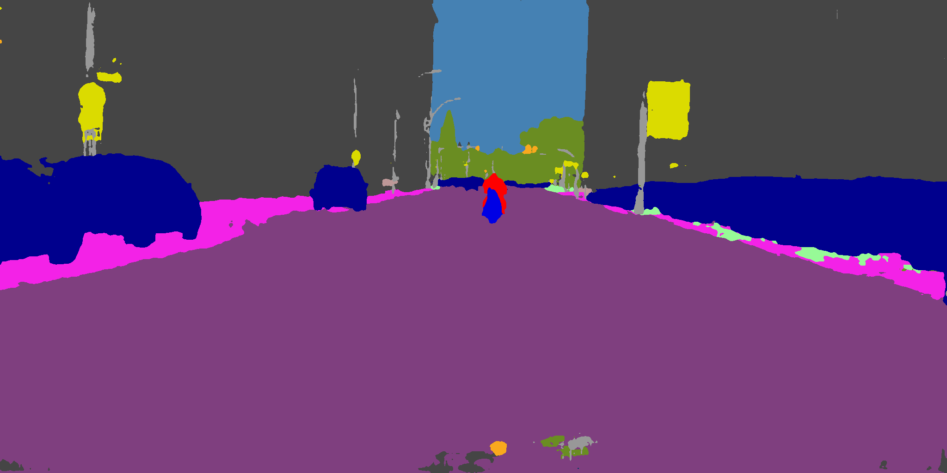 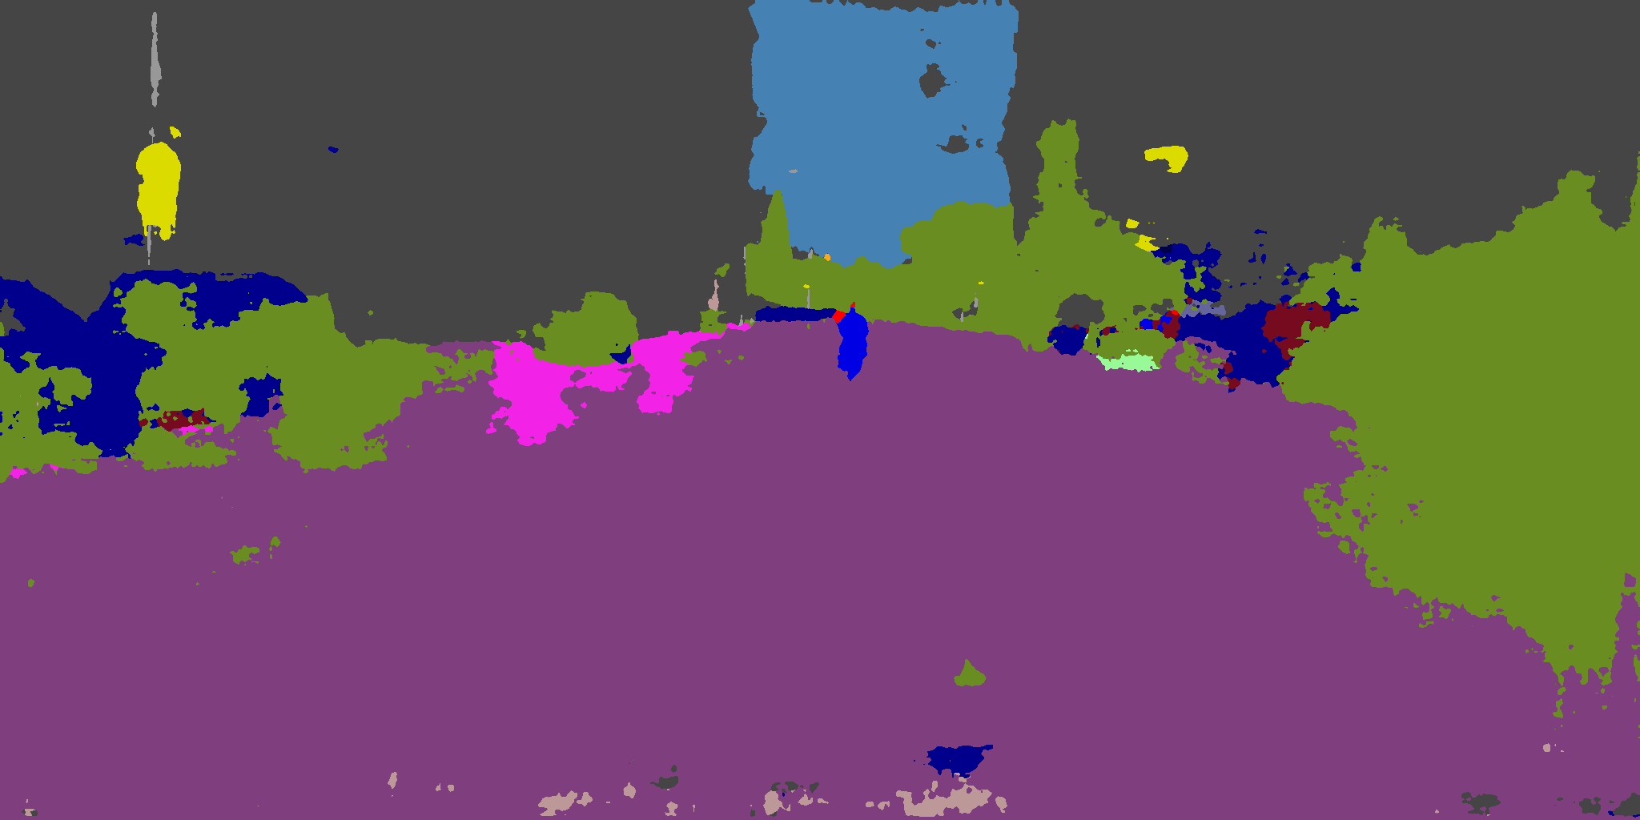  
     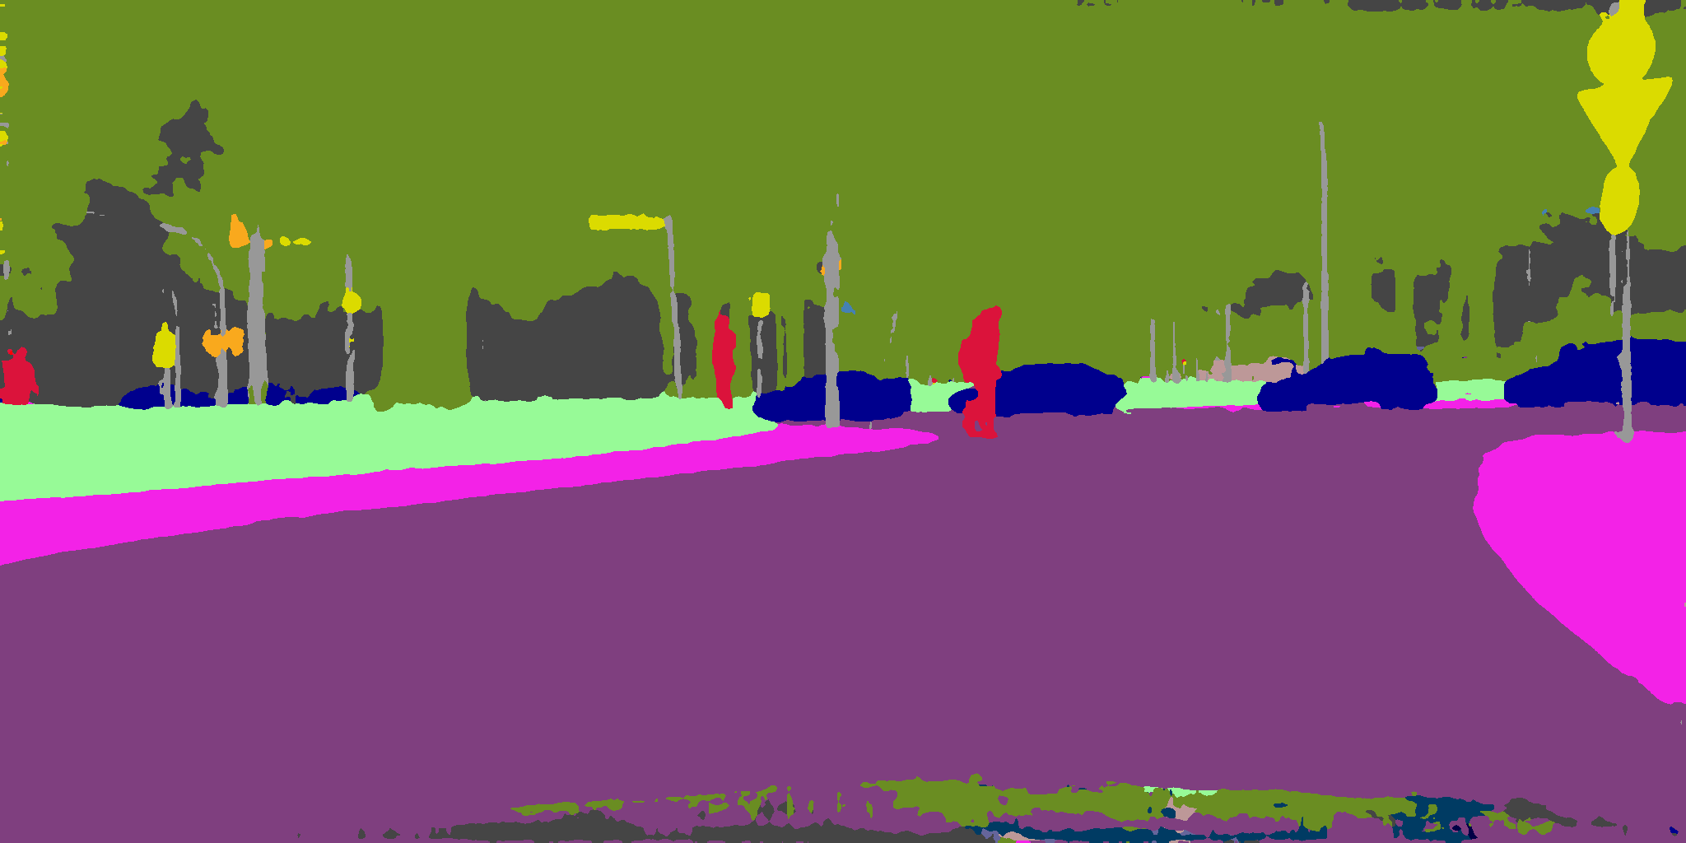 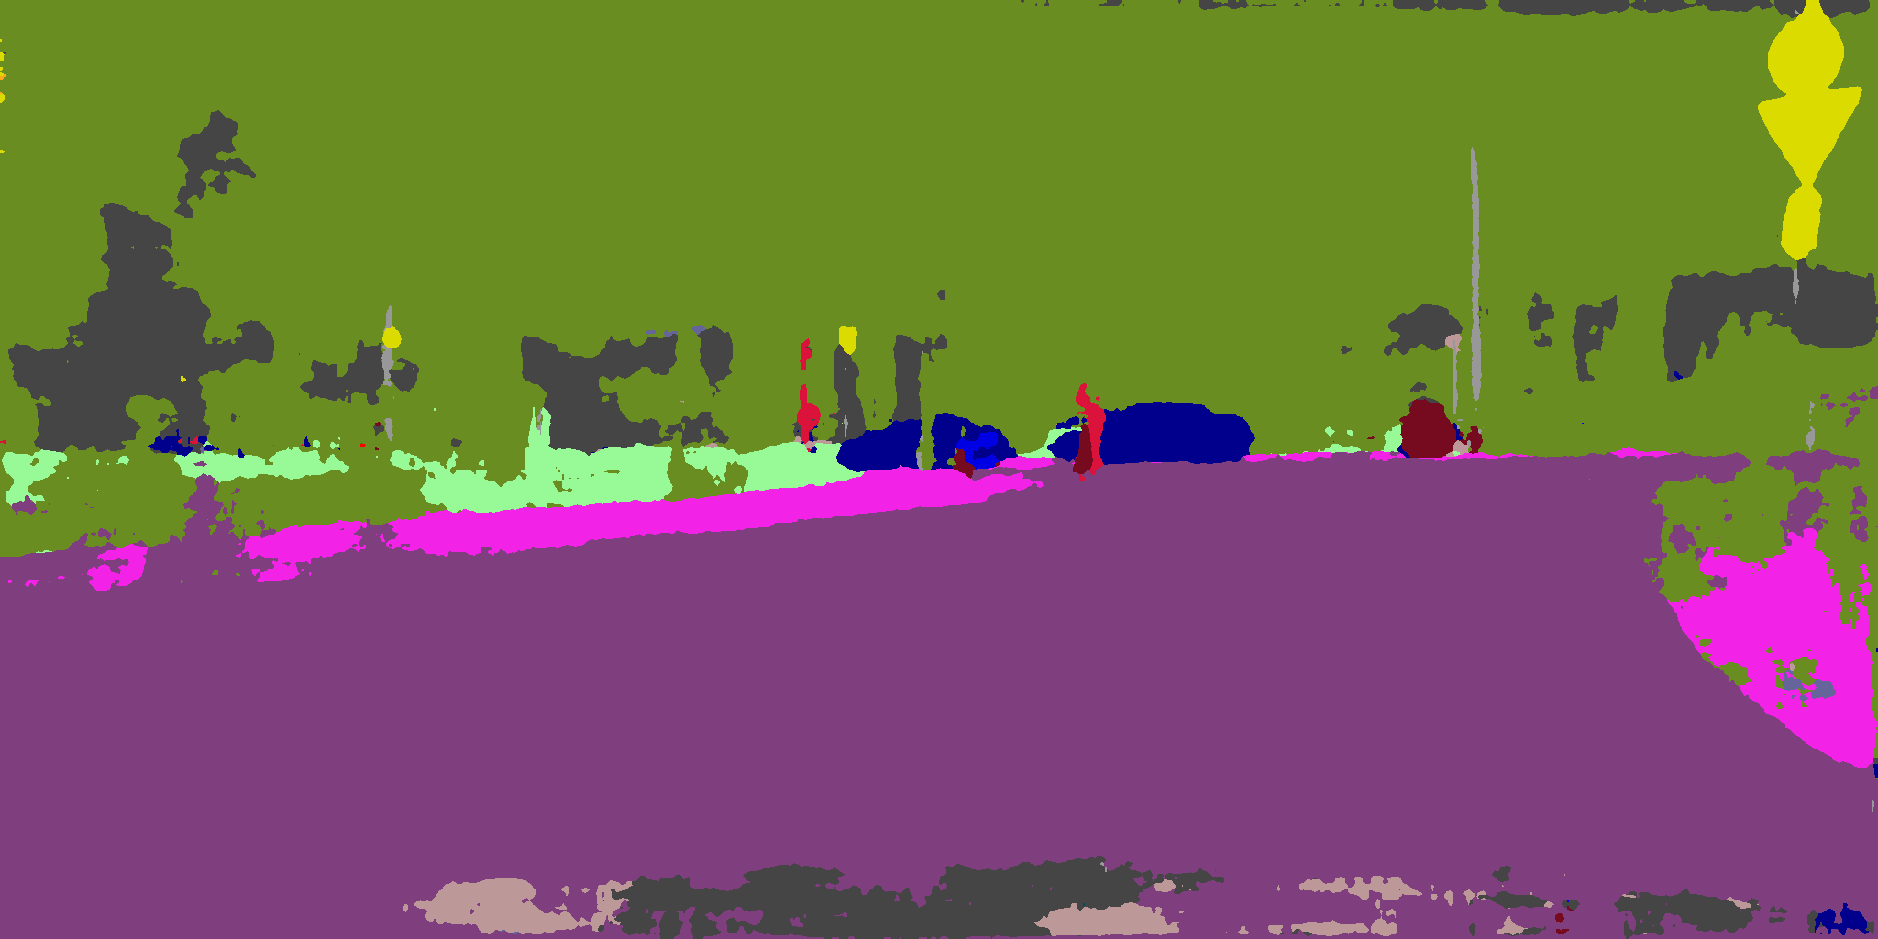  
     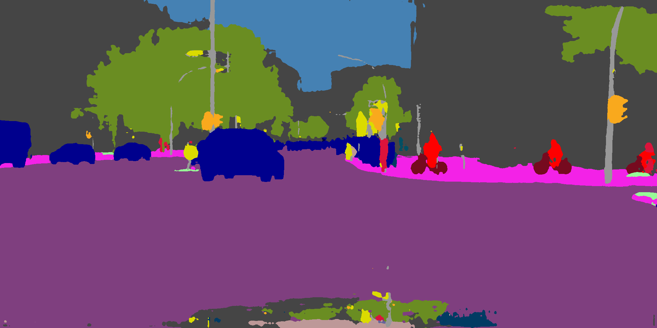 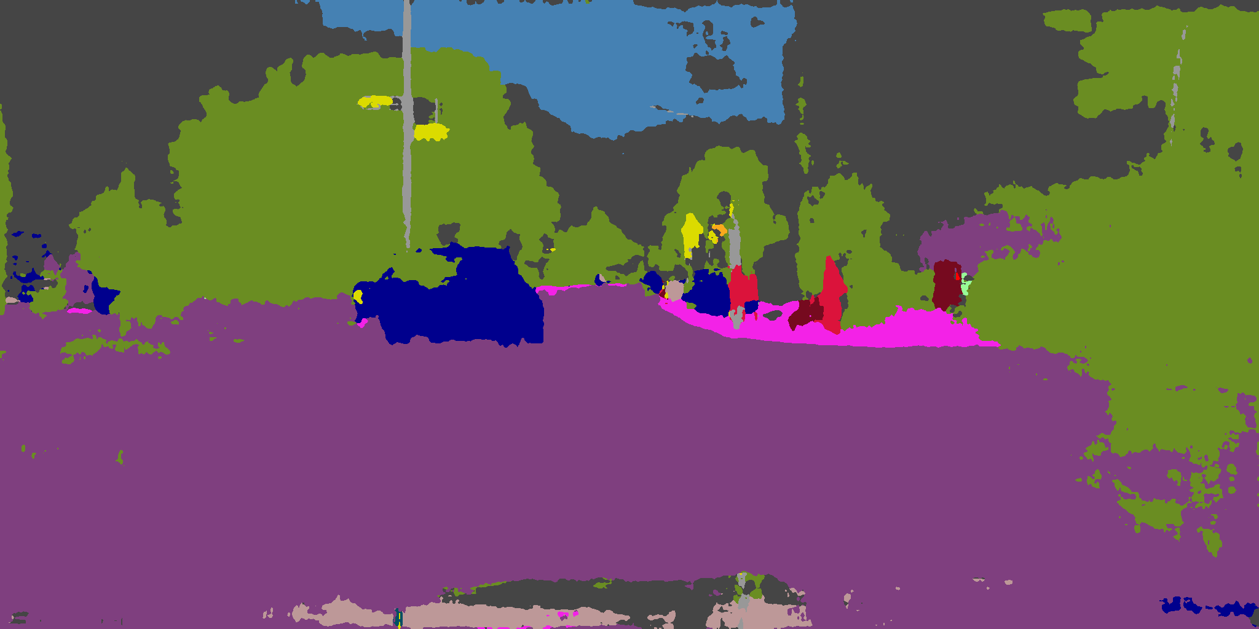  
     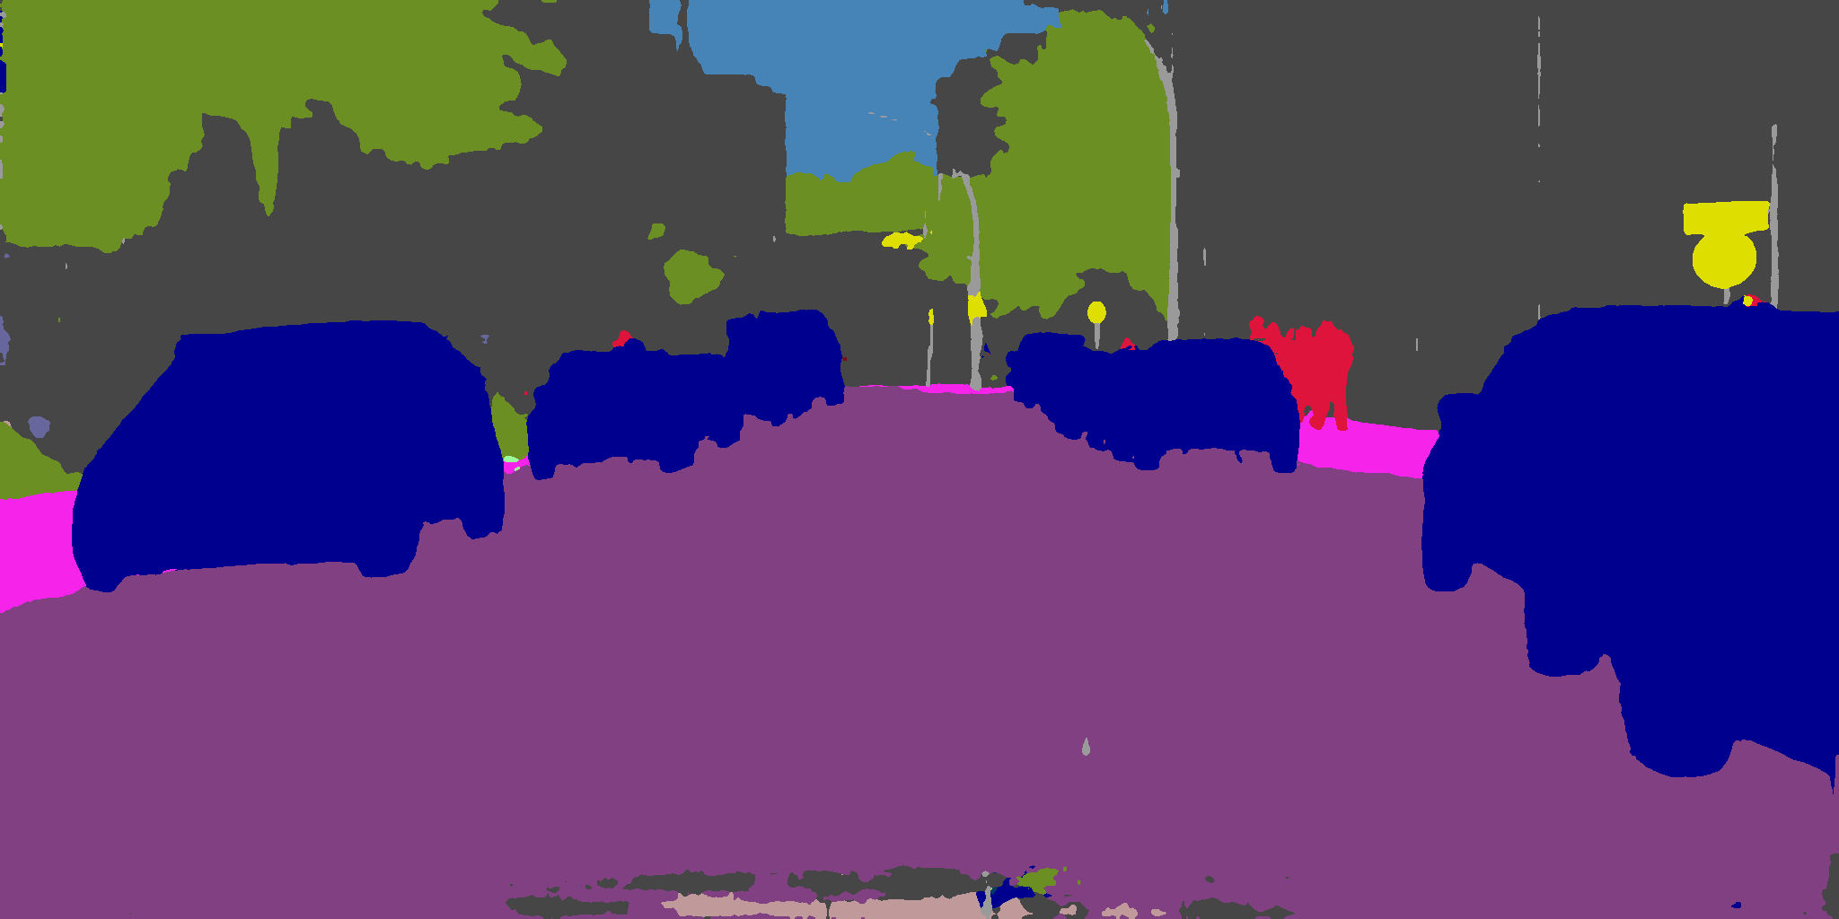 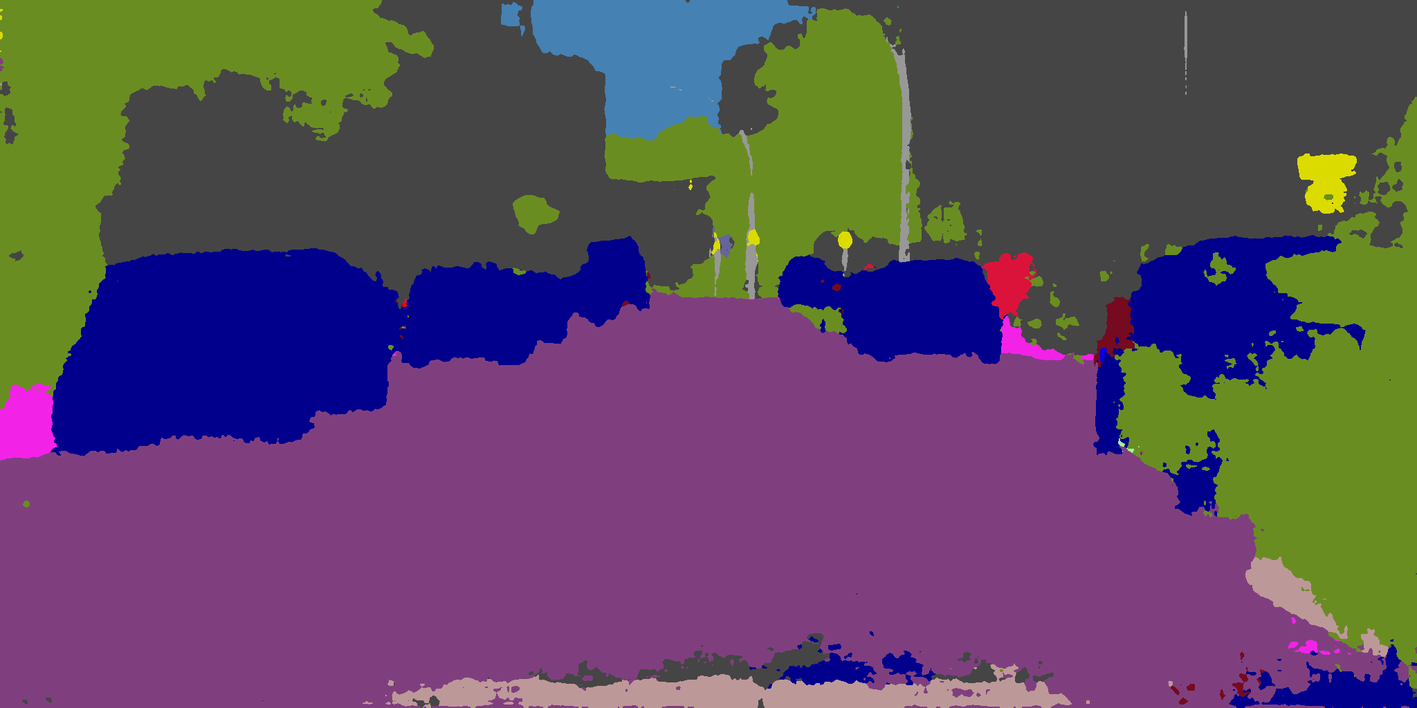  
     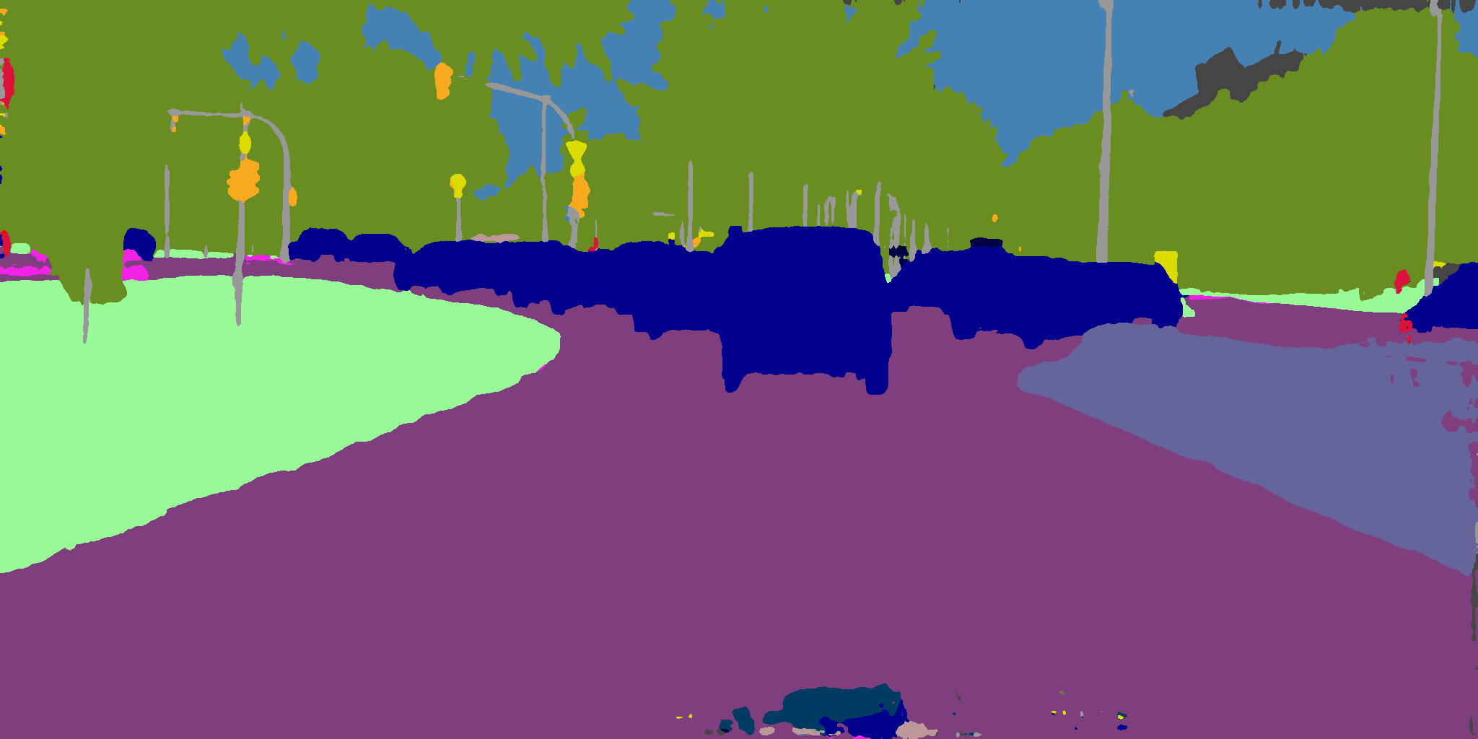 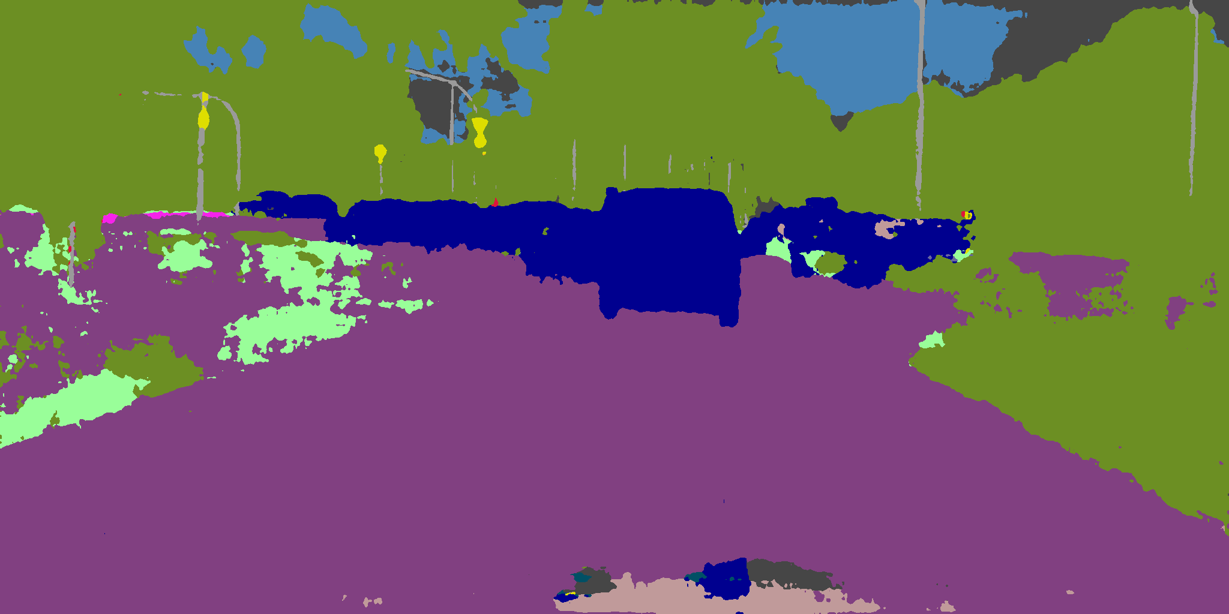  
     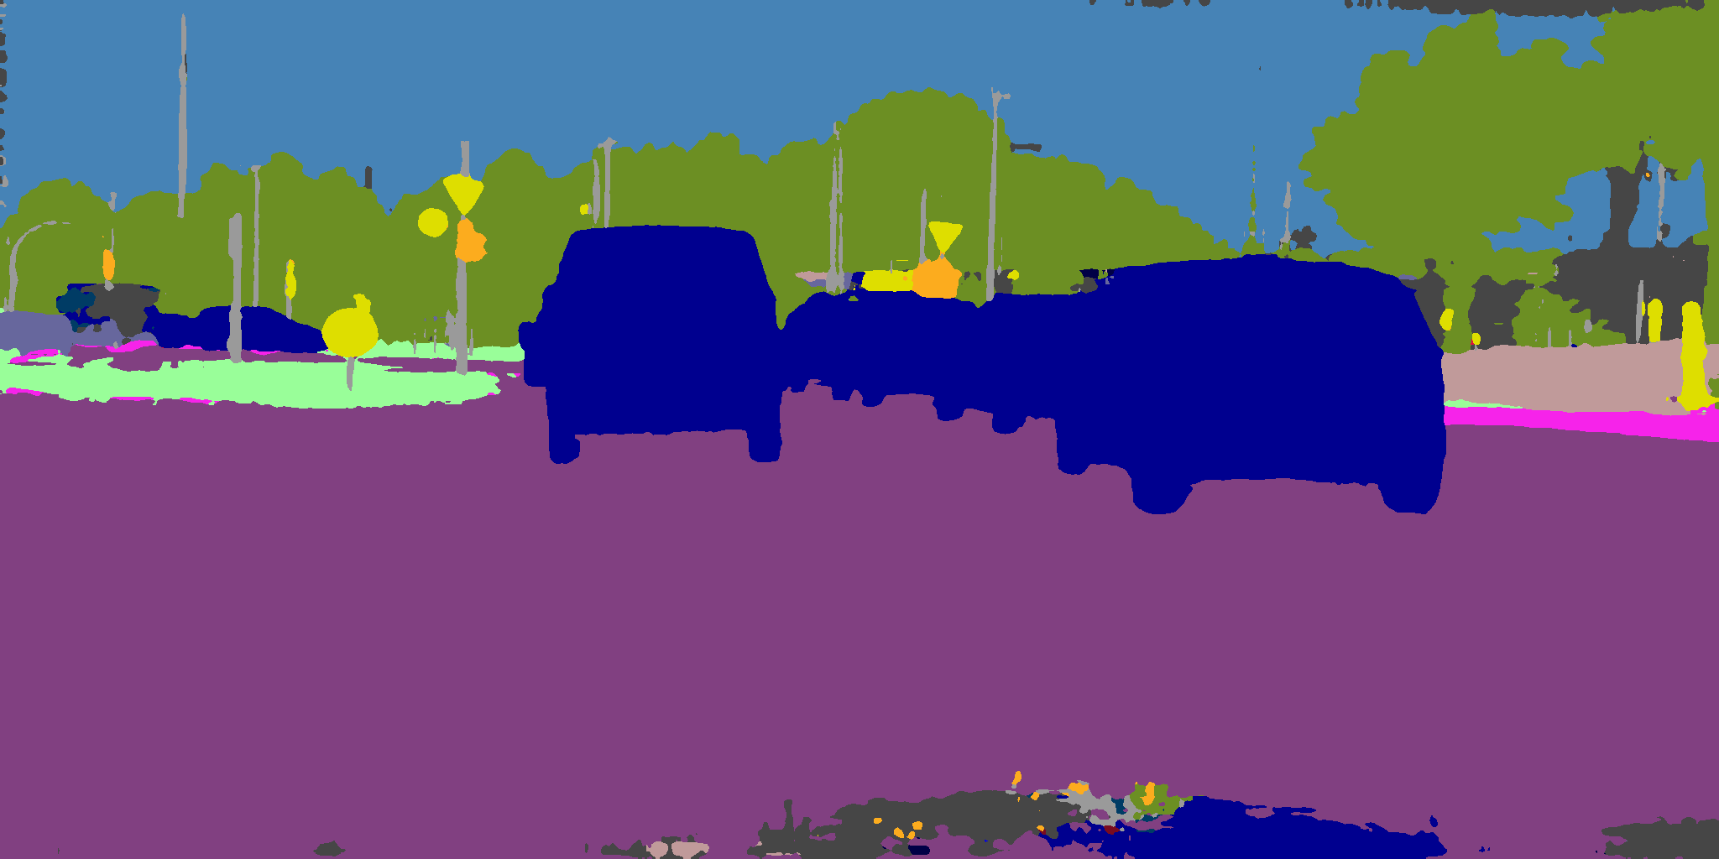 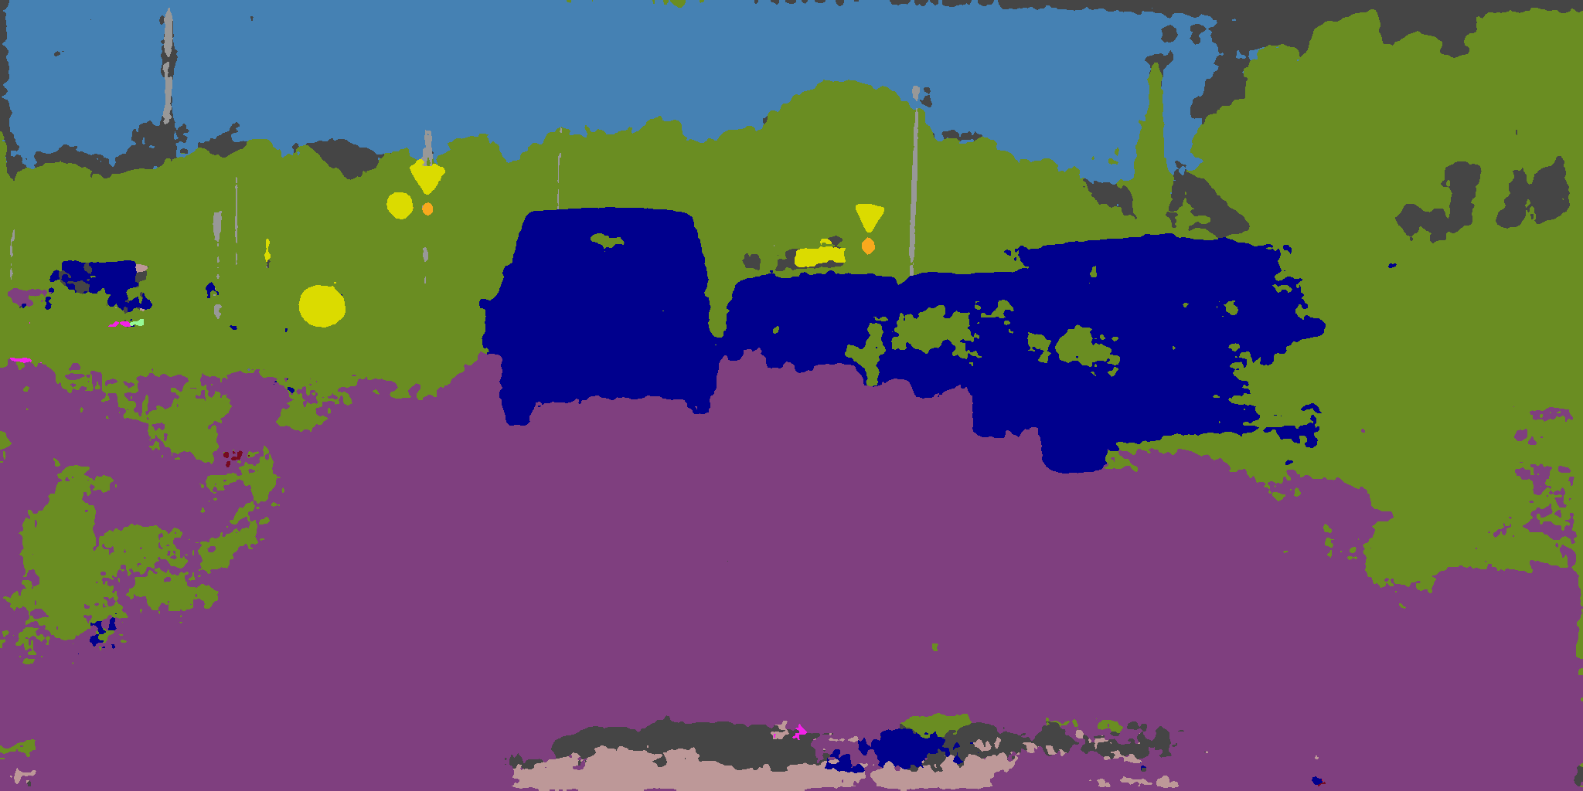  
     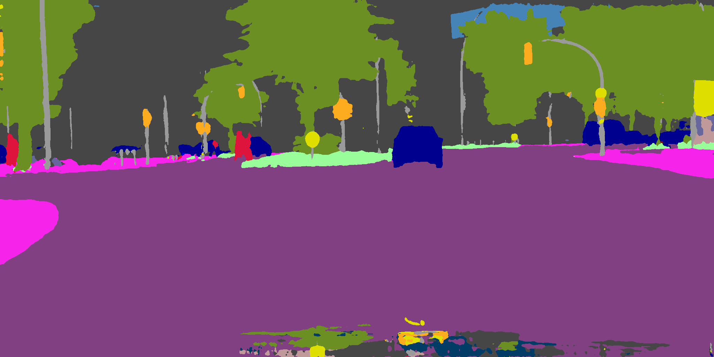 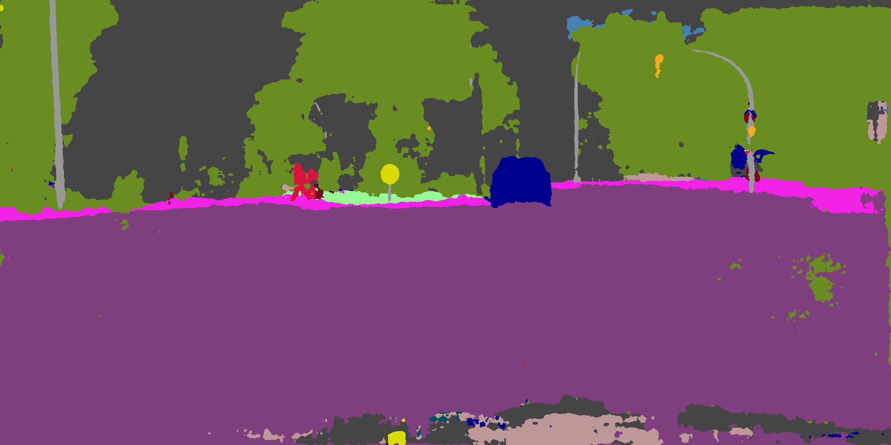  
     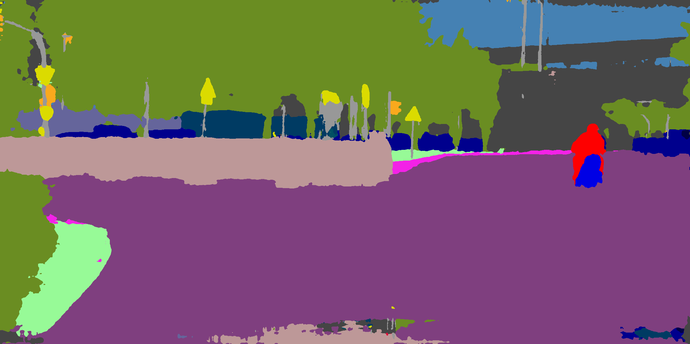 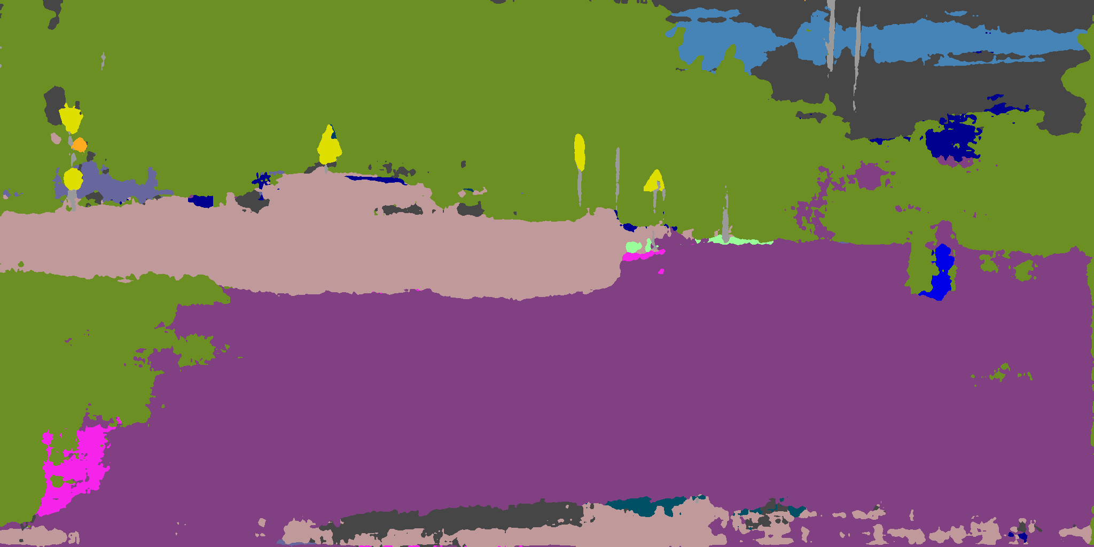  
     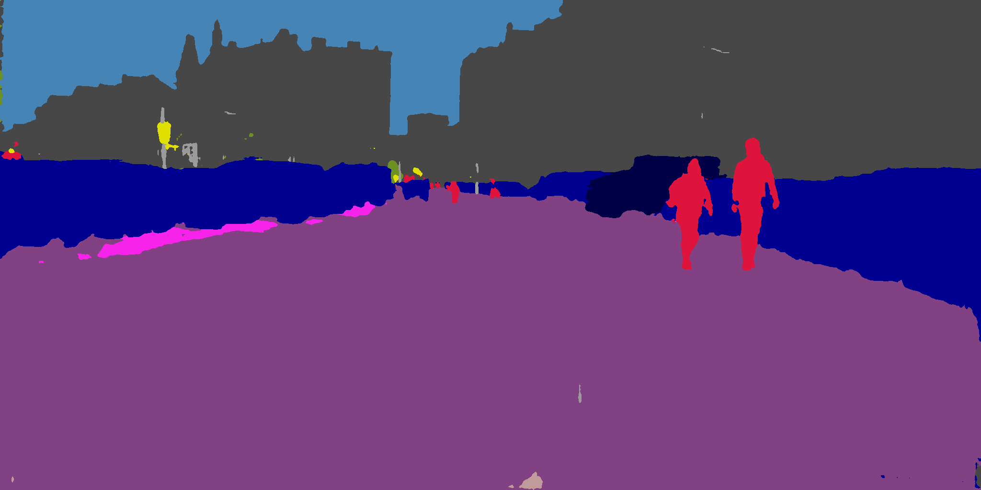 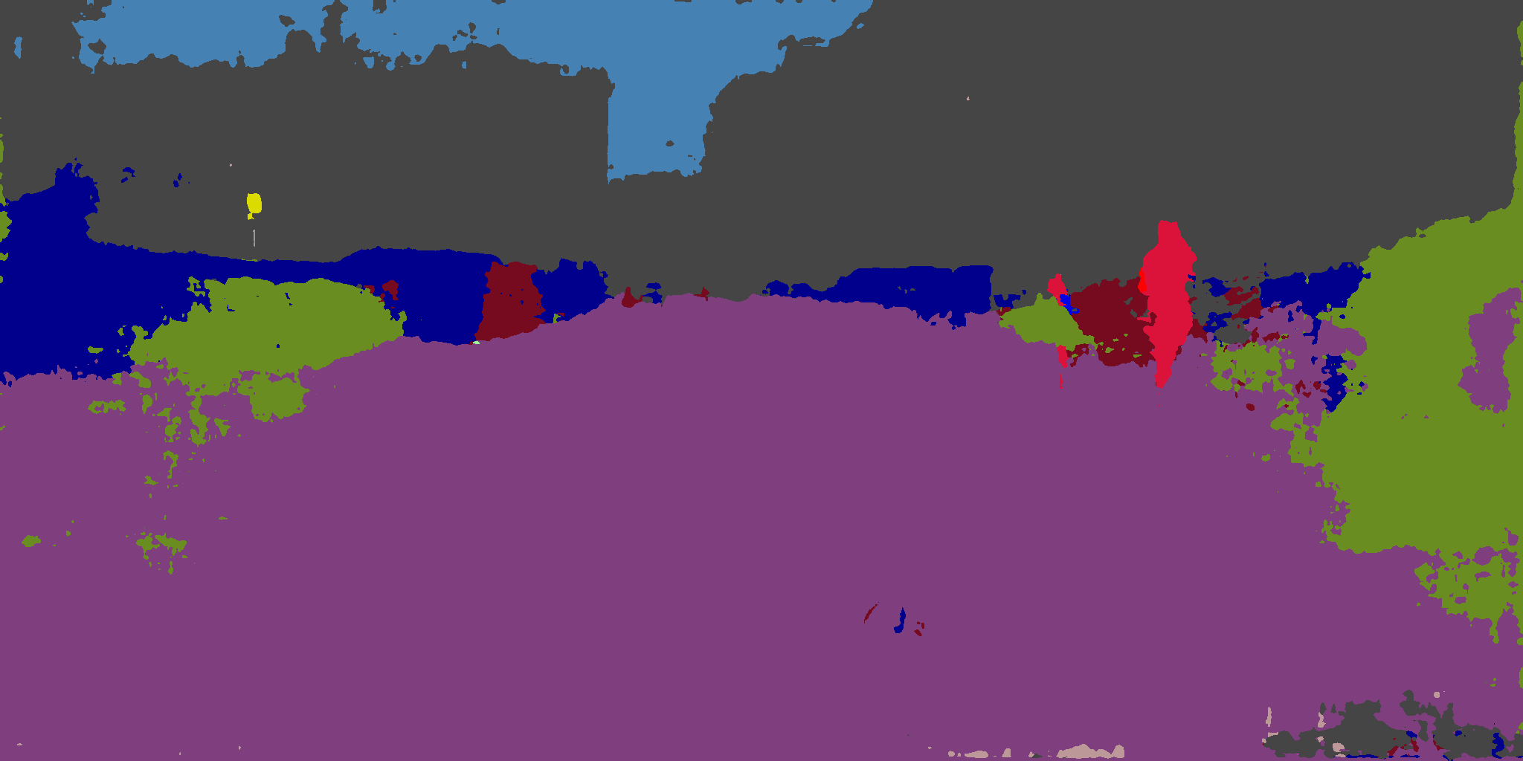  
     We observe some important facts for this attack:  
     * The farer the car, the easier for it to be substituted to vegetation.  
     * Other classes can also become vegetation, such as building class. In fact, it is the car class more prone to be substituted to vegetation, by observing these images.  
     * The perturbation can introduce vegetation, even if benign segmentation does not have vegetation.  
     * Among the regions that are substituted to vegetation, some classes that usually classified by texture (such as building and road) are more likely to be substituted within a region. On the other hand, if a car is not successfully substituted, vegetation pixels can appear only in patches but not continual region. The observation is the same for traffic sign class and pedestrian class.  
       
     Thus, we propose a few hypotheses to explain these observations, listed as follows:  
     * The perturbation contains a component which is the expected direction that given any image, the manifold of vegetation class is on that direction. Kicking off the car class’s direction is also considered since it is directly included in weight. Hence, the final direction of perturbation is an interpolation of these two directions. It is tuned to proceed off the car class manifold while keeping a general direction to vegetation manifold. T  
     * As previous section stated, some classes are usually classified by their texture while others by geometric features. Giving an arbitrary image, forcing a model to classify a benign pixel classified by geometry to an adversary pixel classified by texture can be a hard case. We do a further evaluation on this hypothesis, which attempts to substitute vegetation class (8) to building class (2), with the same attack configuration as the previous attack:  
     T_8-to-2_step16_aLR512_pLR0.06_l1_LW16.00_  
     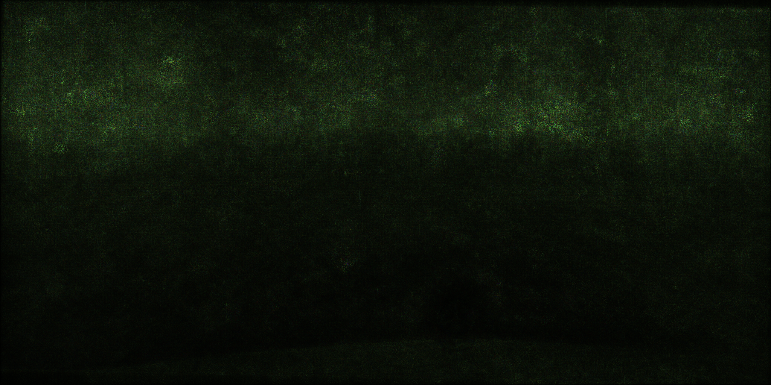  
      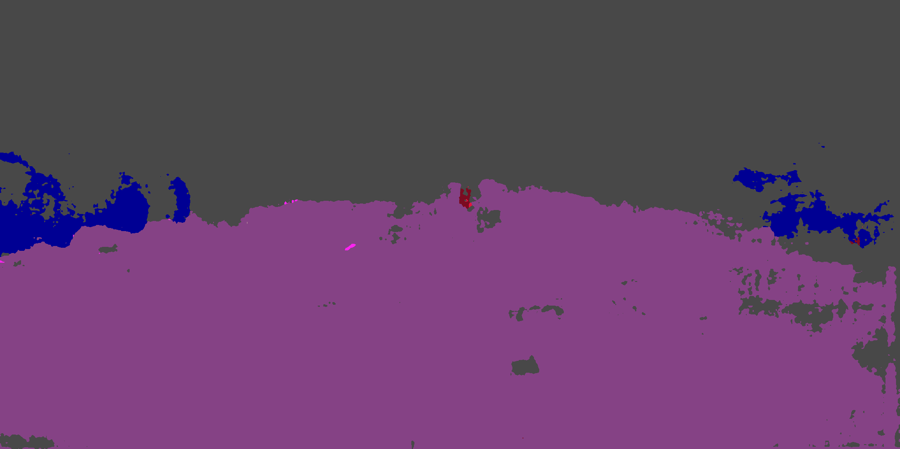  
      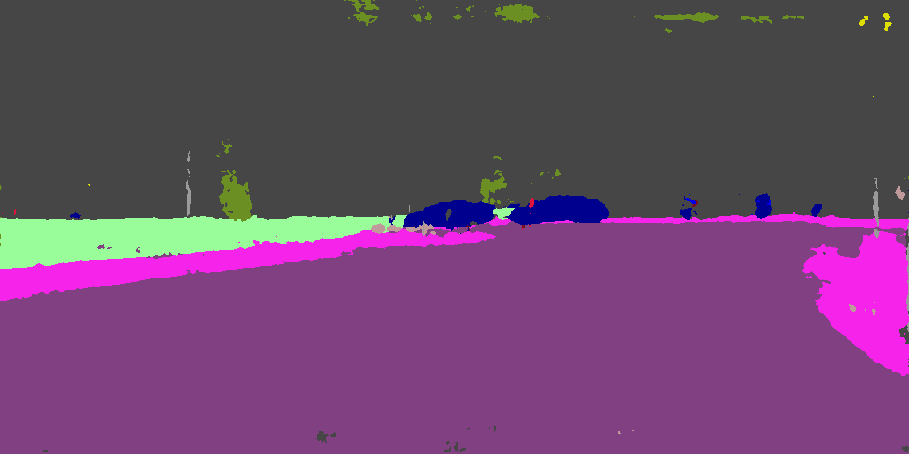  
      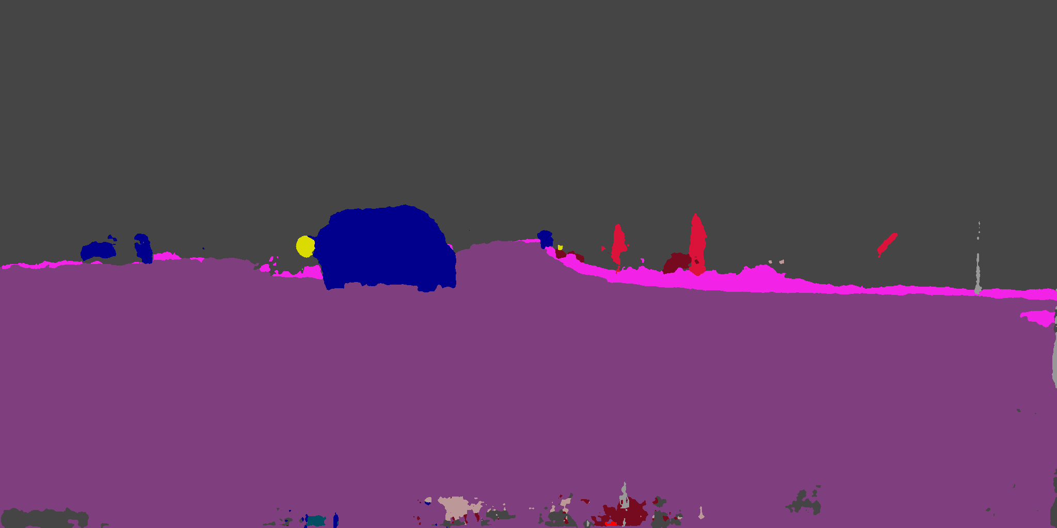  
      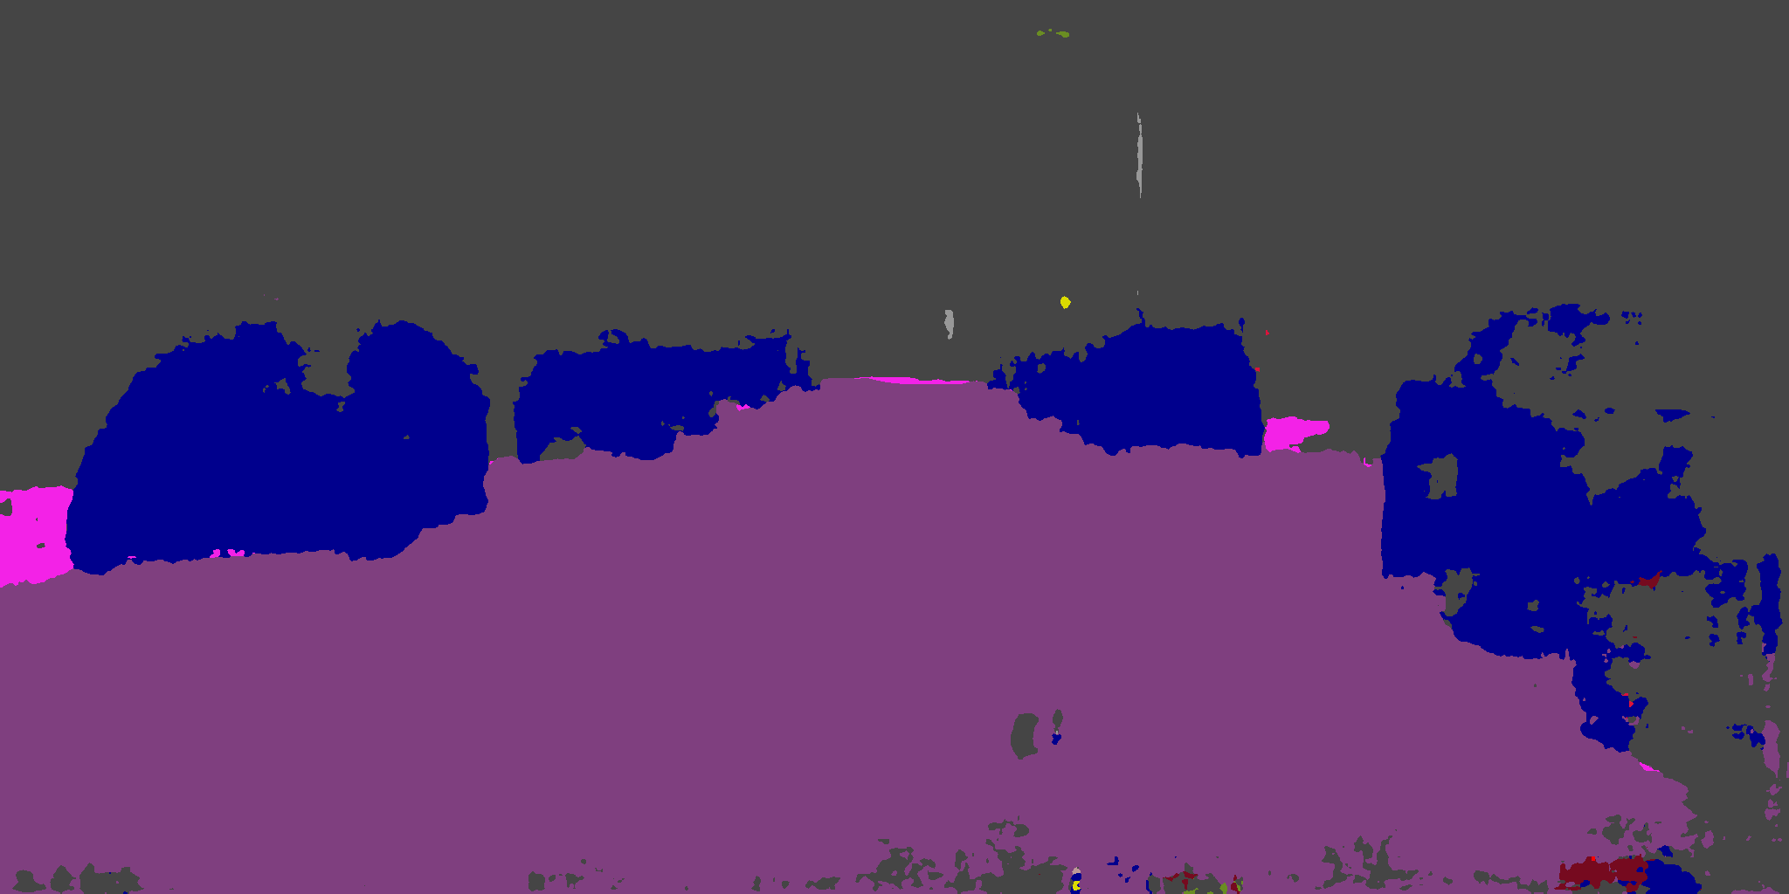  
      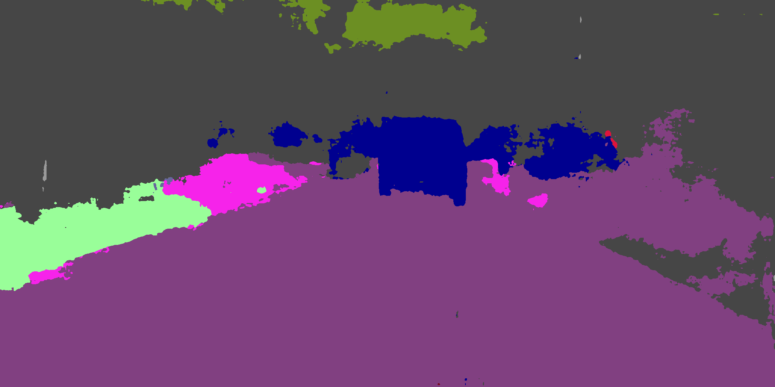  
     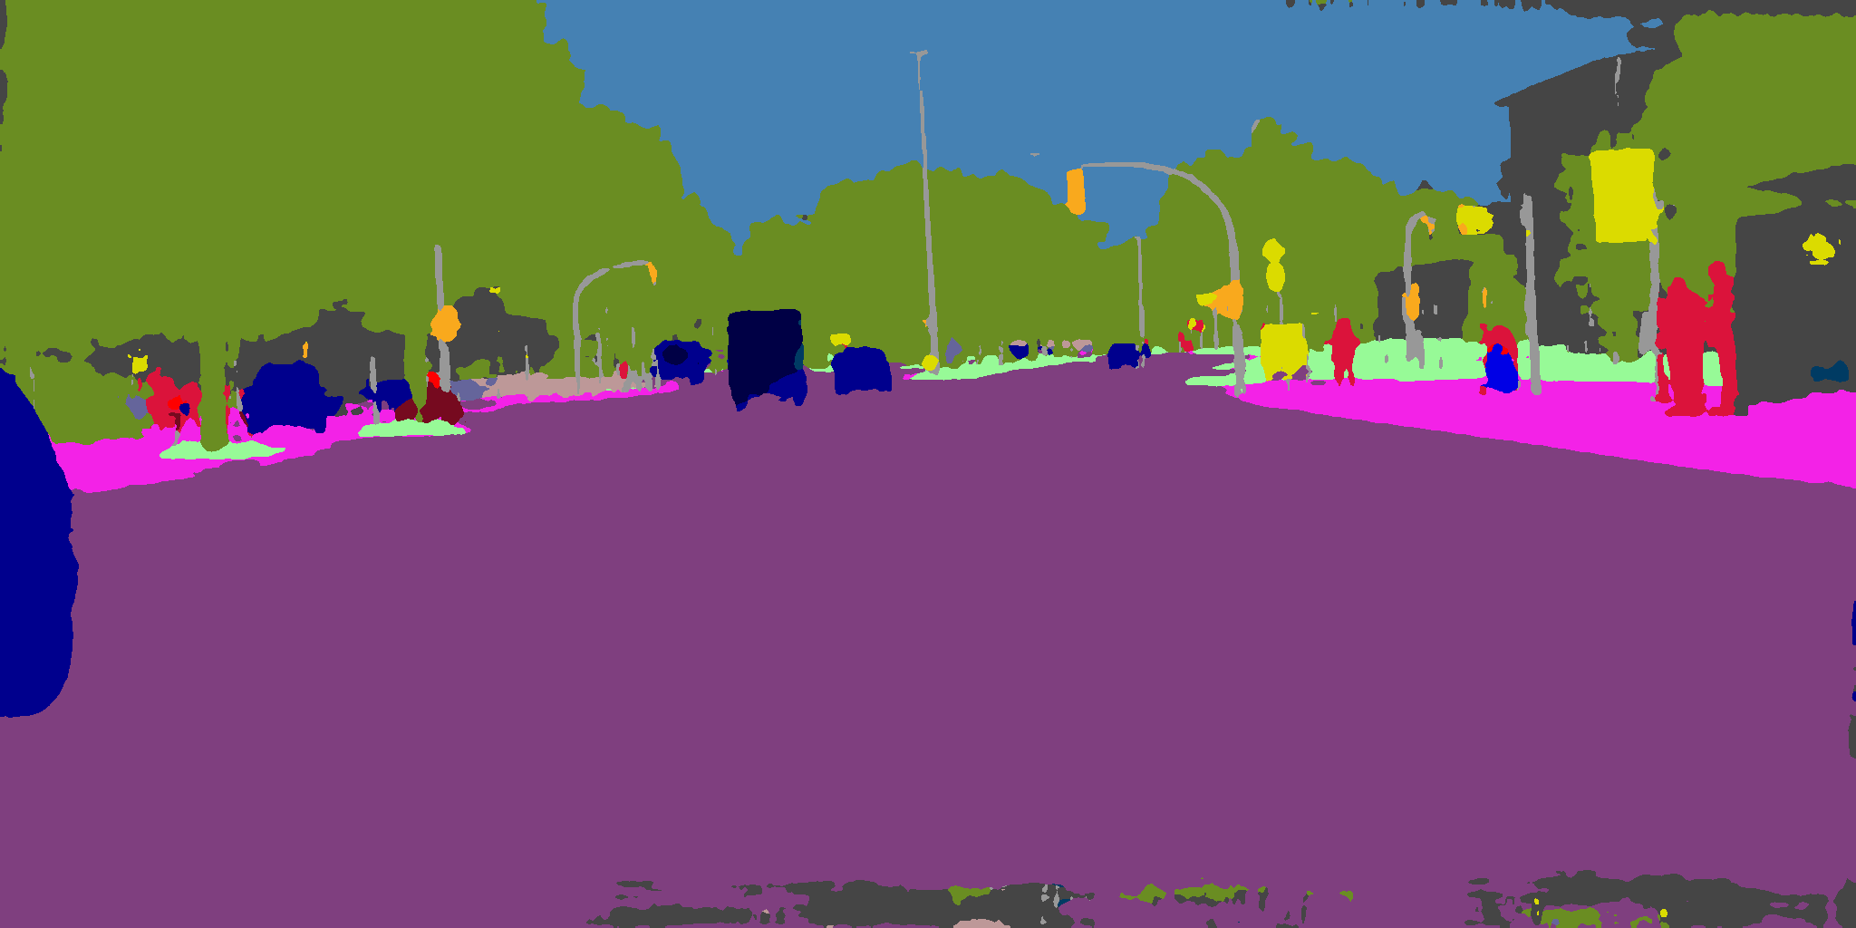 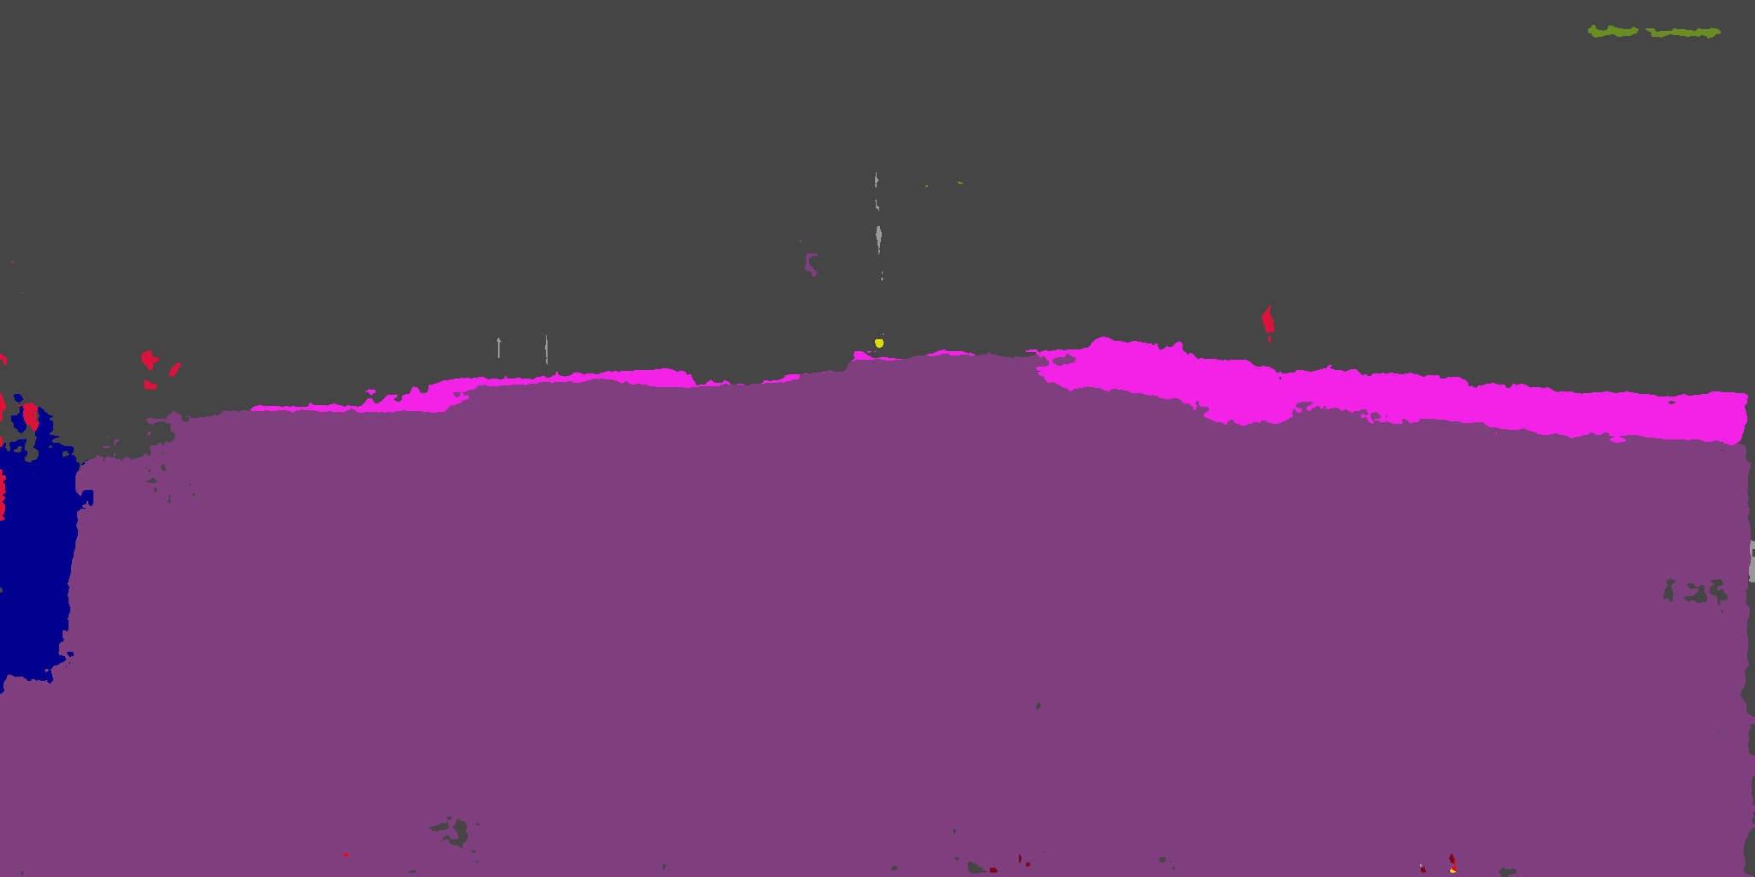  
      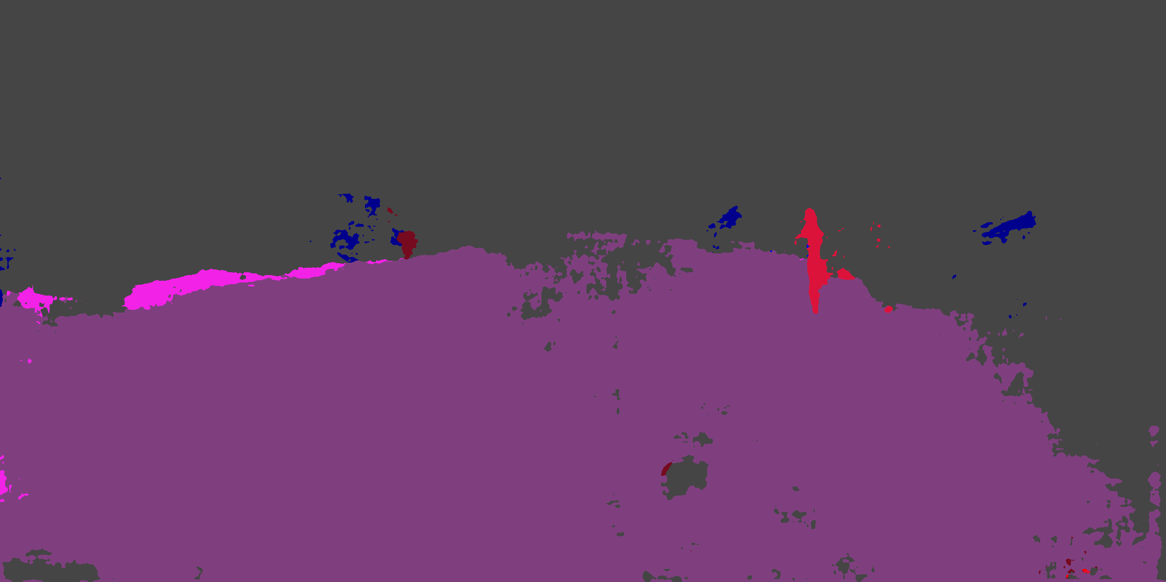  
      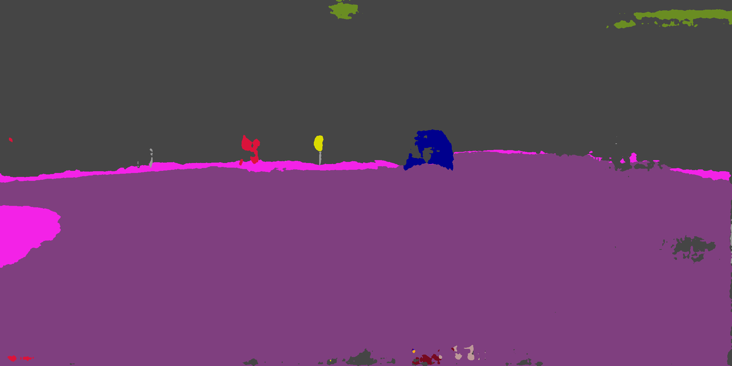  
     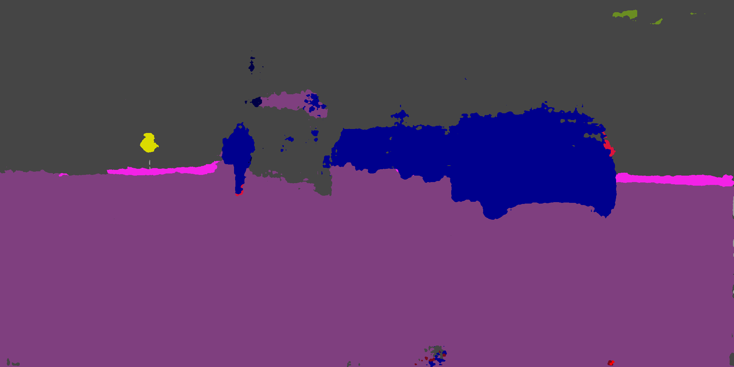   
     This attack exactly proofs our hypothesis. Notice that classes that are more prone to this attack are always the ones which are usually classified by texture, such as vegetation, sky, and sidewalk. Those classes that are usually classified by geometry, such as car and traffic sign, are very robust to this attack.  
     Hence, the first attack which tries to substitute car class to vegetation class is actually a hard problem, partially explaining why it performs poorly for some images.

Algorithm: Universal attack  
Input: target image set: I, perturbation learning rate: PLR, attack stepping rate: LR, number of iteration over I: n, additional parameters for attack: P  
Output: the universal perturbation  
begin

global_pert.initialize()

for iter_time in range(n){

for img in I{

img = img + global_pert

current_pert = attack(img,P)

interpolation(global_pert, current_pert)

}

}

return global_pert

end

* 1. TSV type attack  
     TSV attack setting is a direct generalization to TO type attack which accepts a set of target images instead of a single one. The attacker aims to produce a perturbation, and also specifies a target model. The attacker’s objective is that when adding the perturbation to any image which is sampled from the same distribution as target image set, the model produces a prediction as similar as a pre-defined target mask provided by the attacker. Such attack is useful if the attacker wants to temporarily disable a camera and evade human inspection.  
       
     TS_step32_aLR512_pLR0.06_l1_LW16.00_  
     original mask & final perturbation  
     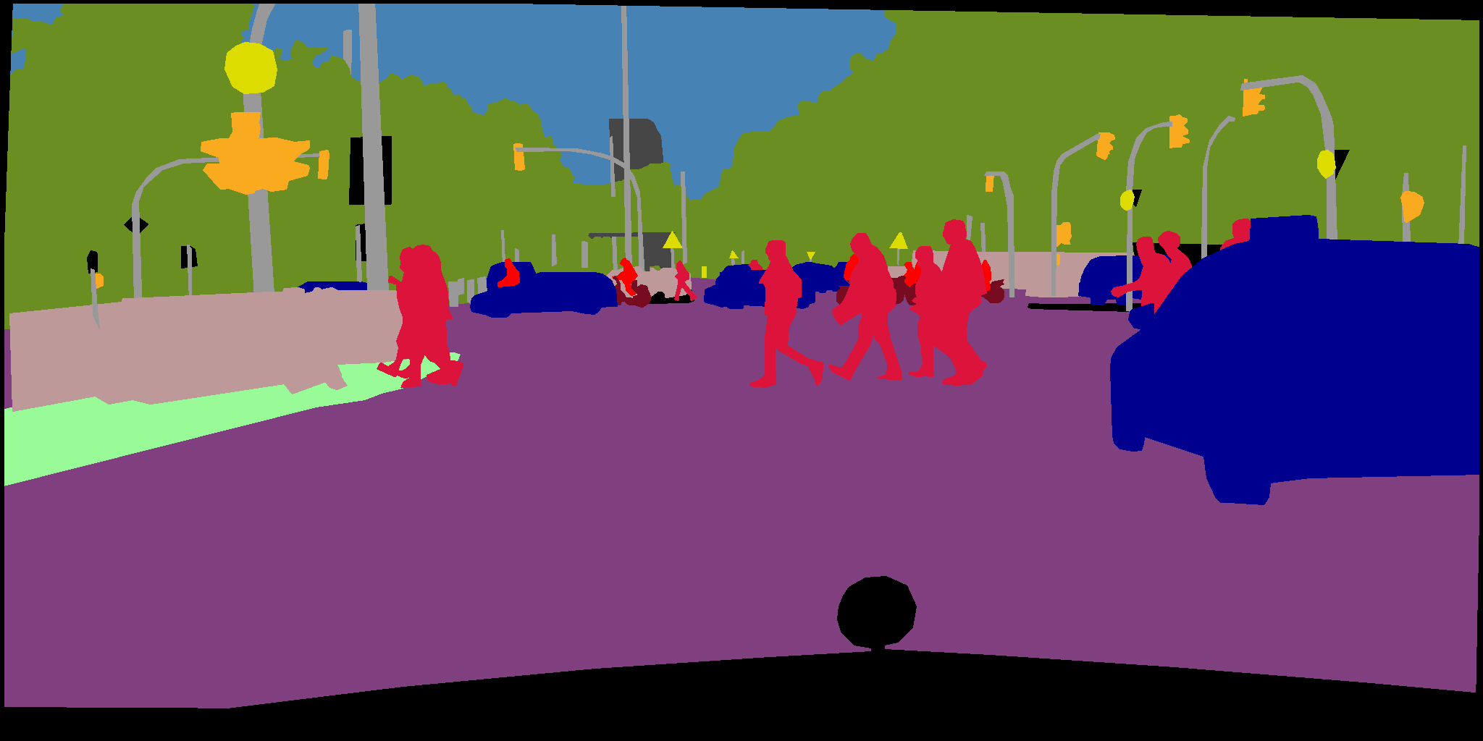 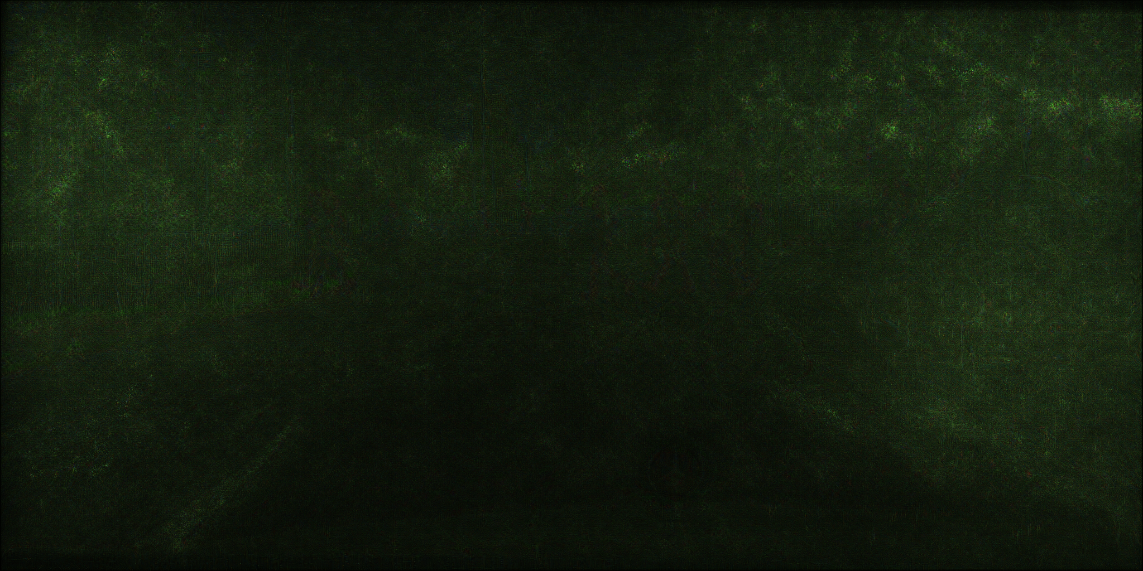  
      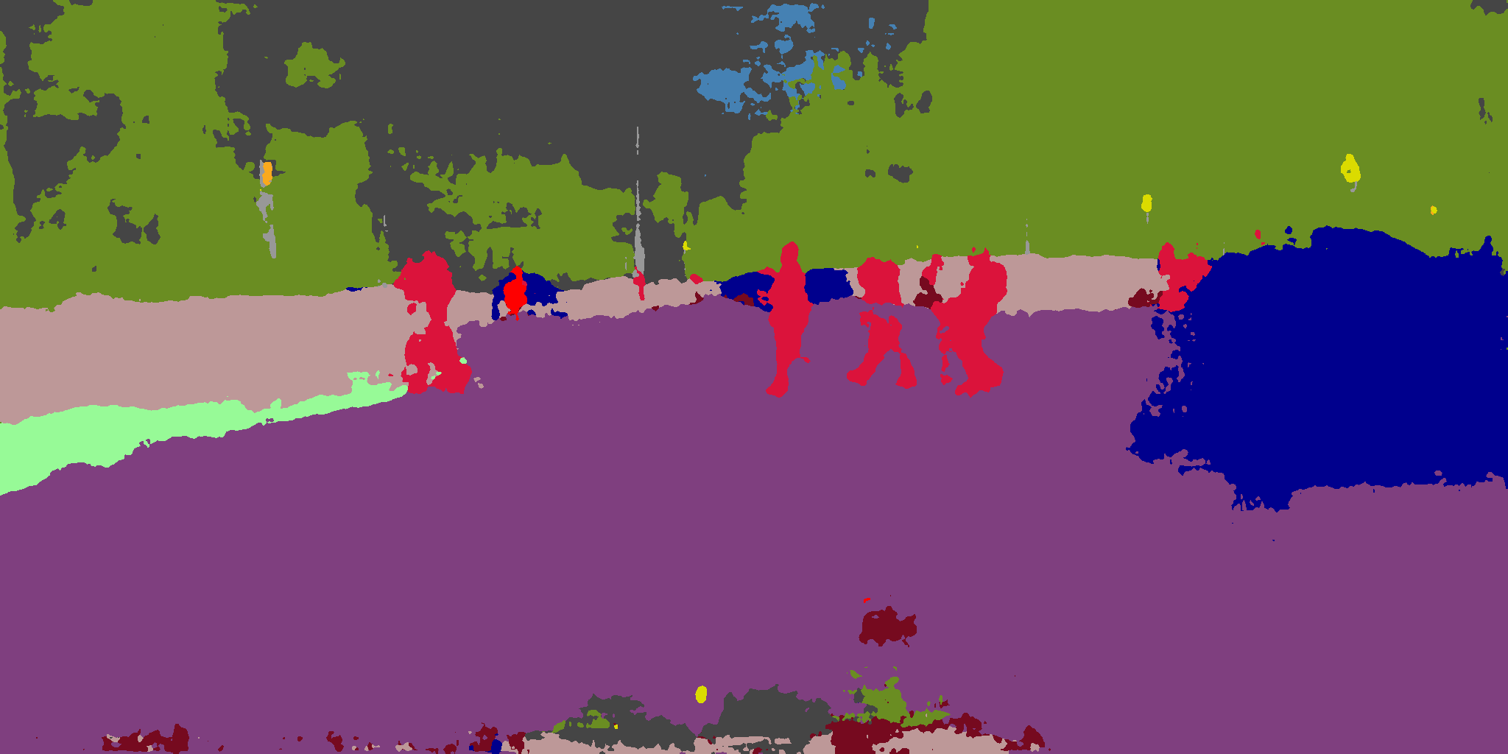  
      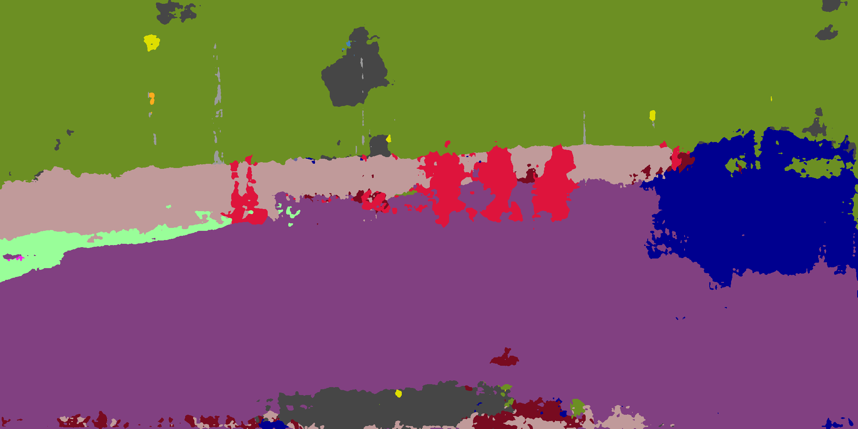  
      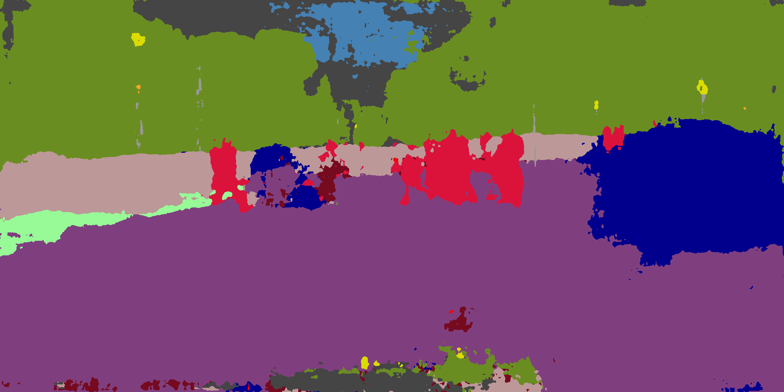  
      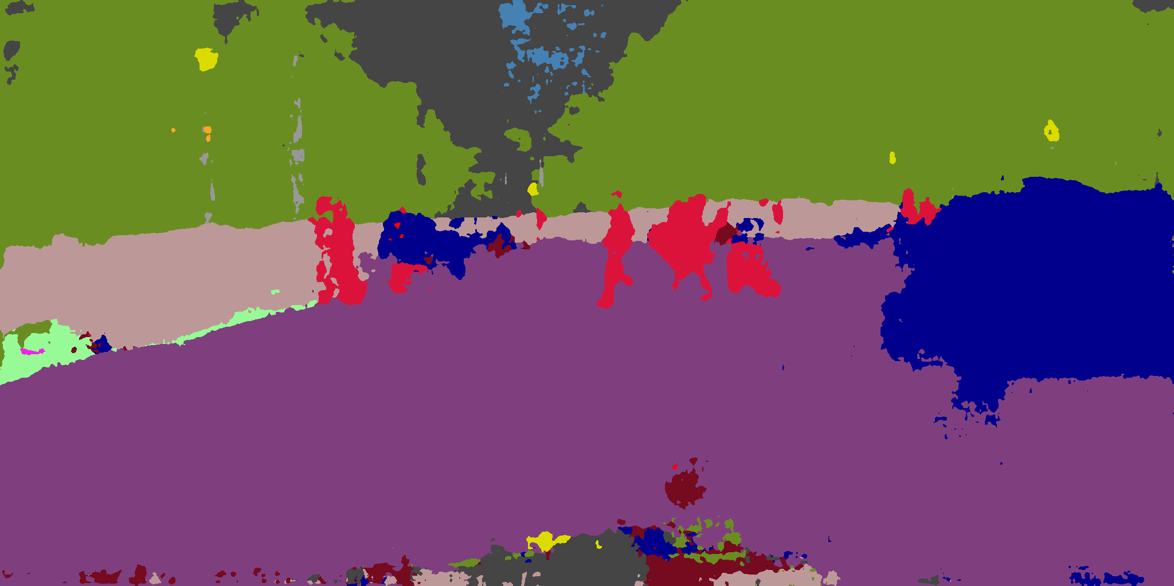  
      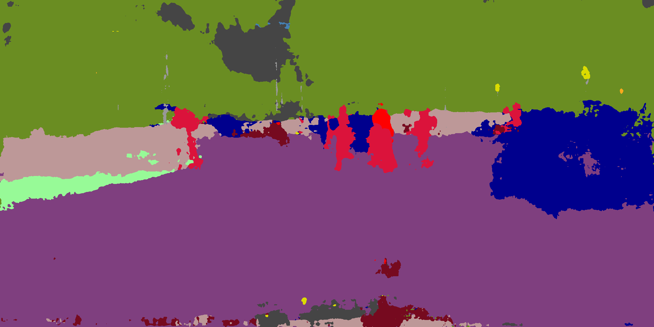  
     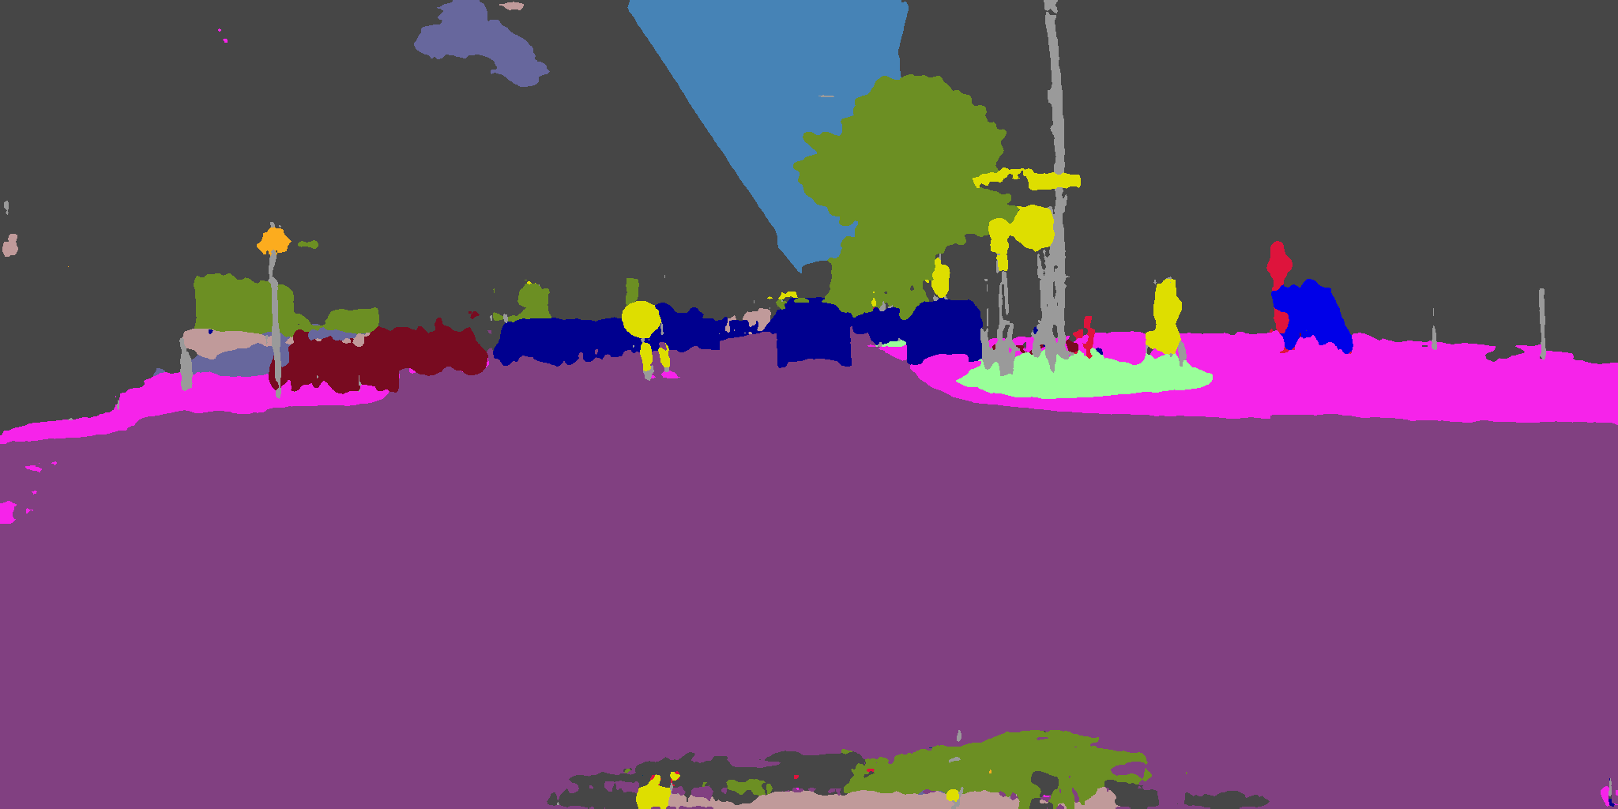 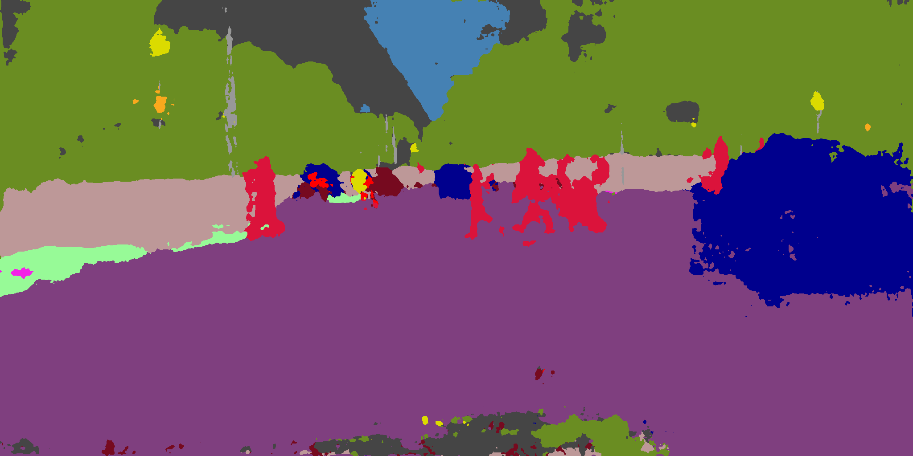  
      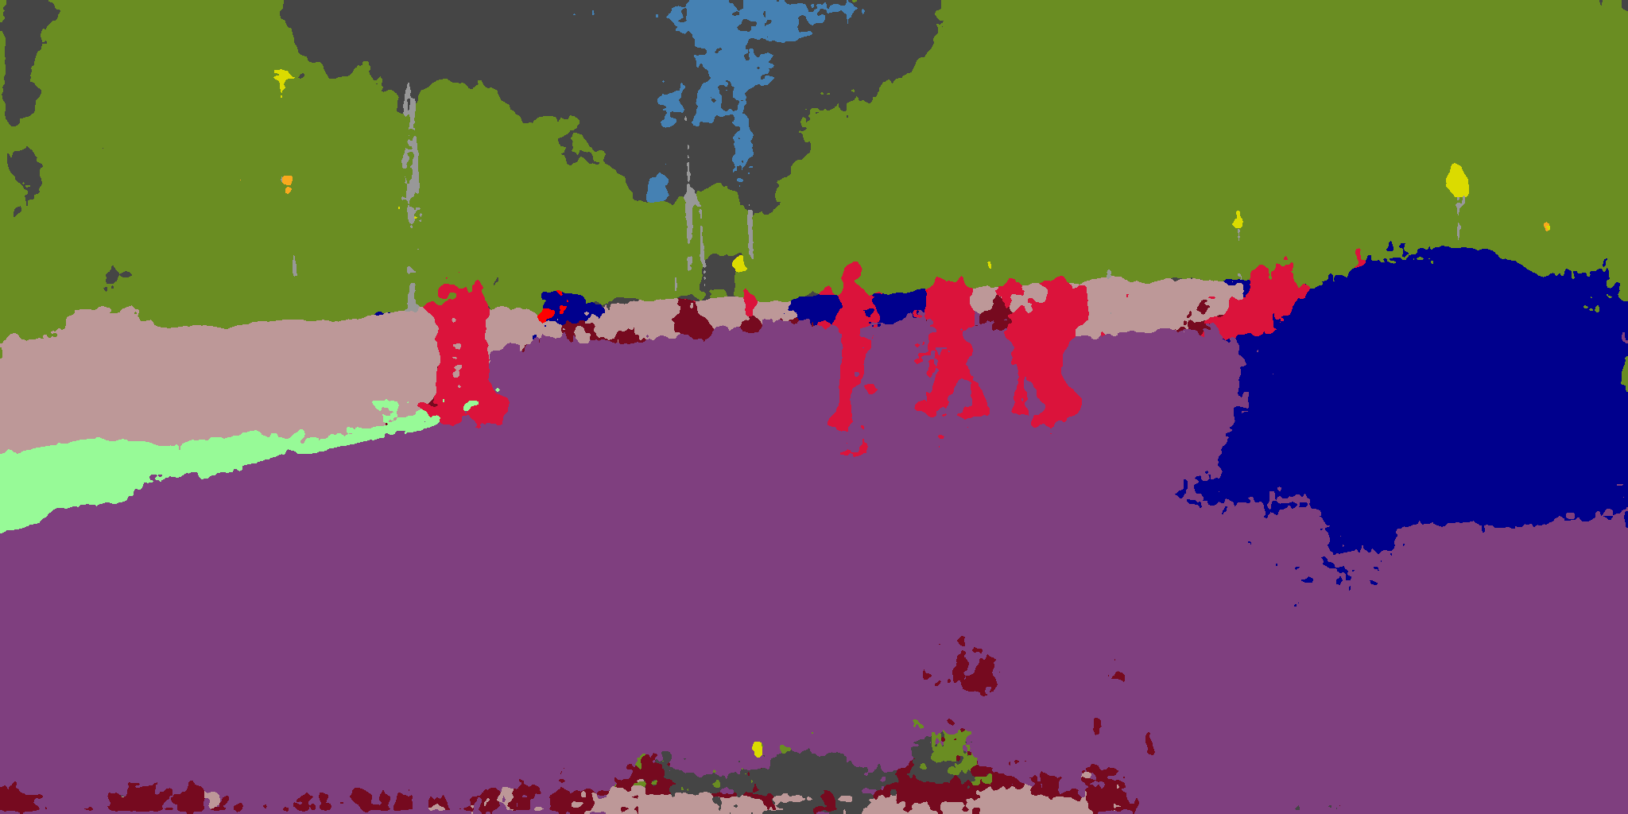  
     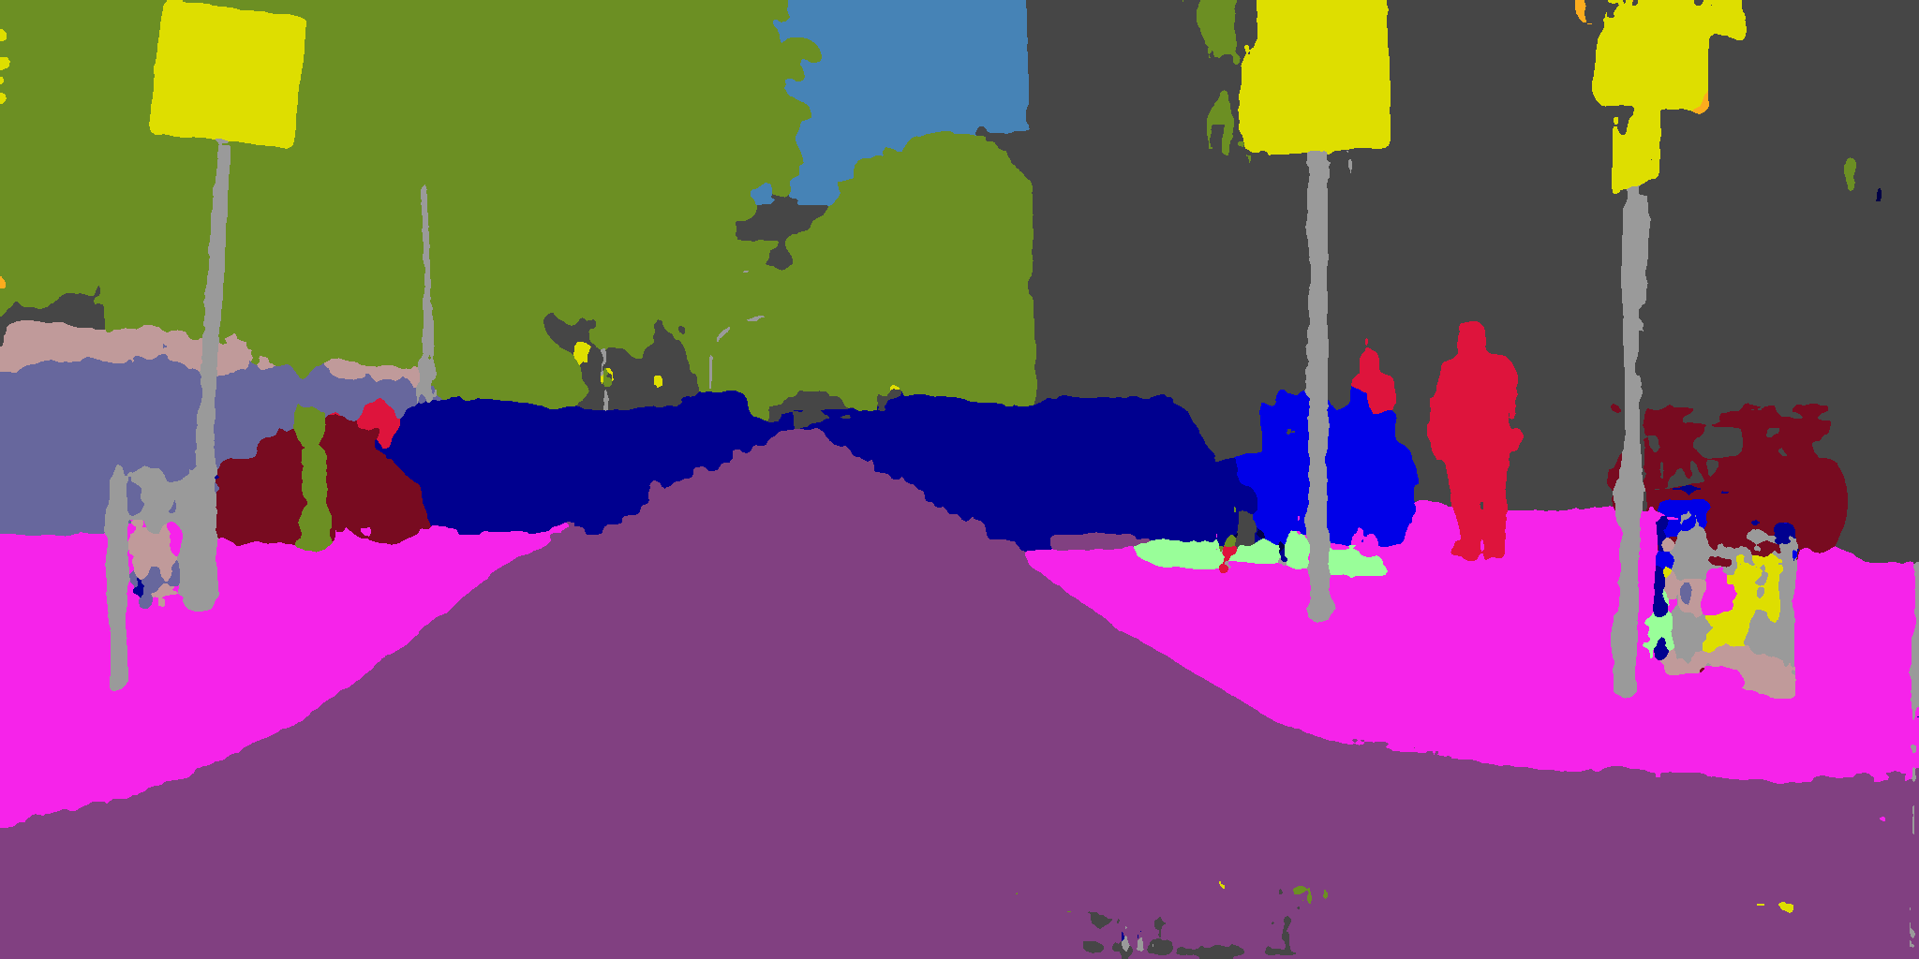 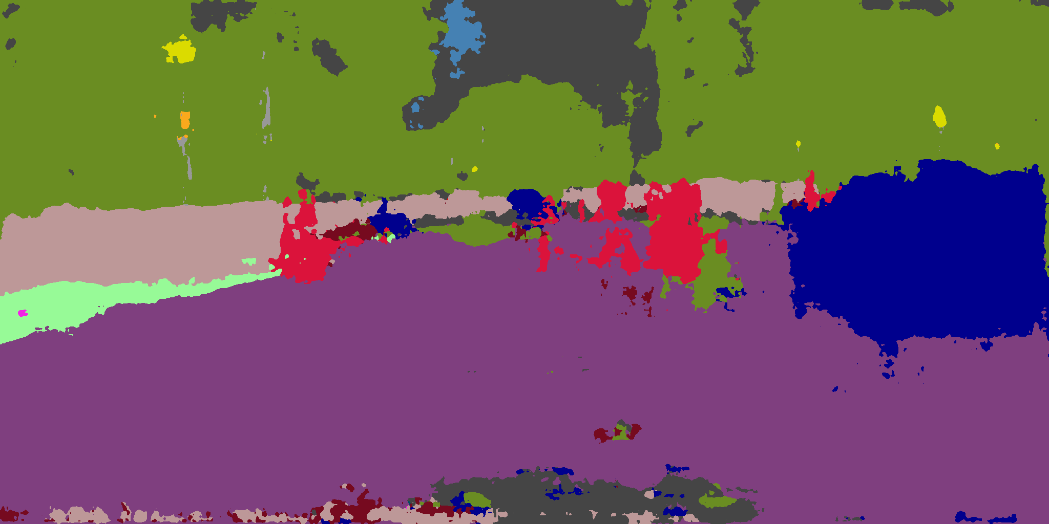  
     this quick result runs for 1758.33 seconds on our machine. We adjust LR to 512 and each attack with 32 iterations, and adopt L1 norm, aiming to quickly find gradient sensitive regions for each image. We iterate this attack on target images only once,  
     further fasting algorithm. Though we use a much smaller set than [19], our marginal speed is much faster than that used in [19].  
     We can see that all perturbed images contain acceptable major structures, and are all similar to target mask. Notice however, that the perturbation fails to introduce some minor structures such as a complete pedestrian or car. We suspect that this is because both our algorithm’s stochastic nature and classified-by-geometry nature of some classes (since we notice that defective structures mostly belong to classes that are usually classified by geometry).  
     Notice that, however, this lightweight attack is far from comparable to [19]. We turn to conduct further attacks and run them to convergence. We tried some other attack settings close to this one. However, we find that this attack setting is near-optimal  
       
     TS_step128_aLR128_pLR0.06_l1_LW16.00_  
      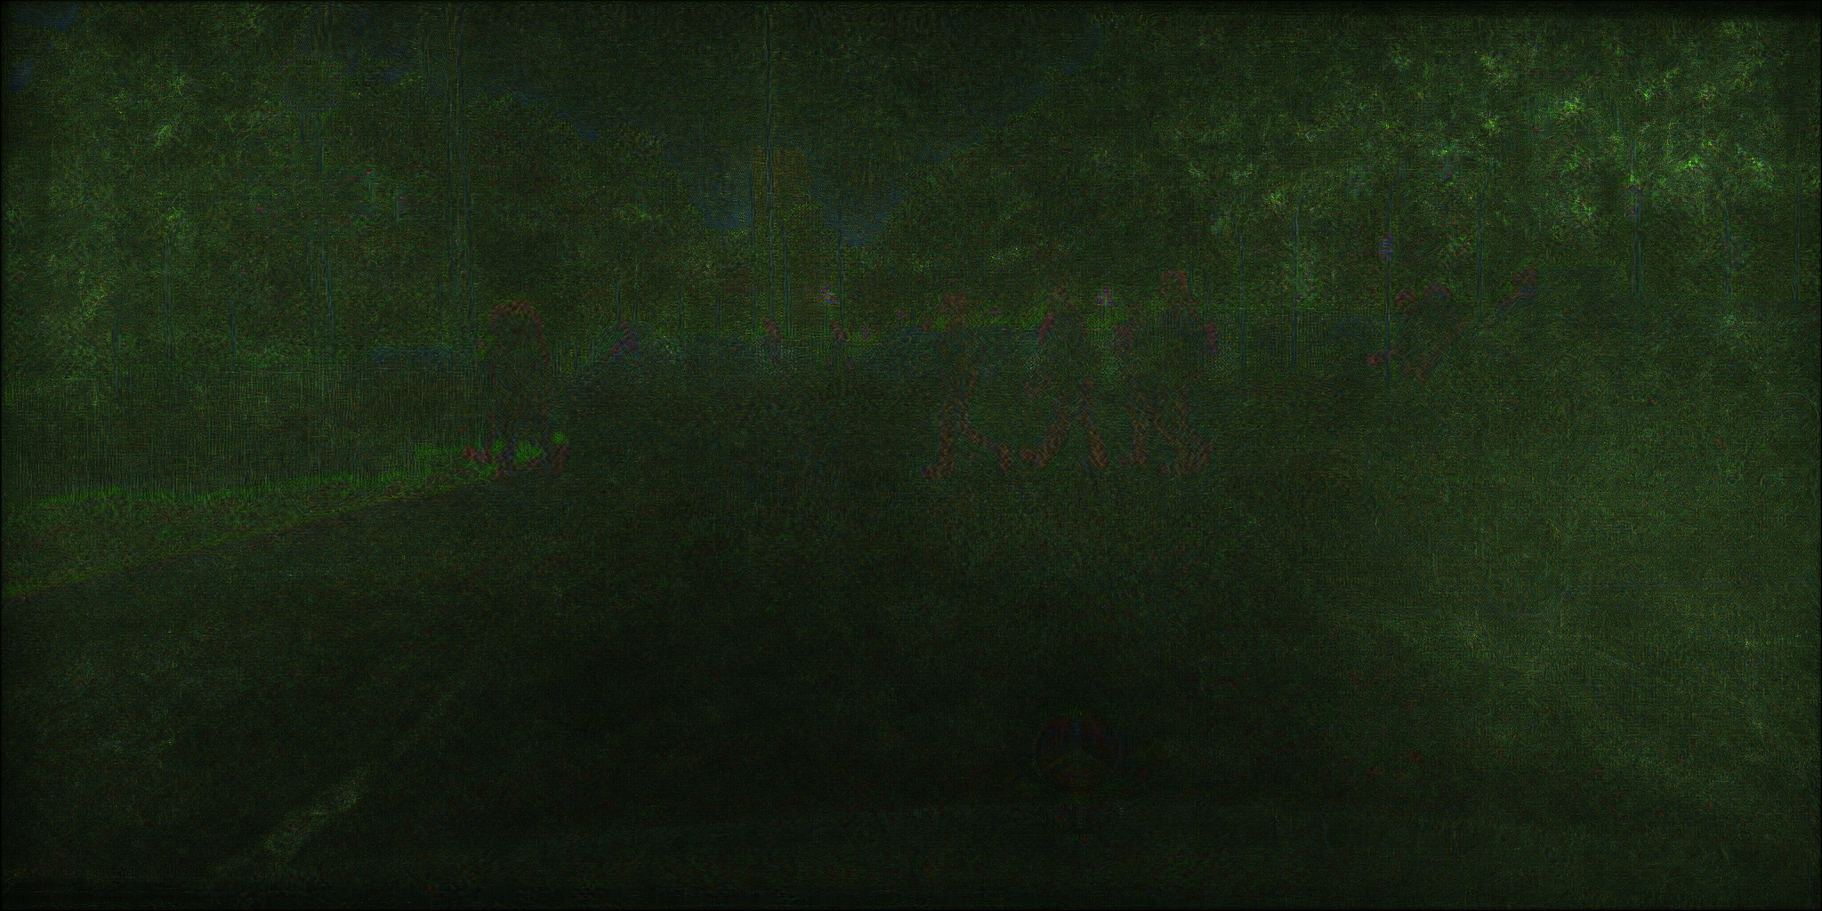  
      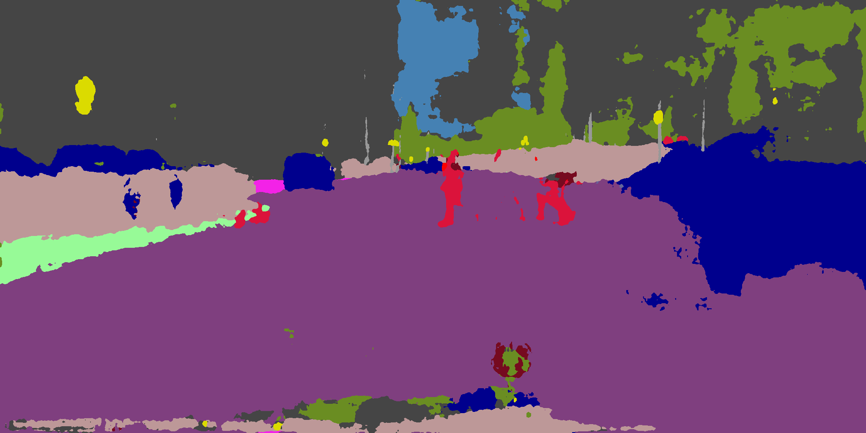  
      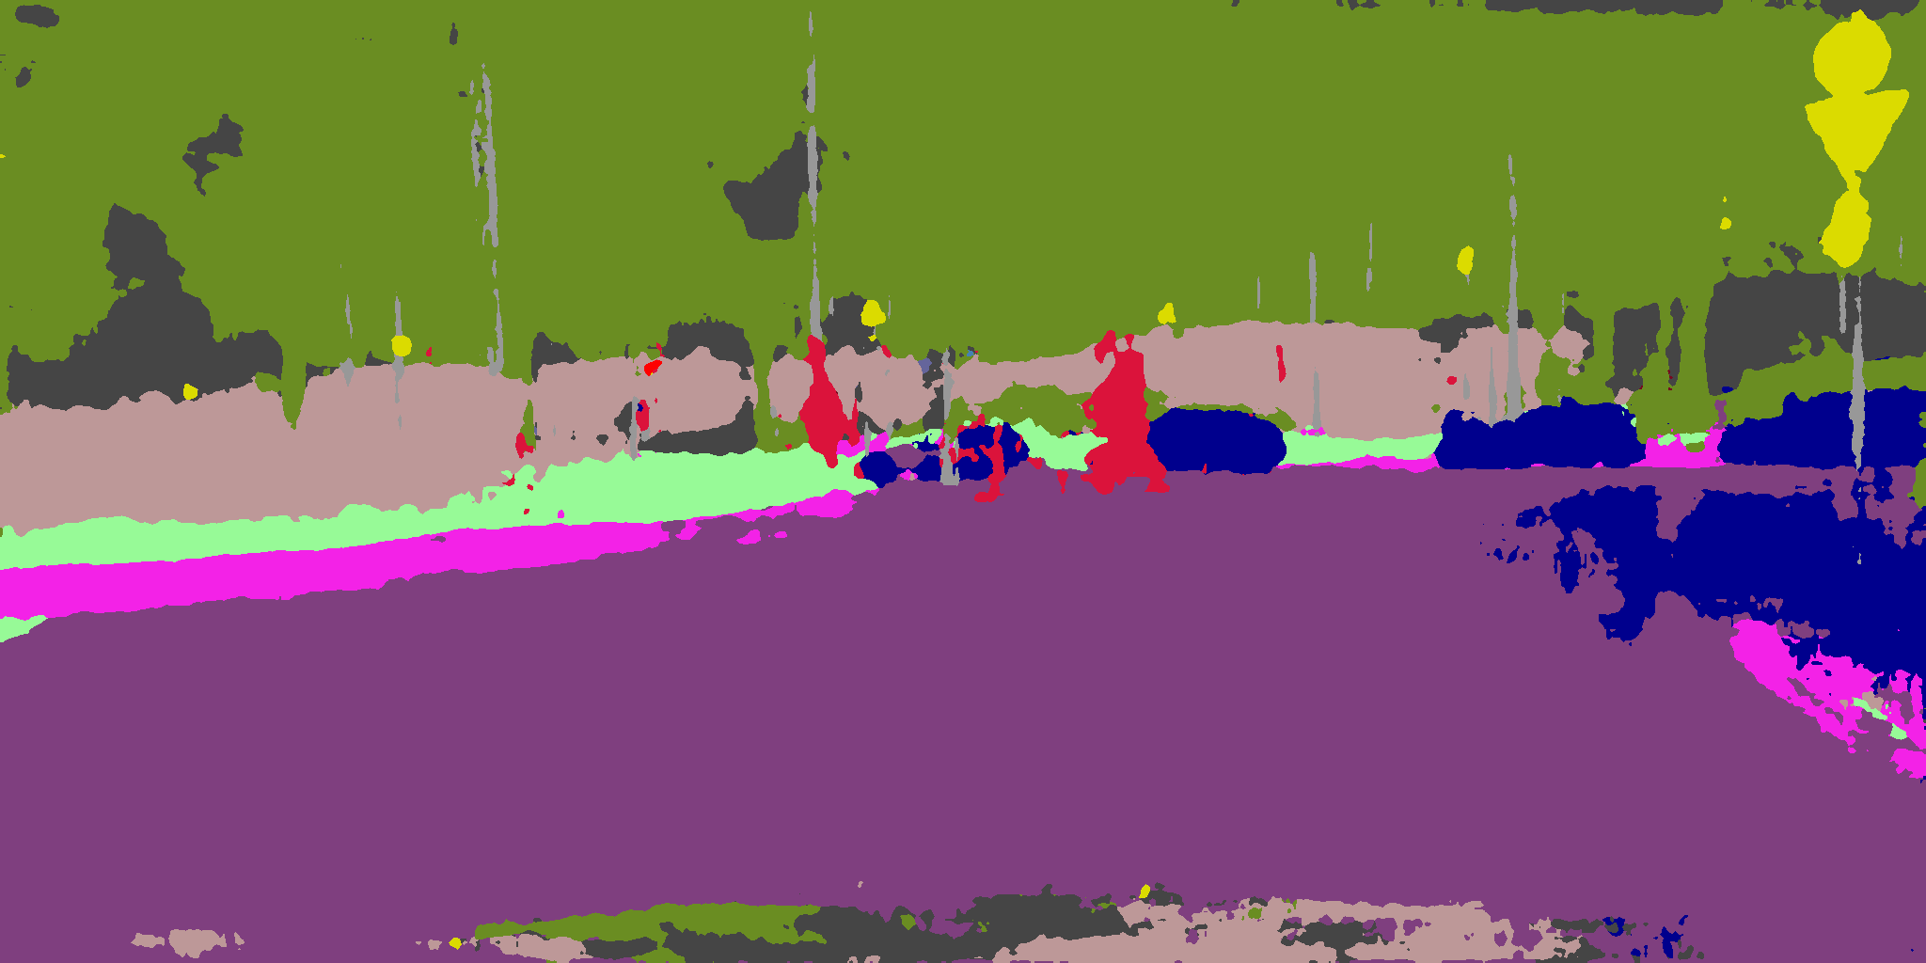  
      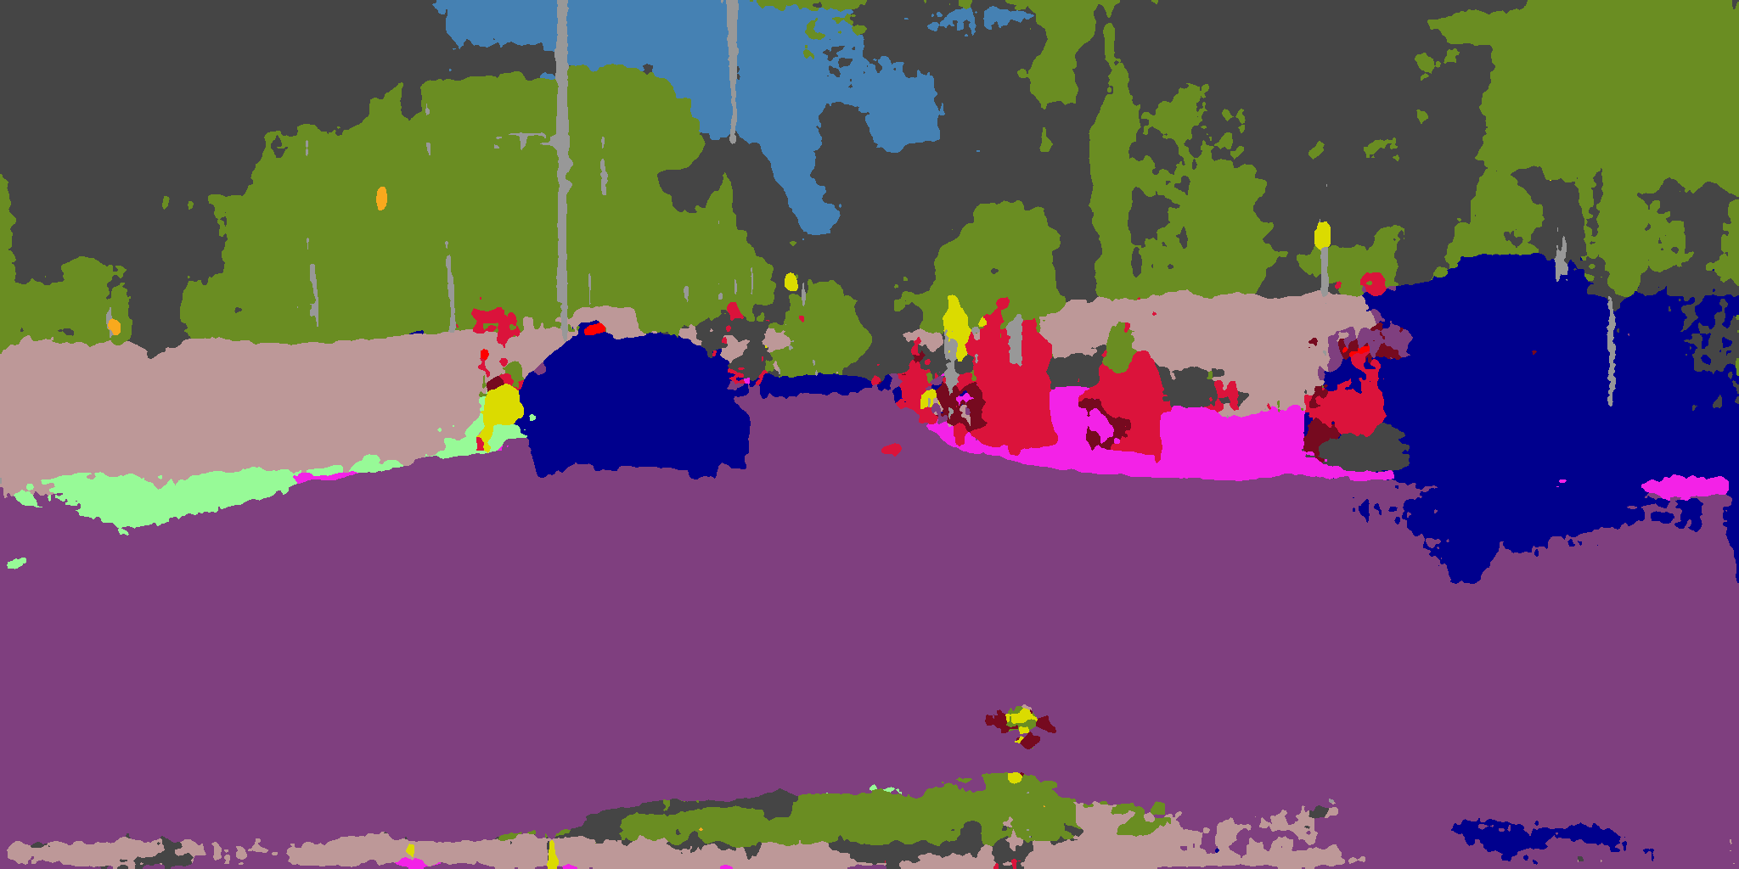  
      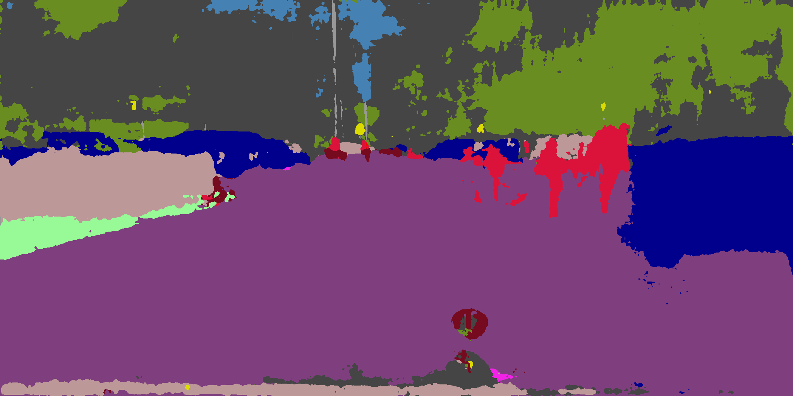  
     During our exploration, we find it interesting that setting iteration steps too high for each single attack can worsen attack performance. We propose a reasonable explanation. The attack with L1 norm always focuses on the most sensitive gradient regions. However, such regions are dynamic during training due to the fact that classification loss has a lower limit. Hence, the attack only focuses on the most sensitive gradient regions at initial stage, and at later stage the attack focuses on other regions instead. At the beginning most gradient intense region corresponds to the misclassified regions, and at later stages it can be artifacts introduced by previous perturbations or unpreserved background. As a result, if a single attack runs for too long, focusing on such local and dynamic regions can ruin effective perturbations introduced by previous attacks.  
     We also propose that our simple implementation as SGD is the main cause of underperforming compared to [19]. Stochastic nature of SGD process can also explain local unstructured artifacts in our attack.

1. **Discussions**

Despite methodologies and experiment progress, there are also some important theoretical reasons that why we select certain methods over others, or why an attack can get acceptable or unacceptable results. There are also some aspects that can only be clear across different attack configurations. Some of significant topics are discussed in this section below.

* 1. Dynamic DAG  
     Section 7.2.5 discussed a DAG that perturbation stepping rate is consistent throughout the attack. However, just any model training with dynamic learning rate (LR), a DAG can also have dynamic stepping rate. Generally, dynamic stepping methods can be categorized into two types by behavior towards convergence, despite their initial behavior:  
     A decrease stepping rate towards convergence.  
     B increase stepping rate towards convergence.  
     Method A looks natural for deep learning model specialists as it involves the same assumption as decreasing LR in model training. As in high dimension non-convex optimization by gradient descent, it is proposed early by Goodfellow et.al. [30] that such objective functions have structures that can cause gradient explosion or vanishing (named as cliffs and plateaus) with high frequency. Proportion of local minima to all points with zero first derivative also decreases. [30] also states that such ill structures appear more frequent in local neighborhood. Hence a non-decreased learning step can step too far from a cliff and void a large portion of existing utilization steps. Since cliffs and plateaus are natural characteristics for high dimensional functions, it make sense for an attack to adopt this assumption.  
     Method B is a reversed version of method A, which has a completely different starting assumption. Current deep models are hypothesized [31] to have decision boundaries as manifold boundaries. In high dimension manifolds, a point on manifold usually has only a small distance to its decision boundary [29] which is asserted as a natural reason for adversarial example existence. Hence method B can be viewed with two hypothetical purposes:  
     * At first, find the right direction to evade original manifold, or approach target manifold, with small steps. Increase the step gradually such that the right stepping direction is more likely to be found towards convergence.  
     * Act as a fast convergence method. Since attacks deal with existing manifolds but not to construct them as if model training, an attack is unlikely to suffer slow convergence problems. Meanwhile, a small stepping can prevent partial divergence well. When adding stepping later on, this facilitates attacking process in both cases of evading original manifold and approaching target manifold.  
     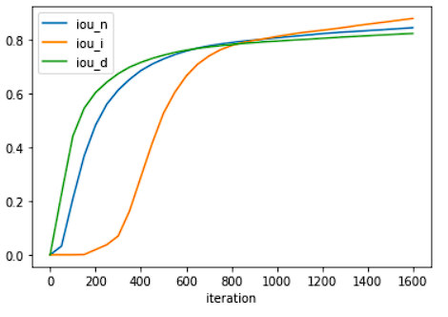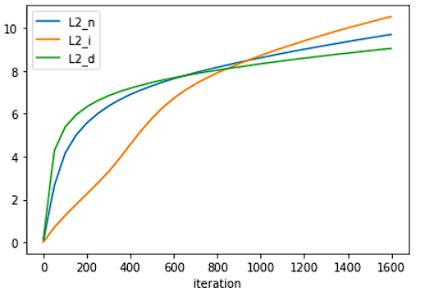  
     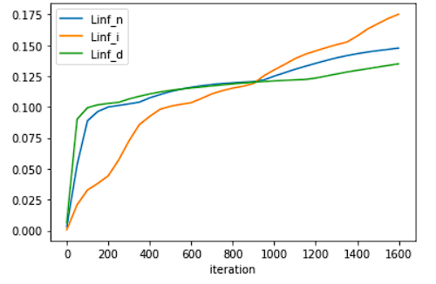  
       
       
     By empirical evidence from our experiment, for a fixed input sample, there is slight performance difference if we run all three settings (increase, decrease, none) to convergence, and difference in perturbation can be visually spotted. We notice that during initial stages of attacks, a larger stepping indeed leads to fast convergence. We notice that for each stepping method there is a period where IOU increases at highest speed throughout the attack. We notice that a large initial stepping rate leads to early rapid increase of IOU. Hence, we assert that the manifold assumption can be more reasonable under this attack setting. We notice that towards convergence IOU tends to increase with linear speed proportional to stepping, which is interesting phenomenon that cannot be well explained under manifold assumption. Furthermore, we argue that this slight convergence performance difference can be caused by deterministic nature of gradient of a fixed sample, compared to model training where samples are sampled on the fly and non-deterministic.
  2. Discussion about segmentation results produced with a mask  
     Though clearly, a mask can decrease performance compared to the same setting without a mask with proper attack optimization, many tasks which concern other objectives such as stealthy under inspection or physical realizability employ a mask by requirement. In this section we discuss how a mask affects attack performance and how the mask forces the perturbation to fulfill additional requirements.  
     Surprisingly, a mask can have various kinds of effects on the objects exerted. Here are a few quick examples on different effects of a mask:  
       
       
     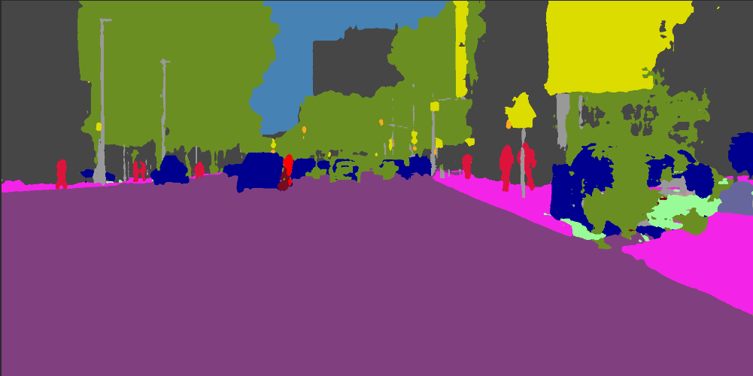  
     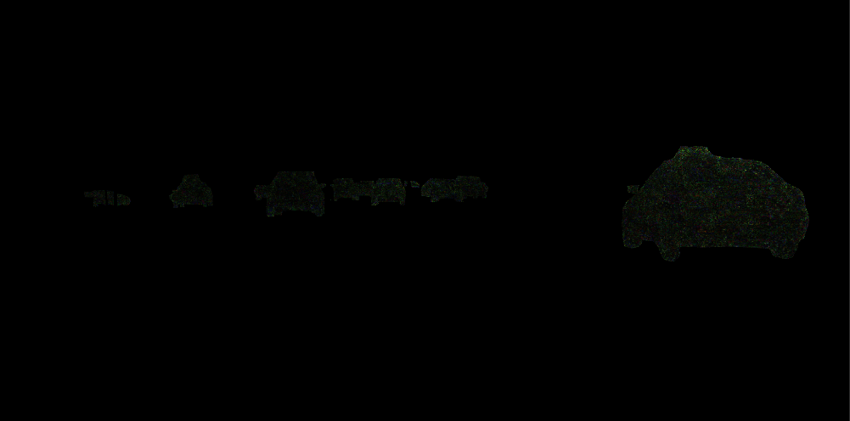  
     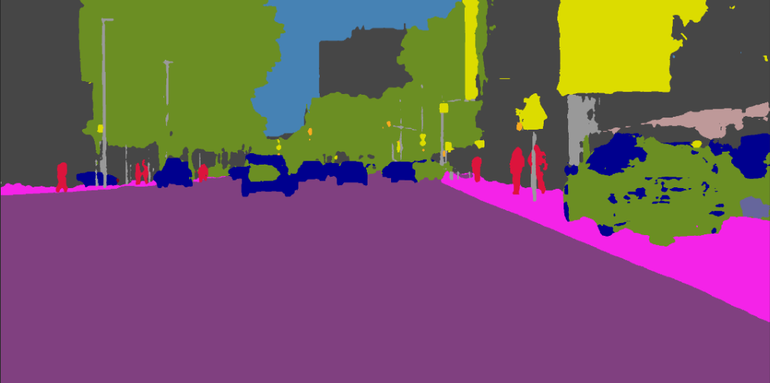  
     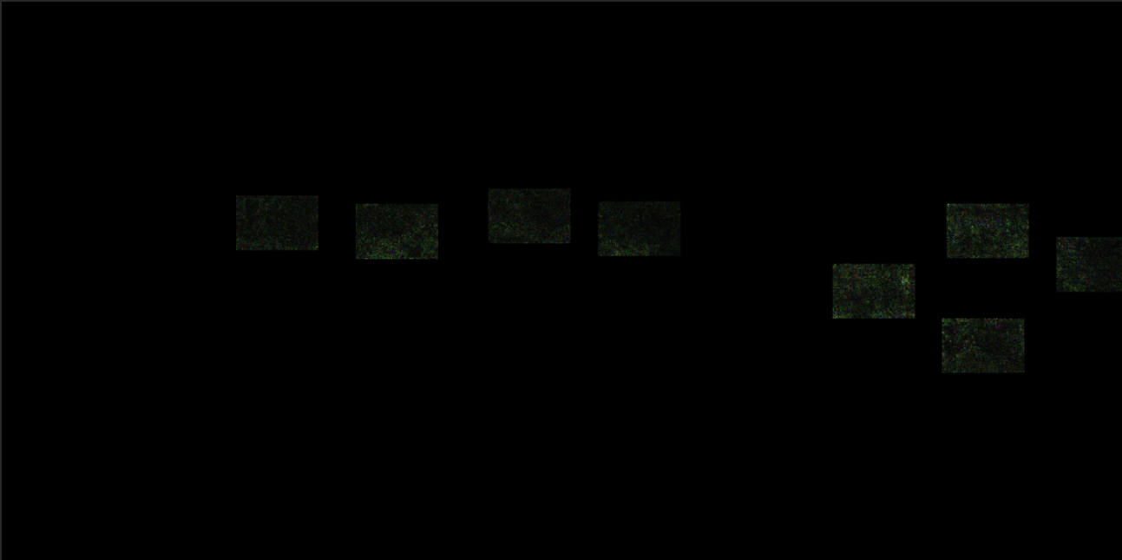  
     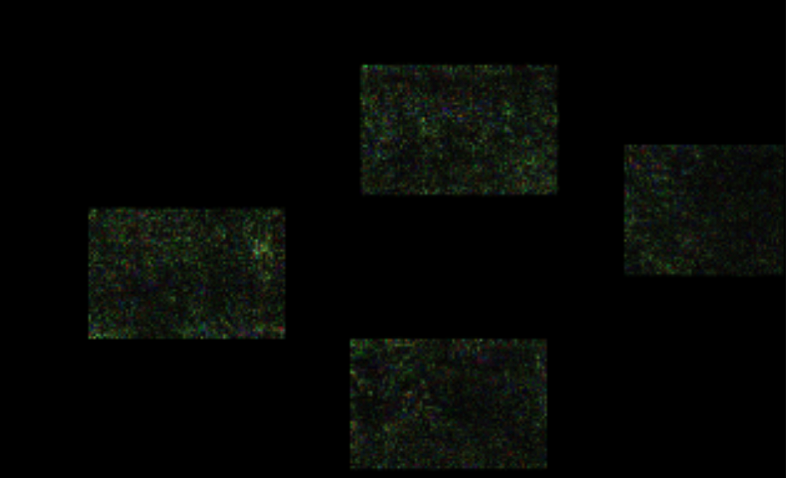  
     In [Fig], a mask covers all car pixels to perform a hiding attack, and the attack runs near convergence. The final perturbation preserves the background well, though in optimization loss we do not specify preserving background as a loss term. However, in [Fig], a mask is exerted partially on the rightmost car, and the perturbation not only introduce externality (substituting car to vegetation) within original car pixels that are outside of mask but also introduce externality for non-car original pixels that are outside of mask. Such non-homogeneous behavior of masks imposes difficulty to explain them. We propose a few hypotheses about how masks can behave in this way.  
     * A mask indeed limit perturbation capability compared to an unmasked attack. This is the natural consequence that manipulating more pixels cannot make the optimal solution worse.  
     * A masked perturbation’s capability is independently determined by gradients provided by pixels inside the mask. We propose that the gradient is its essential cause, and the mask is only a hard constraint on gradient. In this case, constant pixels outside the mask acts as a “wall”, where if gradient descent bumps into the wall, it is clamped. Furthermore, if the mask contains the most local gradient sensitive region, the attack is likely to be more effective, just as [fig] shown.  
     * Classification of a pixel relies more on other pixels within the same semantic structure compared to other pixels. This phenomenon should be stronger for classes that are usually classified by geometry. This assertion also partially explains why in [fig] the perturbation substitutes more car pixels that are outside the mask to vegetation compared to all out-of-mask pixels, and why in [fig] a large region of building is substituted to vegetation.  
       
     We understand that there can be a much larger set of attack cases which can use a mask and a mask can have many methods to be selected. We thus have no way to thoroughly discuss about masking effects. However, with these discussions, we hope that such explanations fits into our project and can be used to explain important facts.
  3. Discussion for why substitution/hiding attack works the best when both original and target class are singular  
     Section 9.1 states that there are two basic assumptions towards deep model training which is also applicable to adversarial attacks. Here we further extend these assumptions and develop our hypothesis about why original and target class are singular works the best through all class mapping configurations. For convenience and clarity, we denote the set of original class(es) as Co, and the set of target class(es) as Ct.  
     There are some common facts about simultaneous gradient descent optimization for multiple objects (in this case, pixels). It is proven by multiple cross-referring sources e.g., [19] such that during a simultaneous update step, an object’s optimization direction can contradict with neighborhood optimization direction. As a result, after a gradient step, the gradients from an object-neighbor object pair can keep unchanged (since their updates cancel each other for this interactive pair component at this step), effectively voiding gradient update for this pair and introduce perturbation. Given that the model is in very high-dimensional space and selection of any neighbor objects with $O\left(n^{2}\right)$ complexity, gradient contradiction between some pairs of neighbors seems often. Furthermore, if for a pair of contradicting neighbor, one of two objects is updated while keeping optimization direction mostly unchanged, the other object is thus “starved” from getting updated by the first pixel, which turns out to be a long-time issue.  
     Notice that it is impossible for the case that Co is singular while Ct is not singular, since the mapping from Co to Ct is a function.  
     So first, assume that Co is not singular while Ct is singular, as case A. Under the manifold assumption, this is equivalent to having multiple starting points which are on different manifolds. Though in high dimension spaces manifolds are expected to have less minimum distance compared to in low dimension spaces (due to the fact that as dimension goes high a ball has its volume more concentrated towards its center), by giving two randomly sampled point from each, we expect they have higher expected distance compared to two sampled point from the same manifold. Hence, during optimization process towards a single target manifold, a pair of objects have greater chance of suffering from illness gradient structures of classification space. If any of such illness structure is revealed, this pair of objects equivalently do not contribute to each other significantly during gradient descent. Given that the chance of gradient conflict becomes higher for non-singular Co, optimization on non-singular Co more likely converges to sub-optimal solutions.   
     Furthermore, the assumption of local illness structures can also partially explain our conclusions. A plateau can temporarily void out almost all gradient contribution for points on it, and a cliff can destroy existing optimization works for both the object itself and neighbors, since cliff direction is often random. Because at each step the stepping length is normalized, if most points are under a single/few illness structure(s), the structure(s) would not cause update problems thanks to normalization. However, if only a fraction of neighbors suffers from illness structures, normalization cannot help such local gradient vanishing or explosion. Starting from points with greater distances in classification spaces increase the chances of local illness structures.  
     Second, assume that Co and Ct are both not singular, as case B. Here if any of two classes in Co maps to the same class in Ct, this local part is the first case and can suffer from the same interaction problems. We consider that Co to Ct is one-to-one and onto mapping instead. Under the same assumption as case A, two neighbor objects can have contradicting gradient descent directions. Furthermore, this pair are likely from two different classes, because two objects from a same original class have the same target class manifold and have expected least expected encoding distance across all object sampling pairs (since they are on the same manifold). Hence, two objects from the same original class tend to have high cosine similarity score, and two objects that have contradicting gradients tend to be in different classes. What is worse, a contradicting pair can have high gradient contribution for each other as neighbor (such as on pixel class boundaries, as a boundary between car class and building class). This can mostly void gradient update for this component as same reason stated in case A (the difference is that in this case, objects have different target class.).  
     Based on case-by-case discussions, if for each step the base value of stepping is the same for any of candidate objects, we assert that the setting with both singular Co and Ct is expected to have the maximum gradient update efficiency under our configuration.
  4. Selection of L1 and L2 norm  
     L1 and L2 norms are the two most commonly used and probably most important norms in deep model training. Since our attacks have a large set of assumptions for encoding spaces that is also valid in model training, it is interesting and important to explore
     1. L1 and L2 norm, near convergence  
        As per experiment section 8 shows, L1 and L2 norms performs both statistically and visually similar. In terms of IOU, pixel accuracy, and L2 norm, their difference is negligible compared to their absolute values. However, they can have noticeable difference in terms of Linf norm. We notice that such difference is much more significant if a mask is not provided. Hence, such difference can because of:  
        * Multiclass gradient optimization. If a mask is provided, pixels within the mask are more likely to have a uniform class or a small set of classes. Hence, their gradient descent directions are more deterministic compared to multi-class gradient descent, which is expected to have higher chance to encounter random local structures on loss updates.   
        * Non-differentiable nature of Linf norm. Linf norm is equivalent to Max() in terms of value. Linf norm itself is non-differentiable. One of its smooth versions, SoftMax, is differentiable, yet is rarely used multiple times in loss computations since it can easily introduce gradient vanishing or explosion. What is more, Linf and L1 have different gradient directions almost everywhere (except near axles) thus are naturally distinctive. Meanwhile, L1 norm and L2 norm can have expected gradient direction cosine angle smaller if dimension goes higher (thus they are much similar than L1-Linf pair.). It is thus reasonable such that a smooth pattern in L2 maps to a chaotic ascending pattern in Linf.
     2. L1 and L2 norm, initial attack stages  
        Though in our experiment, even by human inspection, L1 and L2 norms create perturbation that quite similar to another, and despite the fact that they have similar statistic performance, they are proven to have different impacts at initial stages by multiple existing works. One work that inspires us is [18], where the authors asserted that L1 is efficient in finding the regions where the gradients are the largest. This is because as long as the sum of perturbation is unchanged, L1 loss keeps unchanged. Meanwhile, L2 norm penalizes pixels with spike with square complexity and thus encourage a smoother result. In such way, an attack with L1 norm can focus on gradient sensitive regions to exert perturbation. However, though the effect of L1 is insignificant in our experiment, we do observe that L1 can create perturbations with higher contrast and higher performance at early stages.

1. **Conclusions**

This FYP report introduces a modularized adversarial attack pipeline on segmentation tasks, and a white-box attacking capability. This pipeline supports most common adversarial attacks on segmentation, including targeted one-time attack, untargeted one-time attack, static universal attack, and targeted dynamic universal attack. This report also examines performance of different attack configurations and provides brief illustrations, explanations, and hypothesis. We conduct lightweighted attacks for such evaluation purposes, and proposed further directions for attacking processes. We also discussed about details and further works of some attack components in both experiment and discussion section. We thus prove that our pipeline is an initial attempt to integrate and modularize attacks on segmentation attacks. We believe that our project can provide some convenient and efficient basic tools for research and education in this area.

**References**

|  |  |
| --- | --- |
| [1] | "Autopilot and Full Self-Driving Capability," Tesla, [Online]. Available: https://www.tesla.com/en_eu/support/autopilot. [Accessed 13 1 2023]. |
| [2] | Baidu, "Apollo Auto, An open autonomous driving platform," [Online]. Available: https://github.com/ApolloAuto. [Accessed 13 1 2023]. |
| [3] | "Waymo home page," Waymo, [Online]. Available: https://waymo.com/?ncr. [Accessed 13 1 2023]. |
| [4] | C. Szegedy, I. Goodfellow, W. Zaremba, I. Sutskever, J. Bruna, D. Erhan and R. Fergus, "Intriguing properties of neural networks," 19 2 2014. [Online]. Available: https://arxiv.org/abs/1312.6199. [Accessed 13 1 2023]. |
| [5] | N. Carlini and D. Wagner, "Towards Evaluating the Robustness of Neural Networks," 22 3 2017. [Online]. Available: https://arxiv.org/abs/1608.04644. [Accessed 13 1 2023]. |
| [6] | A. Athalye, N. Carlini and D. Wagner, "Obfuscated Gradients Give a False Sense of Security: Circumventing Defenses to Adversarial Examples," 31 7 2018. [Online]. Available: https://arxiv.org/abs/1802.00420. [Accessed 13 1 2023]. |
| [7] | U. Ozbulak, A. V. Messem and W. D. Neve, "Impact of Adversarial Examples on Deep Learning Models for Biomedical Image Segmentation," 30 7 2019. [Online]. Available: https://arxiv.org/abs/1907.13124. [Accessed 13 1 2023]. |
| [8] | C. Xie, J. Wang, Z. Zhang, Y. Zhou, L. Xie and A. Yuille, "Adversarial Examples for Semantic Segmentation and Object Detection," 21 7 2017. [Online]. Available: https://arxiv.org/abs/1703.08603. [Accessed 16 1 2023]. |
| [9] | A. Bochkovskiy, C.-Y. Wang and H.-Y. M. Liao, "YOLOv4: Optimal Speed and Accuracy of Object Detection," 23 4 2020. [Online]. Available: https://arxiv.org/abs/2004.10934. [Accessed 16 1 2023]. |
| [10] | X. Pan, J. Shi, P. Luo, X. Wang and X. Tang, "Spatial As Deep: Spatial CNN for Traffic Scene Understanding," 17 12 2017. [Online]. Available: https://arxiv.org/abs/1712.06080. [Accessed 16 1 2023]. |
| [11] | R. P. K. Poudel, . S. Liwicki and R. Cipolla, "Fast-SCNN: Fast Semantic Segmentation Network," 12 2 2019. [Online]. Available: https://arxiv.org/abs/1902.04502. [Accessed 16 1 2023]. |
| [12] | "The Cityscapes Dataset," Cityscapes Team, [Online]. Available: https://www.cityscapes-dataset.com/. [Accessed 16 1 2023]. |
| [13] | X. Pan, J. Shi, P. Luo, X. Wang and X. Tang, "CULane Dataset," Multimedia Laboratory, The Chinese University of Hong Kong, [Online]. Available: https://xingangpan.github.io/projects/CULane.html. [Accessed 16 1 2023]. |
| [14] | A. Bär, J. Löhdefink, . N. Kapoor, S. Varghese, . F. Hüger, P. Schlicht and T. Fingscheidt, "The Vulnerability of Semantic Segmentation Networks to Adversarial Attacks in Autonomous Driving: Enhancing Extensive Environment Sensing," 13 1 2021. [Online]. Available: https://arxiv.org/abs/2101.03924. [Accessed 16 1 2023]. |
| [15] | Y. Zhang, H. Foroosh, P. David and B. Gong, "CAMOU: Learning a Vehichle Camouflage for Physical Adversarial Attack on Object Detections in the Wild," in *ICLR 2019*, 2019. |
| [16] | T. Sato, . J. Shen and N. Wang, "Dirty Road Can Attack: Security of Deep Learning based Automated Lane Centering under Physical-World Attack," in *USENIX Security Symposium*, 2021. |
| [17] | X. Han, G. Xu, Y. Zhou, X. Yang, J. Li and T. Zhang, "Physical Backdoor Attacks to Lane Detection Systems in Autonomous Driving," 13 7 2022. [Online]. Available: https://arxiv.org/abs/2203.00858. [Accessed 16 1 2023]. |
| [18] | K. Eykholt, I. Evtimov, E. Fernandes, B. Li, A. Rahmati, C. Xiao, A. Prakash, T. Kohno and D. Song, "Robust Physical-World Attacks on Deep Learning Visual Classification," 2018. [Online]. Available: https://openaccess.thecvf.com/content_cvpr_2018/papers/Eykholt_Robust_Physical-World_Attacks_CVPR_2018_paper.pdf. [Accessed 5 3 2023]. |
| [19] | J. H. Metzen, C. M. Kumar, T. Brox and V. Fischer, "Universal Adversarial Perturbations Against Semantic Image Segmentation," 19 Apr 2017. [Online]. Available: https://arxiv.org/abs/1704.05712. |
| [20] | N. Inkawhich, "Adversarial Example Generation," [Online]. Available: https://pytorch.org/tutorials/beginner/fgsm_tutorial.html. [Accessed 6 3 2023]. |
| [21] | cihangxie, "Adversarial Examples for Semantic Segmentation and Object Detection," 30 1 2018. [Online]. Available: https://github.com/cihangxie/DAG. [Accessed 6 3 2023]. |
| [22] | L. Electronics, "SVL SIMULATOR," [Online]. Available: https://www.svlsimulator.com/. |
| [23] | Y. Cao, C. Xiao, B. Cyr, Y. Zhou, W. Park, S. Rampazzi, Q. A. Chen, . K. Fu and . M. Z. Mao, "Adversarial Sensor Attack on LiDAR-based Perception in Autonomous Driving," 20 8 2019. [Online]. Available: https://arxiv.org/abs/1907.06826. [Accessed 15 1 2023]. |
| [24] | W. Wang, Y. Yao, X. Liu, X. Li, P. Hao and T. Zhu, "I Can See the Light: Attacks on Autonomous Vehicles Using Invisible Lights," 13 11 2021. [Online]. Available: https://dl.acm.org/doi/10.1145/3460120.3484766. [Accessed 16 1 2023]. |
| [25] | B. Nassi, . Y. Mirsky, D. Nassi, R. B. Netanel, O. Drokin and Y. Elovici, "Phantom of the ADAS: Securing Advanced Driver-Assistance Systems from Split-Second Phantom Attacks," 2 11 2020. [Online]. Available: https://dl.acm.org.remotexs.ntu.edu.sg/doi/10.1145/3372297.3423359. [Accessed 16 1 2023]. |
| [26] | utkuozbulak, "Adaptive Segmentation Mask Attack," 6 7 2020. [Online]. Available: https://github.com/utkuozbulak/adaptive-segmentation-mask-attack. [Accessed 13 1 2023]. |
| [27] | "DeepLabv3Plus-Pytorch," [Online]. Available: https://github.com/VainF/DeepLabV3Plus-Pytorch. |
| [28] | harryhan618, "SCNN lane detection in Pytorch," [Online]. Available: https://github.com/harryhan618/SCNN_Pytorch. |
| [29] | N. Ford, J. Glimer, N. Carlini and D. Cubuk, "Adversarial Examples Are a Natural Consequence of Test Error in Noise," 29 1 2019. [Online]. Available: https://arxiv.org/abs/1901.10513. [Accessed 8 3 2023]. |
| [30] | I. Goodfellow, Y. Bengio and A. Courville, "," in *Deep Learning (Chinese version), 4th Edition*, 2017, pp. 243-246. |
| [31] | I. Goodfellow, Y. Bengio and A. Courville, in *Deep learning (Chinese version), 4th edition*, 2017, pp. 139-143. |
| [32] | "Welcome to AirSim," Microsoft Research, [Online]. Available: https://microsoft.github.io/AirSim/. |
| [33] | UlrichFreitag, "Integration of Large Model Support in PyTorch #35633," [Online]. Available: https://github.com/pytorch/pytorch/issues/35633. [Accessed 17 1 2023]. |

**Glossary**

AV: Autonomous Vehicles

CNN: Convolution Neural Network

CV: Computer Vision

DAG: Dense Adversarial Generation

FYP: Final Year Project  
GD: Gradient Descent (process)

IOU: Intersection Over Union (a metric for segmentation accuracy)  
L1: L-1 norm  
L2: L-2 norm  
Linf: L-infinity norm

LMS: Large Model Support  
LR: Learning Rate. Since our pipeline is normalized, this is the multiple of a base learning rate.  
MITM: Man In The Middle attack

SCNN: Spatial CNN   
SGD: Stochastic Gradient Descent